Attention Campbell Elementary!
The School Counselor, School Social Worker, and School Psychologist are still hard at work and available to support students and families during these challenging and unusual circumstances. We are here to assist with any needs such as food, shelter, and mental health. Please contact one of our team members using the contact information below or by completing the Request for Services Form or Formulario de Solicidud de Servicios. We will respond to nonemergency calls and emails within 24 hours! We will have limited access to email and phone outside of regular school hours.
Meet your Campbell CPSW Support Team!
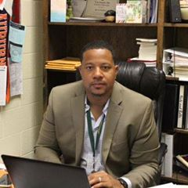 | School Counselor  Byron Kellam LPC  kellam@fultonschools.org  470-473-8536
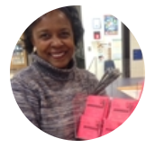 | School Social Worker  Chandra Hall PhD  hallcv@fultonschools.org  404-245-7809
 | School Psychologist  Nicole Wojahn EdS  wojahnn@fultonschools.org

You can also access several resources through the Fulton County Schools website. Click the link below for more information!
Resources
- Health and Social Services  - Behavior and Mental Health  - Food Assistance | - Shelters and Housing  - Internet and WiFi Services  - Technical Support
https://www.fultonschools.org/communityresources

If you are experiencing an emergency, please call 911. If you or someone you know is experiencing a mental health crisis and you need immediate support, please call one of the 24/7 hotline numbers listed below.
Crisis Hotlines
Georgia Crisis and Access Line | 1-800-715-4224
National Suicide Prevention Hotline | 1-800-273-8255
National Domestic Violence Hotline | 1-800-799-7233
National Parent Helpline | 1-855-427-2736

