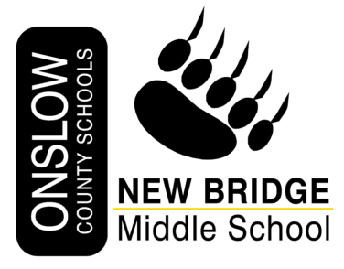

***New Bridge Middle School***

***2024 Scholarship*** ***Application***

* This one time award is based on available scholarship funds in terms of number of recipients and amount awarded.
* Scholarship is available to former NBMS students who are graduating from an Onslow County High School in June 2024. Students who attended NBMS and will graduate from the North Carolina School of the Arts or the North Carolina School of Science and Mathematics will be considered if their permanent address is in Onslow County.
* The nominee’s academic status and character will be considered.
* Application, with attachments, must be complete including application form, transcript, resume, three letters of recommendation, and any supporting information.
* Completed application is due May 17, 2024, submitted to:

New Bridge Middle School

401 New Bridge Street

Jacksonville, NC 28540

Attention: Jennifer Sullivan

**2022-2023 Scholarship Committee**

* Committee Chair- Mrs. Sullivan
* 6th Grade Representative- Mrs. Mueller
* 7th Grade Representative- Ms. Caston
* 8th Grade Representative- Mr. Stoneham
* Encore Representative- Mrs. Mahouchick
* Admin Representative- Ms. Padgett

**PART I: Applicant Information**

Name of Applicant Age

Address

Applicant’s Phone Number:

Applicant’s E-Mail Address:

Current High School

What grades and years did you attend New Bridge Middle School? Was it a full, partial or none for each year?

Grade Years Full Year Partial Year None

6th Grade

7th Grade

8th Grade

Name and Address of college/university you will attend

Major area of study

Degree you are seeking

**Part Two: Essay**

Please respond to the prompt by writing an essay of no less than 500 words. Type your response and include it with your submission.

Prompt

In an essay, tell three ways in which New Bridge Middle School prepared you for academic success and fostered good citizenship.

**Part Three: Certification**

To: New Bridge Scholarship Committee,

I hereby certify that the foregoing facts and statements are correct to the best of my knowledge and belief. Furthermore, I certify that the essay submitted with this application was prepared and written solely by me.

Applicant’s Name

Applicant’s Signature Date

**Part Four: Supporting Documentation**

* Attach an up-to-date transcript of high school courses and grades, showing GPA, rank in class and test scores.
* Attach a resume/list of your activities and honors.
* 3 letters of recommendation, at least two from high school teachers who have taught you recently.
* Include any other information you think would be helpful to the scholarship committee.

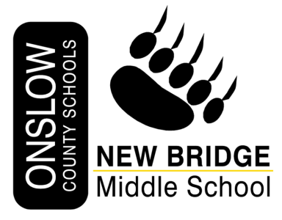

**RECOMMENDATION**

**TO APPLICANT:**

Please complete the top section of this form and deliver the form to your selected reference.

Reference will return the completed form to you in a sealed, signed envelope.

APPLICANT’S NAME:

NAME OF REFERENCE:

RELATIONSHIP TO APPLICANT:

ADDRESS OF REFERENCE:

Phone Number:

Email Address:

TO REFERENCE:

The applicant named above has applied for a scholarship from The New Bridge Scholarship Fund. The scholarship is competitive and is awarded only to the best of the applicants. Your opinion will be given considerable weight; consequently, your attention to the completion of this form is very important***. If you are willing to provide a reference for this applicant, please complete and return this form to the applicant in a SEALED envelope, identifying the name of the applicant on the outside of the envelope and your signature across the seal. You may also send it by attachment through OCS email.*** For purposes of clarification, the committee reserves the right to contact any person submitting a recommendation for the applicant.

The application with all references MUST BE SUBMITTED to New Bridge Middle School by May 17, 2024.

**\*Rating Scale (Rubric involved. Applicant must have 40 or more points to be considered for a scholarship.)**

Please rate the applicant on the following characteristics using the following scale:

5=Outstanding

4=Excellent

3=Good

2=Fair

1=Poor

0=Unable to Judge

_____ Academic performance _____ Ability to do independent work

_____ Leadership _____ Writing skills

_____ Morals/Integrity _____ Perseverance/Follow-through

_____Maturity level _____Communication skills

_____ Ability to work with others _____ Problem solving

Please add any comments you believe would be helpful to the scholarship committee. Thank you.

______________________________________________________________________________________________________________________________________________________________________________________________________________________________________________________________________________________________________________________________________________________________________________________________________________________________________________________________________________________________________________________________________________________________________________________________________________________________________________________

*New Bridge Middle School 401 New Bridge Street, Jacksonville, NC 28540 (910)-346-5144*