Gifted Services at SDE

Contact Person: Amy Hartman- amy.hartman@onslow.k12.nc.us

Services Offered:

3rd-5th Grades: Weekly pull outs for both math and reading for advanced learners. Exposure to accelerated content, and curriculum extensions. Talent Development opportunities for high achieving students.

K-2nd Grades: Flexible talent development small groups focusing on critical thinking skills.

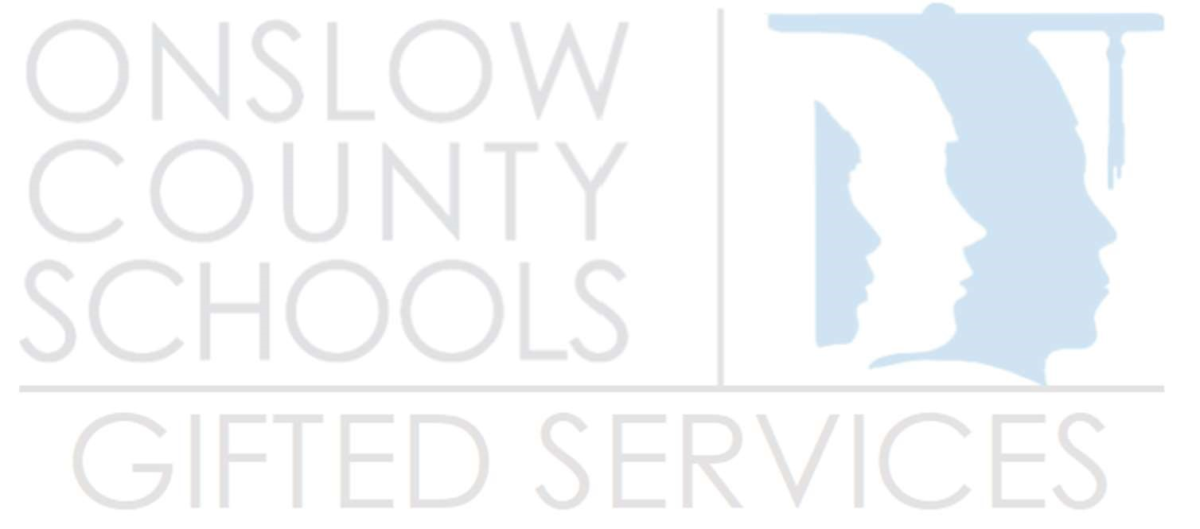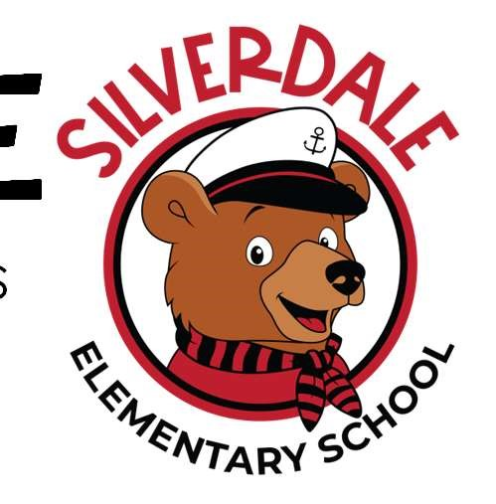Teachers: Push in/co-teaching, consultative services for individual students, differentiation support and referrals for assessing students.

Enrichment Opportunities:

* Chess
* Math Counts
* Battle of the Books
* Science Olympiad
* Odyssey of the Mind and more!

Curriculum Resources:

* Hands on Equations
* ThinkLaw
* CKLA Extensions
* Greek & Latin Roots
* STEM Activities
* Byrdseed and more!