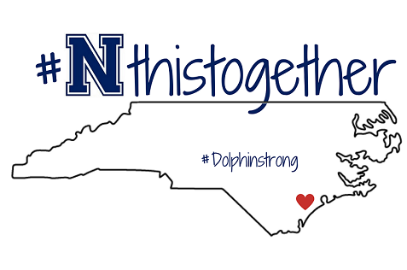
9
2023-24 Class Policies & Procedures
6th Grade Team

Excellence: Every Student. Every Day.
Schoolwide Grading Policy
Grading Scale
A: 90-100 B: 80-89 C: 70-79 D: 60-69 F: Below 59

- Assignments turned in on time are eligible for full credit.
- Assignments not turned in on time are subject to late deduction.
- Last day of a grading period assignment(s) will not be accepted.

What are the behavior expectations in this class and at NWPMS?
As a school, we follow PBIS procedures that have been established school wide. Inside each classroom you will follow the individual teacher’s guidelines. As a school policy, when a teacher or staff member raises his or her hand, you will follow the teacher’s example by raising your hand and being silent.
- Be Respectful. Be engaged and ready to participate. Accept directions, feedback, or corrections from any staff member by listening and asking appropriate questions. Respect others’ right to learn. Raise your hand to participate in whole class activities or to get my attention. I will also raise my hand as a signal that I need everyone to stop, look and listen to my directions. Value the property of others.
- Be Responsible. Arrive on time. Be prepared for instruction with all necessary materials. Leave your area clean and free of trash.
- Be Safe. Use materials only as instructed.

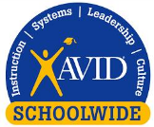  What does it mean for Northwoods Park Middle School to be AVID schoolwide? | In all classes at Northwoods Park Middle, the teachers and students use the AVID approach for teaching and learning. Schoolwide components of AVID at NWPMS include the AVID binder and student agenda for organization. Teachers will use research based high yield strategies in the classroom to empower students with access to the content for all subjects. As an AVID school, our staff believes that all students can experience academic success with the right tools and support.
What major topics will we learn in this class? | Math: Ratios and proportional relationships, the number system, expressions and equations, geometry, statistics and probability.  Science: Forces and motion, matter, energy, Earth and the universe, Earth systems, and structures and functions of living organisms/ecosystems.  Humanities/Social Studies: map skills and geography, early humans, Mesopotamia, Greece, Rome, Egypt, Israelites, India, China, Feudalism, Mayans/Incans/Aztecs, Early Americas  ELA: poetry, figurative language, theme, textual evidence, central Idea, meaning of words and phrases, plot outline, analyzing texts, point of view, compare/contrast different types of media, compare/contrast different genres, cause and effect, evaluate arguments & claims, compare/contrast point of view of particular events
What kind of assignments and assessments will we have in this class? | In all core classes, students will do the following assignments but not limited to:  - Journals  - Projects, quizzes, tests,  - Problem sets  - Group activities  - AVID based activities  - Technology based activities  Math and ELA: iReady diagnostic, Ready quizzes and unit assessments.
What books and resources will we use? | Math: Ready North Carolina  ELA: AVID Weekly, Iready Online curriculum, Springboard  S.S: Discovery Education  Science: Discovery Education
What supplies will students need to be successful? | You will need the items on the School Supply List. You will not be able to share materials with other students.  Fully charged 1:1 laptop every day. Do not loan your laptop or charger to anyone. The technology is checked out to you. The replacement cost for laptops that are lost or damaged beyond repair is based upon the laptop model and the replacement cost of a lost charger is based upon the type of charger. Our middle school laptops are new this year. (The approximate replacement cost for a laptop and charger is $800.00). Write the inventory number for your laptop and your charger in the front cover of your Student Agenda.
How do we save assignments and projects when using our 1:1 laptop?  Will homework be assigned in this class? | All students will have an Office 365 account that can be accessed from any computer at home or at school. Always save your work to your Office 365 account.  Every Dolphin is assigned 15 minutes of reading each night and to charge your laptop at night to ensure it is charged for the next day. IReady Math 45 minutes, two lessons passed each week and IReady Reading 45 minutes and two lessons passed each week.  Other homework assignments will support classroom instruction to practice skills learned. Science and Social Studies typically do mot assign homework unless they have not completed classwork.
Are there other places to go to find class information? | Each teacher will have a Week at a Glance (WAG) posted in teacher webpage.  School web address is https://www.onslow.k12.nc.us/northwoodsparkms
Teacher Contacts | Jennifer.hardy@onslow.k12.nc.us  Amber.laurence@onslow.k12.nc.us  Jakeya.washington@onslow.k12.nc.us  Autumn.lambertmiller@onslow.k12.nc.us

I have read and understand the attached classroom policies and procedures.

Please return this section to your HOMEROOM TEACHER.

Student’s printed name: _______________________________________________

Student signature: ____________________________ Date: __________________

Parent signature: _____________________________ Date: _________________

