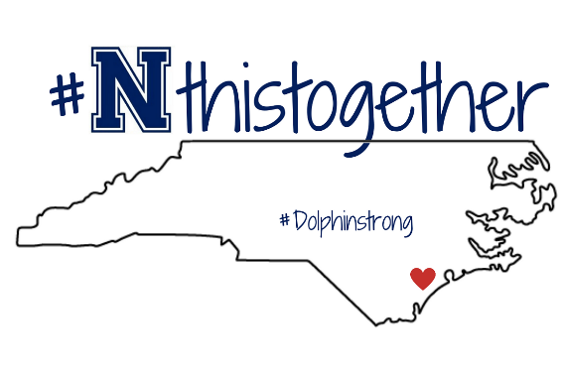
WEEK AT A GLANCE
Week of: 3/22-26
Teacher: Johnson  Subject / Grade:(7)  Exploring Econ. | MON  Encore 1 | TUES  Encore 2 | WED | THURS  Encore 1 | FRI  Encore 2
Essential Question | What is Entrepreneurship? |  | Virtual Day  No Live Classes | What is Entrepreneurship?
NC Standard/ Objective | 1.02 Understand Entrepreneurship |  | Students will watch the video posted in teams and complete the flip grid assignment that goes along with it.  Students must share how they feel about their journey in Covid and their thoughts about returning to school full time. | 1.02 Understand Entrepreneurship
Learning Target | I can understand the skills needed to accomplish my entrepreneurial goals. |  |  | I can understand the skills needed to accomplish my entrepreneurial goals.
Assignments/ Activities | - Introduce Entrepreneurial Skills  - Shark Tank Video  - Flip Grid Assignment (Graded) |  |  | - Introduce Entrepreneurial Skills  - Shark Tank Video  - Flip Grid Assignment (Graded)
Assessments/  Projects | Flip Grid Assignment |  |  | Flip Grid Assignment
Homework | *Read for 15 min & complete Reading Log |  | School-wide HW assignment |  | *Read for 15 min &  complete Reading Log

WEEK AT A GLANCE
Week of: 3/22-26
Teacher:  Johnson  Subject / Grade:(6)  Keyboarding | MON  Encore 1 | TUES  Encore 2 | WED | THURS  Encore 1 | FRI  Encore 2
Essential Question | What type of software is Microsoft Word? |  | Virtual Learning  No Live Classes | What type of Software is Microsoft Word?
NC Standard/ Objective | Understand Formatting Skills |  | Students will watch the video posted in teams and complete the flip grid assignment that goes along with it.  Students must share how they feel about their journey in Covid and their thoughts about returning to school full time. | Understanding Formatting Skills
Learning Target | I can identify the parts and functions of Microsoft Word. |  |  | I can identify the parts and functions of Microsoft Word.
Assignments/ Activities | - Closed Notes  - Label the Screen Activity |  |  | - Closed Notes  - Label the Screen Activity
Assessments/  Projects | Online Students will complete 2 Lessons of typing.com |  |  | Online Students will complete 2 lessons of typing.com
Homework | *Read for 15 min & complete Reading Log |  | School-wide HW assignment |  | *Read for 15 min &  complete Reading Log
WEEK AT A GLANCE
Week of: 3/22-26
Teacher: Johnson  Subject / Grade:  Employment | MON  Encore 1 | TUES  Encore 2 | WED | THURS  Encore 1 | FRI  Encore 2
Essential Question | Why is typing an important skill in the work force? |  | Virtual Day  No Live Classes | Why is typing an important skill in the work force?
NC Standard/ Objective | 1.02 Understand various skill s needed for employment success |  | Students will watch the video on Digital Citizenship created by Mr. Johnson | 1.02 Understand various skill s needed for employment success
Learning Target | I Can use my typing skill to produce a professional business document in a timely manner |  | Students will watch the video posted in teams and complete the flip grid assignment that goes along with it.  Students must share how they feel about their journey in Covid and their thoughts about returning to school full time. | I can use my typing skill to produce a professional business document in a timely manner.
Assignments/ Activities | - iReady  - Typing Drill  - Pg.106-108 |  |  | - iReady  - Typing Drill  - Pg. 106 - 108
Assessments/  Projects | iReady |  |  | iReady
Homework | *Read for 15 min & complete Reading Log |  | School-wide HW assignment |  | *Read for 15 min &  complete Reading Log

WEEK AT A GLANCE
Week of: 3/22-26
Teacher: Johnson  Subject / Grade:  GQ | MON  Encore 1 | TUES  Encore 2 | WED | THURS  Encore 1 | FRI  Encore 2
Essential Question | How do gender stereotypes impact society and the world of work? |  | Virtual Day  No Live Classes | How do gender stereotypes impact society and the world of work?
NC Standard/ Objective | 1.02 Foundational Skills |  | Students will watch the video on Digital Citizenship created by Mr. Johnson | 1.02 Foundational Skills
Learning Target | I can use the professional skills learned to lead a professional podcast. |  | Students will watch the video posted in teams and complete the flip grid assignment that goes along with it.  Students must share how they feel about their journey in Covid and their thoughts about returning to school full time. | I can use the professional skills learned to lead a professional podcast.
Assignments/ Activities | - PodCast w/ LQ  - Cotton Ball Ice Breaker  - GQ Leadership Building Lesson  - 8 Week Contract |  |  | - Podcast w/ LQ  - GQ Leadership Building Lesson  - 8 Week Contract
Assessments/
Projects
Homework | *Read for 15 min & complete Reading Log |  | School-wide HW assignment |  | *Read for 15 min &  complete Reading Log

