Madison County Schools
Board of Education  Karen Blevins, Chairman  Kelby Cody, Vice Chair  Kevin Barnette, Member  Barbara Wyatt, Member  Keith Ray, Member | 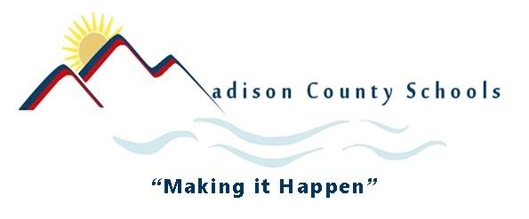 | Superintendent  Dr. Will Hoffman.  Contact Information:  5738 US Highway 25/70  Marshall, NC 28753  Phone: 828-649-9276  Fax: 828-649-9334
Purpose: This letter is to be given to the student and their family at the point that the student exits school. It is intended to alert them to the fact that they will be contacted in the next year to see how they are doing in terms of employment and/or postsecondary education.
Dear <student name>:_________________________________________
You were selected to participate in a survey. This survey will tell us how our students do after they leave school and help us decide what we can do to better prepare our students for work and college after high school.
Next year, between April and September, an interviewer from the State University of New York at Potsdam will contact you by telephone from this number: (315)-267-2000. It will take you about 10 minutes or less to answer the questions. The interviewer will ask if you obtained a job or have gone to college or other training since you left high school. What you say during the interview is private and confidential. No one at our school will know what you said. Your name will not appear in any report.
Please share this letter with your parents. If you or your parents want more information or are concerned about participating, please contact Sheila Paxton at 828-649-3086.
Please check the box below:
- I wish to participate in the survey.
- I do not wish to participate in this survey.
Thank you for your help. Our goal is for every student to succeed. Your responses will help our school district better prepare students to continue their education and become employed after leaving high school.
Sincerely,

Sheila Paxton, Madison High School (EC Teacher)
………………………………………………………………………………………………
Student Name: _________________________________________________________
Signed __________________________________________ Date________________
(If signed by someone other than the student, indicate relationship:_________________)

