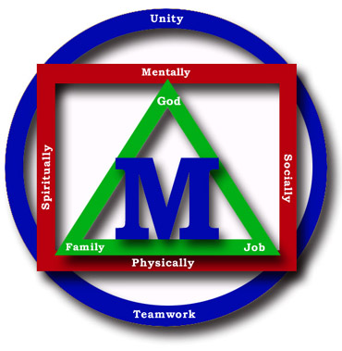
Madison County Schools


“Children Are Our Business”

Date: _________________

To Parents/Guardians:

A student in your child’s classroom has been diagnosed with scabies. Below is some information that you may find helpful in answering any questions that you may have. If you find a suspicious rash on your child, please take them to their doctor or the health dept for further evaluation.

Thanks,

______________________________

Michele Bailey, RN Laura Kirkpatrick, RN

Madison Middle School Mars Hill Elementary School

Laurel Elementary School Madison Early College H.S.

Kathey Lee, RN Teresa Nolan, RN

Madison High School Brush Creek Elementary School

Hot Springs Elementary School

What is scabies?
Scabies is an infestation of the skin with a microscopic mite. It affects people of all races and social classes.

What are the signs and symptoms of scabies infestation?
- Pimple-like irritations, burrows or rash of the skin, especially the webbing between the fingers; the skin folds on the wrist, elbow, or knee; private areas; or shoulder blades.
- Intense itching, especially at night and over most of the body.
- Sores on the body caused by scratching. These sores can sometimes become infected with bacteria.

How do you get scabies?
By direct, prolonged, skin-to-skin contact with a person already infested with scabies. Contact must be prolonged (a quick handshake or hug will usually not spread infestation). Infestation is easily spread to other household members. Infestation may also occur by sharing clothing, towels, and bedding.

How soon after infestation will symptoms begin?
For a person who has never been infested with scabies, symptoms may take 4-6 weeks to begin. For a person who has had scabies, symptoms appear within several days. You do not become immune to an infestation.

Can scabies be treated?
Yes. Several lotions and oral medications are available to treat scabies. Always follow the directions provided by your physician or the directions on the package insert. Apply lotion to a clean body from the neck down to the toes and leave overnight (8 hours). After 8 hours, take a bath or shower to wash off the lotion. Put on clean clothes. All clothes, bedding, frequently slept with or played with stuffed animals, and towels used by the infested person 2 days before treatment should be washed in hot water; dry in a hot dryer. A second treatment of the body with the same lotion may be necessary 7-10 days later. Also, vacuum carpets, furniture, and car upholstery too as an extra precaution.
If my child is infected with scabies, how soon can he/she return to school?
Students should not be back at school until at least 24 hours after oral or topical treatment has been used by the student and possibly the other household members. Treatment of household items above should have already taken place too. It is also strongly encouraged to have a note from the healthcare provider stating when the student may return to school.

Who should be treated for scabies?
Anyone who is diagnosed with scabies, and persons who have close, prolonged contact to the infested person should also be treated. Health care providers usually instructed other family members to be treated. Everyone should receive treatment at the same time to prevent reinfestation.

How soon after treatment should a person feel better?
Itching may continue for 2-3 weeks, and does not mean that you are still infested. Your health care provider may prescribe additional medication to relieve itching if it is severe. No new burrows or rashes should appear 24-48 hours after effective treatment.

