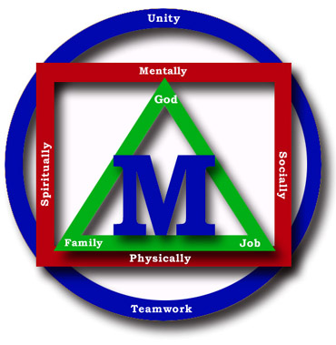
Madison County Schools


“Children Are Our Business”

Date: ___________________________

Dear parents/guardians,

This letter is to notify you that a child in your child’s class has contracted chickenpox. Varicella causes an acute illness with a rash that results in children missing days at school while they have a rash and parents missing work when they stay home to take care of their children. Most children now are vaccinated with at least one dose of varicella vaccine but because one dose of the vaccine is 80-85% effective for preventing chickenpox, it is not unusual to see breakthrough disease. Two doses of varicella vaccine are now routinely recommended for children.

Background : Chickenpox is a very contagious infection caused by a virus. It is spread from person to person by direct contact or through the air from an infected person’s coughing or sneezing. It causes a blister-like rash, itching, tiredness, and fever lasting an average of 4 to 6 days. Most children recover without any problems. Chickenpox can be spread for 1-2 days before the rash starts and until all blisters are crusted or no new lesions appear within a 24-hour period. It takes between 10-21 days after contact with an infected person for someone to develop chickenpox. Chickenpox in vaccinated persons is generally mild, with a shorter duration of illness and fewer than 50 lesions. The rash may be atypical with red bumps and few or no blisters.

What should you do? The CDC strongly encourages you to have your child receive their first or second dose of varicella vaccine if your child has not been vaccinated and has never had chickenpox. For children who had received 1 dose, a second dose is recommended.
If your child or anyone in your household currently has symptoms that look like chickenpox, contact your regular health care provider to discuss your child's symptoms and to see if anyone in the home needs to be vaccinated. Please contact me if your child has been diagnosed with the chickenpox.

Anyone who has chickenpox should avoid contact with others who have not had chickenpox or who are not vaccinated against chickenpox. They should not attend school, day care, work, parties and/or other gatherings until the blisters become crusted (about 4-6 days after rash appears), or no new lesions appear within a 24-hours period. Keep all chickenpox spots and blisters and other wounds clean and watch for possible signs of infection; including increasing redness, swelling, drainage and pain at the wound site.
If you or anyone else in your household has a weakened immune system or is pregnant and has never had chickenpox or the vaccine, talk with your doctor immediately.

If you have any further questions or concerns, please feel free to contact your child’s school nurse.

