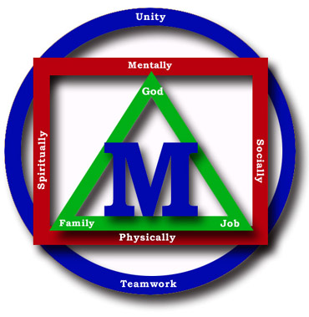
Madison County Schools


“Children Are Our Business”

Date: _________________________

Re: ________________________________________ Immunization/Physical Records

Dear Parent(s)/Guardian(s)

North Carolina law requires that we check every student’s school health record to be sure that the following immunizations have been received and are up to date; or that there is legal documentation of a medical or religious exemption on file.

- DTP (Diphteria, Tetanus, and Pertussis)
- OPV( Oral Polio Vaccine or IPV )
- MMR (Measles, Mumps, and Rebella)
- Hep B (Hepatitis B)
- Hib (Hemophilus Influnzae, Type B) Individuals who have passed their 5th birthday are not required to receive Hib vaccine.
- Varicella (Chicken Pox vaccine)

A review of your child’s immunization record indicates that it is incomplete in the area(s) circled or checked below.

______Incomplete record* ______No Record

______Needs DTP #1-2-3-4-5 ______Needs Polio 1-2-3-4

______ Needs Hep. B 1-2-3 ______Needs Physical

______Needs MMR 1-2 ______Needs Varicella

______Other_____________________________________

Please send an official statement indication the date(s) he/she received the immunization(s), or send an official statement documenting a religious or a medical exception.

The NC General Statute 130-87 requires that students not having proper documentation of the above are to be suspended from school thirty (30) days from the dated of enrollment. If you cannot obtain this information, your child will need additional immunizations to comply with the law. If we do not have proper documentation by___________________, your child will be suspended until we receive the correct documentation.

Thank-you for your cooperation in getting your child’s immunization records complete.

___________________________________
Principal

*All states do not require this, but NC requires that all immunizations have a specific date.

