How to Use Your Inhaler
Metered Dose Inhaler (MDI or pMDI)
How to Use a Metered-Dose Inhaler "Puffer"
A metered-dose inhaler, called an MDI for short, is a pressurized inhaler that delivers medication by using a propellant spray.
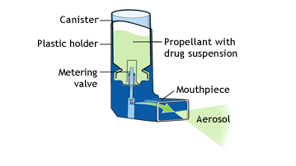
To use an MDI:
- Shake the inhaler well before use (3 or 4 shakes)
- Remove the cap
- Breathe out, away from your inhaler
- Bring the inhaler to your mouth. Place it in your mouth between your teeth and close you mouth around it.
- Start to breathe in slowly. Press the top of you inhaler once and keep breathing in slowly until you have taken a full breath.
- Remove the inhaler from your mouth, and hold your breath for about 10 seconds, then breathe out.
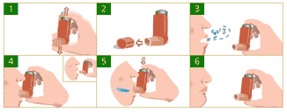
If you need a second puff, wait 30 seconds, shake your inhaler again, and repeat steps 3-6. After you've used your MDI, rinse out your mouth and record the number of doses taken.
Store all puffers at room temperature
Cleaning Your MDI
To clean your MDI, follow the instructions that came with it. In most cases, they will advise you to:
- Remove the metal canister by pulling it out.
- Clean the plastic parts of the device using mild soap and water. (Never wash the metal canister or put it in water.)
- Let the plastic parts dry in the air (for example, leave them out overnight).
- Put the MDI back together.
- Test the MDI by releasing a puff into the air.
Important Reminders About MDIs
Always follow the instructions that come with your MDI.
As well:
- Keep your reliever MDI somewhere where you can get it quickly if you need it, but out of children's reach.
- Show your doctor, pharmacist or asthma educator how you're using your metered-dose inhaler.
- Store your MDI at room temperature. If it gets cold, warm it using only your hands.
- Never puncture or break the canister, or try to warm it using anything except your hands.
- When you begin using an MDI, write the start date on the canister.
- Check the expiry date on the MDI before you use it.
- If you're having trouble using your MDI, ask your doctor for tips or to recommend another device.
- Many doctors recommend the use of a spacer, or a holding device to be used with the MDI.
- Do not float the canister in water.

