How to Use a Diskus®
A DISKUS® is a dry-powder inhaler that holds 60 doses. It features a built-in counter, so that you always know how many doses you have left in it.
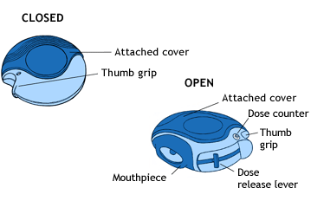
- Open your DISKUS®: Hold it in the palm of your hand, put the thumb of your other hand on the thumb grip and push the thumb grip until it "clicks" into place
- Slide the lever away from you as far as it will go to get your medication ready
- Breathe out away from the device
- Place the mouthpiece gently in your mouth and close your lips around it
- Breathe in deeply until you have taken a full breath
- Remove the DISKUS® from your mouth
- Hold your breath for about ten seconds, then breathe out
- Always check the number in the dose counter window to see how many doses are left.
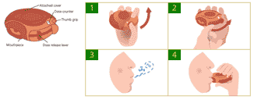
If you drop your DISKUS® or breathe into it after its dose has been loaded, you may cause the dose to be lost. If either of these things happens, reload the device before using it.

