How to Use a Turbuhaler®
A Turbuhaler® is a dry-powder inhaler available in an easy-to-use format.
Some Turbuhalers® feature a dose counter that shows the exact amount of medication left. If your Turbuhaler® doesn't have a dose counter, then check for a red indicator in the windows on the side of the device. When you see red in the window, there are approximately 20 doses left and it's time to order a refill.
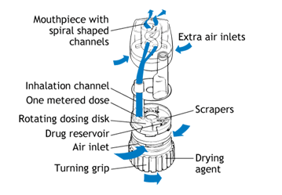
- Unscrew the cap and take it off. Hold the inhaler upright
- Twist the coloured grip of your Turbuhaler® as far as it will go. Then twist it all the way back. You have done it right when you hear a "click"
- Breathe out away from the device
- Put the mouthpiece between your teeth, and close your lips around it. Breathe in forcefully and deeply through your mouth
- Remove the Turbuhaler® from your mouth before breathing out
- Always check the number in the side counter window under the mouthpiece to see how many doses are left. For the Turbuhalers® that do not have a dose counter window, check the window for a red mark, which means your medication is running out. When finished, replace the cap.
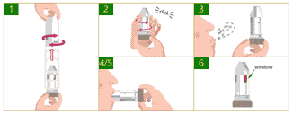
If you drop your Turbuhaler® or breathe into it after its dose has been loaded, you may cause the dose to be lost. If either of these things happens, reload the device before using it.
Clean your Turbuhaler® as needed. To do this, first wipe the mouthpiece with a dry tissue or cloth. Never wash the mouthpiece or any other part of the Turbuhaler® - if it gets wet, it won't work properly.

