How to Use A Diskhaler®
A Diskhaler® is a dry-powder inhaler that holds small pouches (or blisters), each containing a dose of medication, on a disk. The Diskhaler® punctures each blister so that its medication can be inhaled.
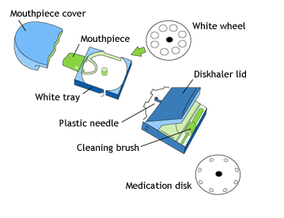
- Remove the cover and check that the device and mouthpiece are clean.
- If a new medication disk is needed, pull the corners of the white cartridge out as far as it will go, then press the ridges on the sides inwards to remove the cartridge.
- Place the medication disk with its numbers facing up on the white rotating wheel. Then slide the cartridge all the way back in.
- Pull the cartridge all the way out, then push it all the way in until the highest number on the medication disk can be seen in the indicator window.
- With the cartridge fully inserted, and the device kept flat, raise the lid as far as it goes, to pierce both sides of the medication blister.
- Move the Diskhaler® away from your mouth and breathe out as much as you can until no air is left in your lungs.
- Place the mouthpiece between your teeth and lips, making sure you do not cover the air holes on the mouthpiece. Inhale as quickly and deeply as you can. Do not breathe out.
- Move the Diskhaler® away from your mouth and continue holding your breath for about 10 seconds.
- Breathe out slowly.
- If you need another dose, pull the cartridge out all the way and then push it back in all the way. This will move the next blister into place. Repeat steps 5 through 9.
- After you have finished using the Diskhaler®, put the mouthpiece cap back on.
If you drop your Diskhaler® or breathe into it after its dose has been loaded, you may cause the dose to be lost. If either of these things happens, reload the device before using it.
Your Diskhaler® should always be cleaned according to its instructions and before you insert a new medication disk into it.

