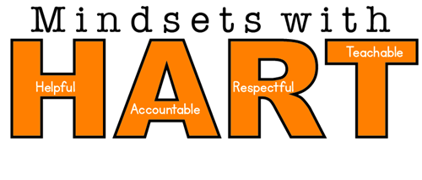

**Hartwell Elementary uses the 7 Mindsets Curriculum to encourage positive thinking and actions.  Students can earn rewards when they are seen being Helpful, Accountable, Respectful and Teachable.  Our 7 Mindsets program and our behavior expectations work together to provide students with skills that will be helpful at school and beyond.**

***7Mindsets***

***August-*100% Accountable**

***September*-We are Connected**

***October*-We are Connected (Bullying Prevention Month)**

***November*-Attitude of Gratitude**

***December*-Live to Give**

***January*-100% Accountable**

***February*-Passion First**

***March*-The Time is Now**

***April*-Everything is Possible**

***May-*Everything is Possible**