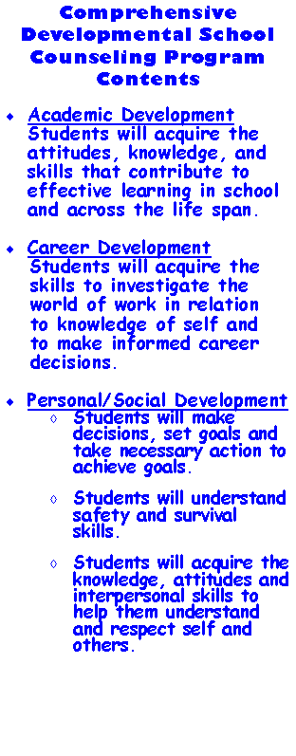

***Academic Development:*** Current academic standards set forth by the Georgia Department of Education require that students demonstrate academic competencies and skills during the school years and translate those into post-secondary options or work readiness. Students will complete school and be confident that the knowledge they have gained can lead to many post-secondary options. Students will be taught the relationship of academics to career and home. Programs that enhance this area of competency include: academic study skills/test taking skills, classroom guidance, individual academic counseling, and group counseling for students with academic enrichment needs.

***Career Development:*** Students will discover skills to recognize their personal strengths and use that knowledge to formulate a short-term and long-term career plan. Career awareness classroom guidance and interest inventories are two examples of career development delivery methods.

***Personal/Social Development: S***tudents will obtain the intrapersonal and interpersonal skills to better understand themselves as well as others. Students will learn to be good decision makers, goal setters, and be action-oriented in order to achieve the goals they have set for themselves. Also, students will contribute to a safe, bully-free environment via participation in bullying prevention activities, of which social skills and respect are major components. Lastly, students will comprehend safety and survival skills and be able to apply them to real world situations. Personal and social development will be enhanced via programs including: the 7 Mindsets, character education, individual counseling, and group counseling for students experiencing social and/or personal problems.