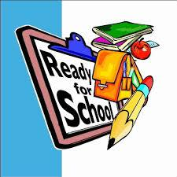
August 2015

Dear Parents,
Welcome to 2nd grade! I'm looking forward to working with you and your child this year in school. We have so much to learn and do together. I thought that you would like to know a little about our routines that we will be following beginning on our first day.

We have snack each day around 10:00 A.M. Please pack this separately from their lunch and label it with your child's name. Please do not send in snacks with nuts or snacks made in a factory that also produces peanut products. Water bottles are a great idea to send in daily with your child!

Here is a list of some school supplies that are recommended for your child to start off the year: a low odor dry erase marker, a dry erase eraser, a glue stick, a box of 24 crayons, a pair of ear buds for use with our computers (preferably a small pair that can be stored in their desk), a box of tissues, a roll of paper towels, and a container of baby wipes for the classroom. I could also use some Ziploc bags. Please feel free to send in sandwich or gallon size. When thinking about a backpack for the year, please do not get one on wheels. Space constraints are always an issue.

Thanks in advance for your help and assistance. This will surely make your child's year a rewarding and successful one. Please feel free to contact me with any questions or concerns throughout the year.

Sincerely,
Michelle Klein
E-mail mklein@glenridge.org

