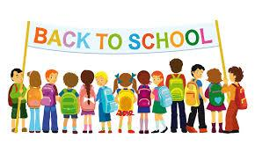
Dear Boys & Girls,

I hope that you are enjoying your summer so far. I know I am having a wonderful time with my family and friends.

School will be starting very soon and I am looking forward to seeing you. I know that second grade will be a special year for you.

I can't wait for us to read together this year. I have so many books to share with you and I know that you will enjoy reading many to me.

On the first day of school please bring in one of your favorite books. We will share them with the class those first couple of weeks and have some fun with them.

Enjoy the rest of your summer vacation and I will see you on September 8th!

From,
Miss Klein

