**How can a student send their Transcript to college?**

1. Log into your PowerSchool
2. In the top right hand corner click the  button.

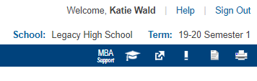

1. The click 

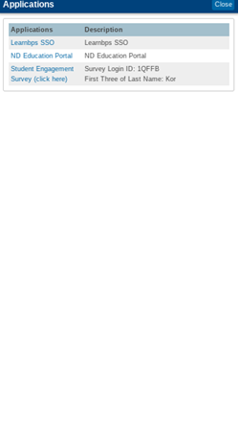

1. Then click on your name.

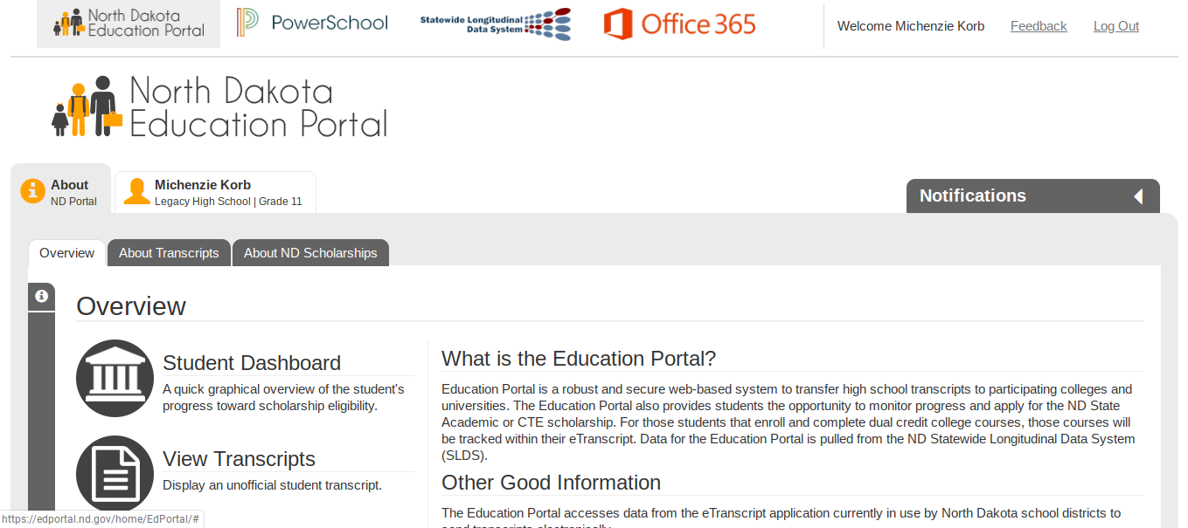

1. Then click on Send Transcripts.

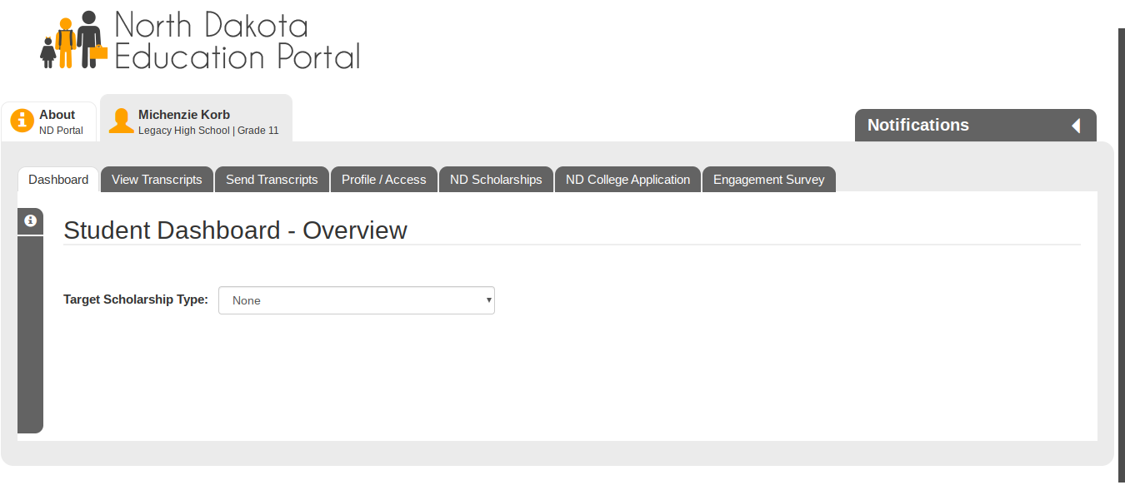

1. Then you can search for schools.

* If you want to send something to NDSU, be sure to type in a key word (such as North) instead of NDSU.

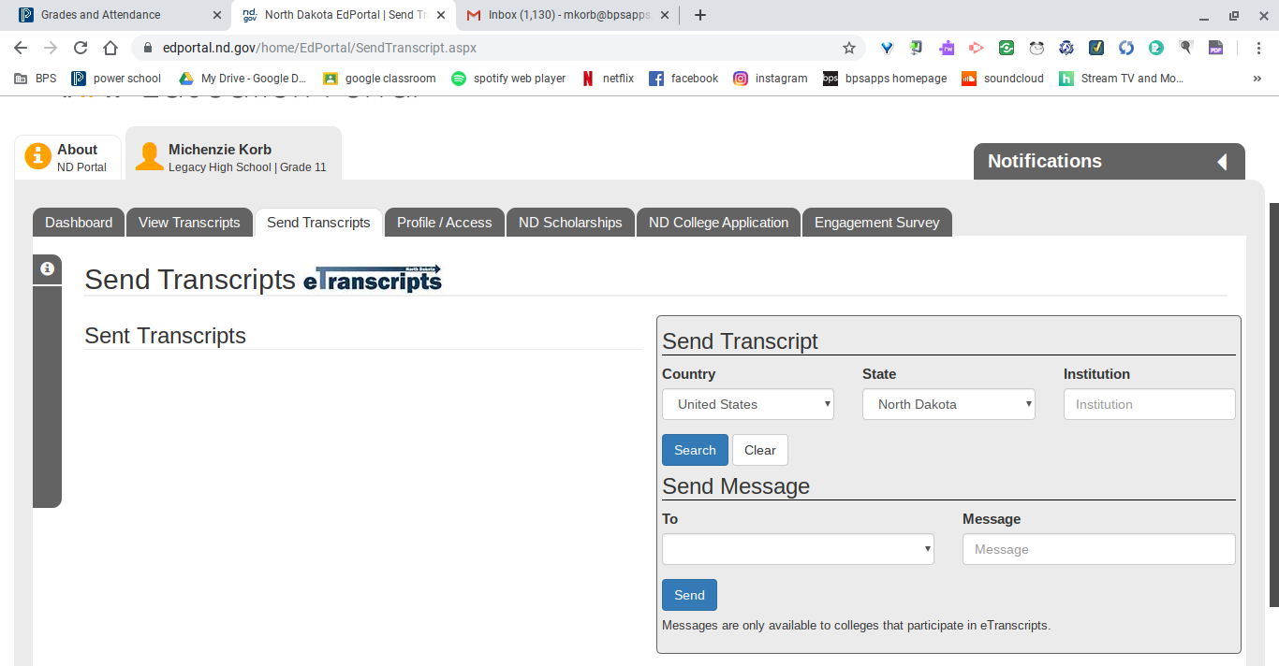

1. If you do not see the school you want to send your transcript to, please stop in the counseling office and see Ms. Wald. You will need to get a parent/guardian signature (if under 18), along with $2.

**\*If you have any questions, please stop in and ask Ms. Wald\***