**PUSD Substance Abuse Assessment**

Student Name: __________________________Grade: ________ Date: ___________ Time: ________

**I. Reason for Referral to Health Office**: ____________________________________________________

_____________________________________________________________________________________

_____________________________________________________________________________________

**II. History/Date of most recent use**: ______________________________________________________

Substance: _________________________________________________

**III. Observations:**

Vitals: Temp: ___________ Pulse: _________ Resp: _____________ BP: _______________

Gait: _______________ Hair: _______________ Clothing: _____________

Demeanor/Mood/Activity: ______________________________________________________________

Level of Consciousness:__________________________________________________________________

Speech: _____________________________________________________________________________

Face/Lips: ____________________________________________________________________________

Mouth/Breath: ________________________________________________________________________

Nose: _______________________________________________________________________________

Appearance of hands/arms: _____________________________________________________________

Meds taken today? ____________________________________________________________________

Drugs taken today? ____________________________________________________________________

Alcohol ingested? ______________________________________________________________________

Allergies? ____________________________ When/what did you last eat: _____________________

Last slept: ________________________ How long: _____________________________________

Glasses? Yes No Contacts? Yes No Contacts in? Yes No Both eyes? Yes No

Horizontal Nystagmus: ________________________________________________________________

Lack of smooth pursuit: _______________________ Maximum Deviation: ___________________

Vertical Nystagmus: __________________________ Lack of Convergence: ___________________

Romberg: __________________________________ Walk and Turn: ________________________

One leg stand: ______________________________

Finger to Nose:

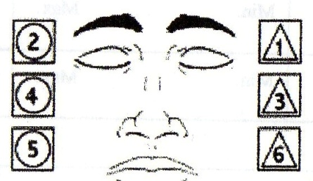

Pupil size: Room light ______ Near total darkness _______ Indirect light _______ Direct light ______

Hippus present? (rhythmatic pulsation of pupils as they dilate): ________________________________

Rebound dilation? (pupils pulsating, growing steadily larger): ___________________________________

**IV. Assessment**

_____________________________________________________________________________________

_____________________________________________________________________________________

_____________________________________________________________________________________

_____________________________________________________________________________________

**V. Plan**

_____________________________________________________________________________________

_____________________________________________________________________________________

_____________________________________________________________________________________

_____________________________________________________________________________________

Assessment Completed by:

__________________________________________ _______________ _________________

Signature of School Nurse Date Time