Students who would like to complete a total 150 volunteer hours WITH NON-PROFIT ORGANIZATIONS while a student at LMHS will earn a Volunteer Sash for graduation. It is recommended to start your freshman year and submit hours each academic school year
prior to May 15th.
(150 hours = 37 ½ hours per year for 4 years = 3 ¼ hours per month for 4 years)

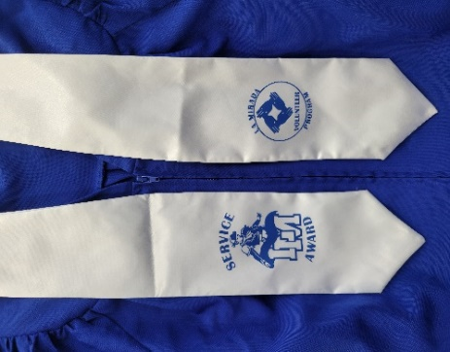

Do volunteer hours help in getting various scholarships?
In addition to academic performance and financial needs, many
scholarships require community involvement. If it is not a requirement,
it does help exemplify the student’s scholarship application as it shows
diversity in the student’s academic and social profile.

Many clubs offer hours, please check with your club teacher/sponsor. All hours completed off-site must be accompanied by a letter from the organization on letterhead or their business card, and only non-profit organizations can be utilized. If there are concerns about an organization, please send an email to the contacts below. Bulletin board within the administration building offers multiple sources/opportunities, along with the official volunteer forms. The list and forms are also posted on Schoology each semester.

- Volunteer hours include service to benefit the school community and the greater community. (This does not include band, color guard, VAPA, or athletic performances at school or district events. Volunteer performances at community centers, athletic camps, etc. may be included.)
- Volunteer hours may not be earned during school hours/school days and may not include donation of items.
- Due Dates for Volunteer Worksheets: 9th, 10th, 11th Grades are Due by May 15th of each school year.
- 12th Grade is due March 1st of Graduation year. Submit ALL Volunteer Worksheets to Ms. Ramos in the main office with confirmation letters or business cards.
- Hours earned after the last day of a school year may be submitted with the next school year's volunteer hours.
- Any volunteer service hours outside of school activity, must first be approved by an Administrator and the approval email should accompany the completed log sheet.

For questions or concerns, please send an email to:

Student Services, Ms. Ramos at caramos@nlmusd.k12.ca.us

