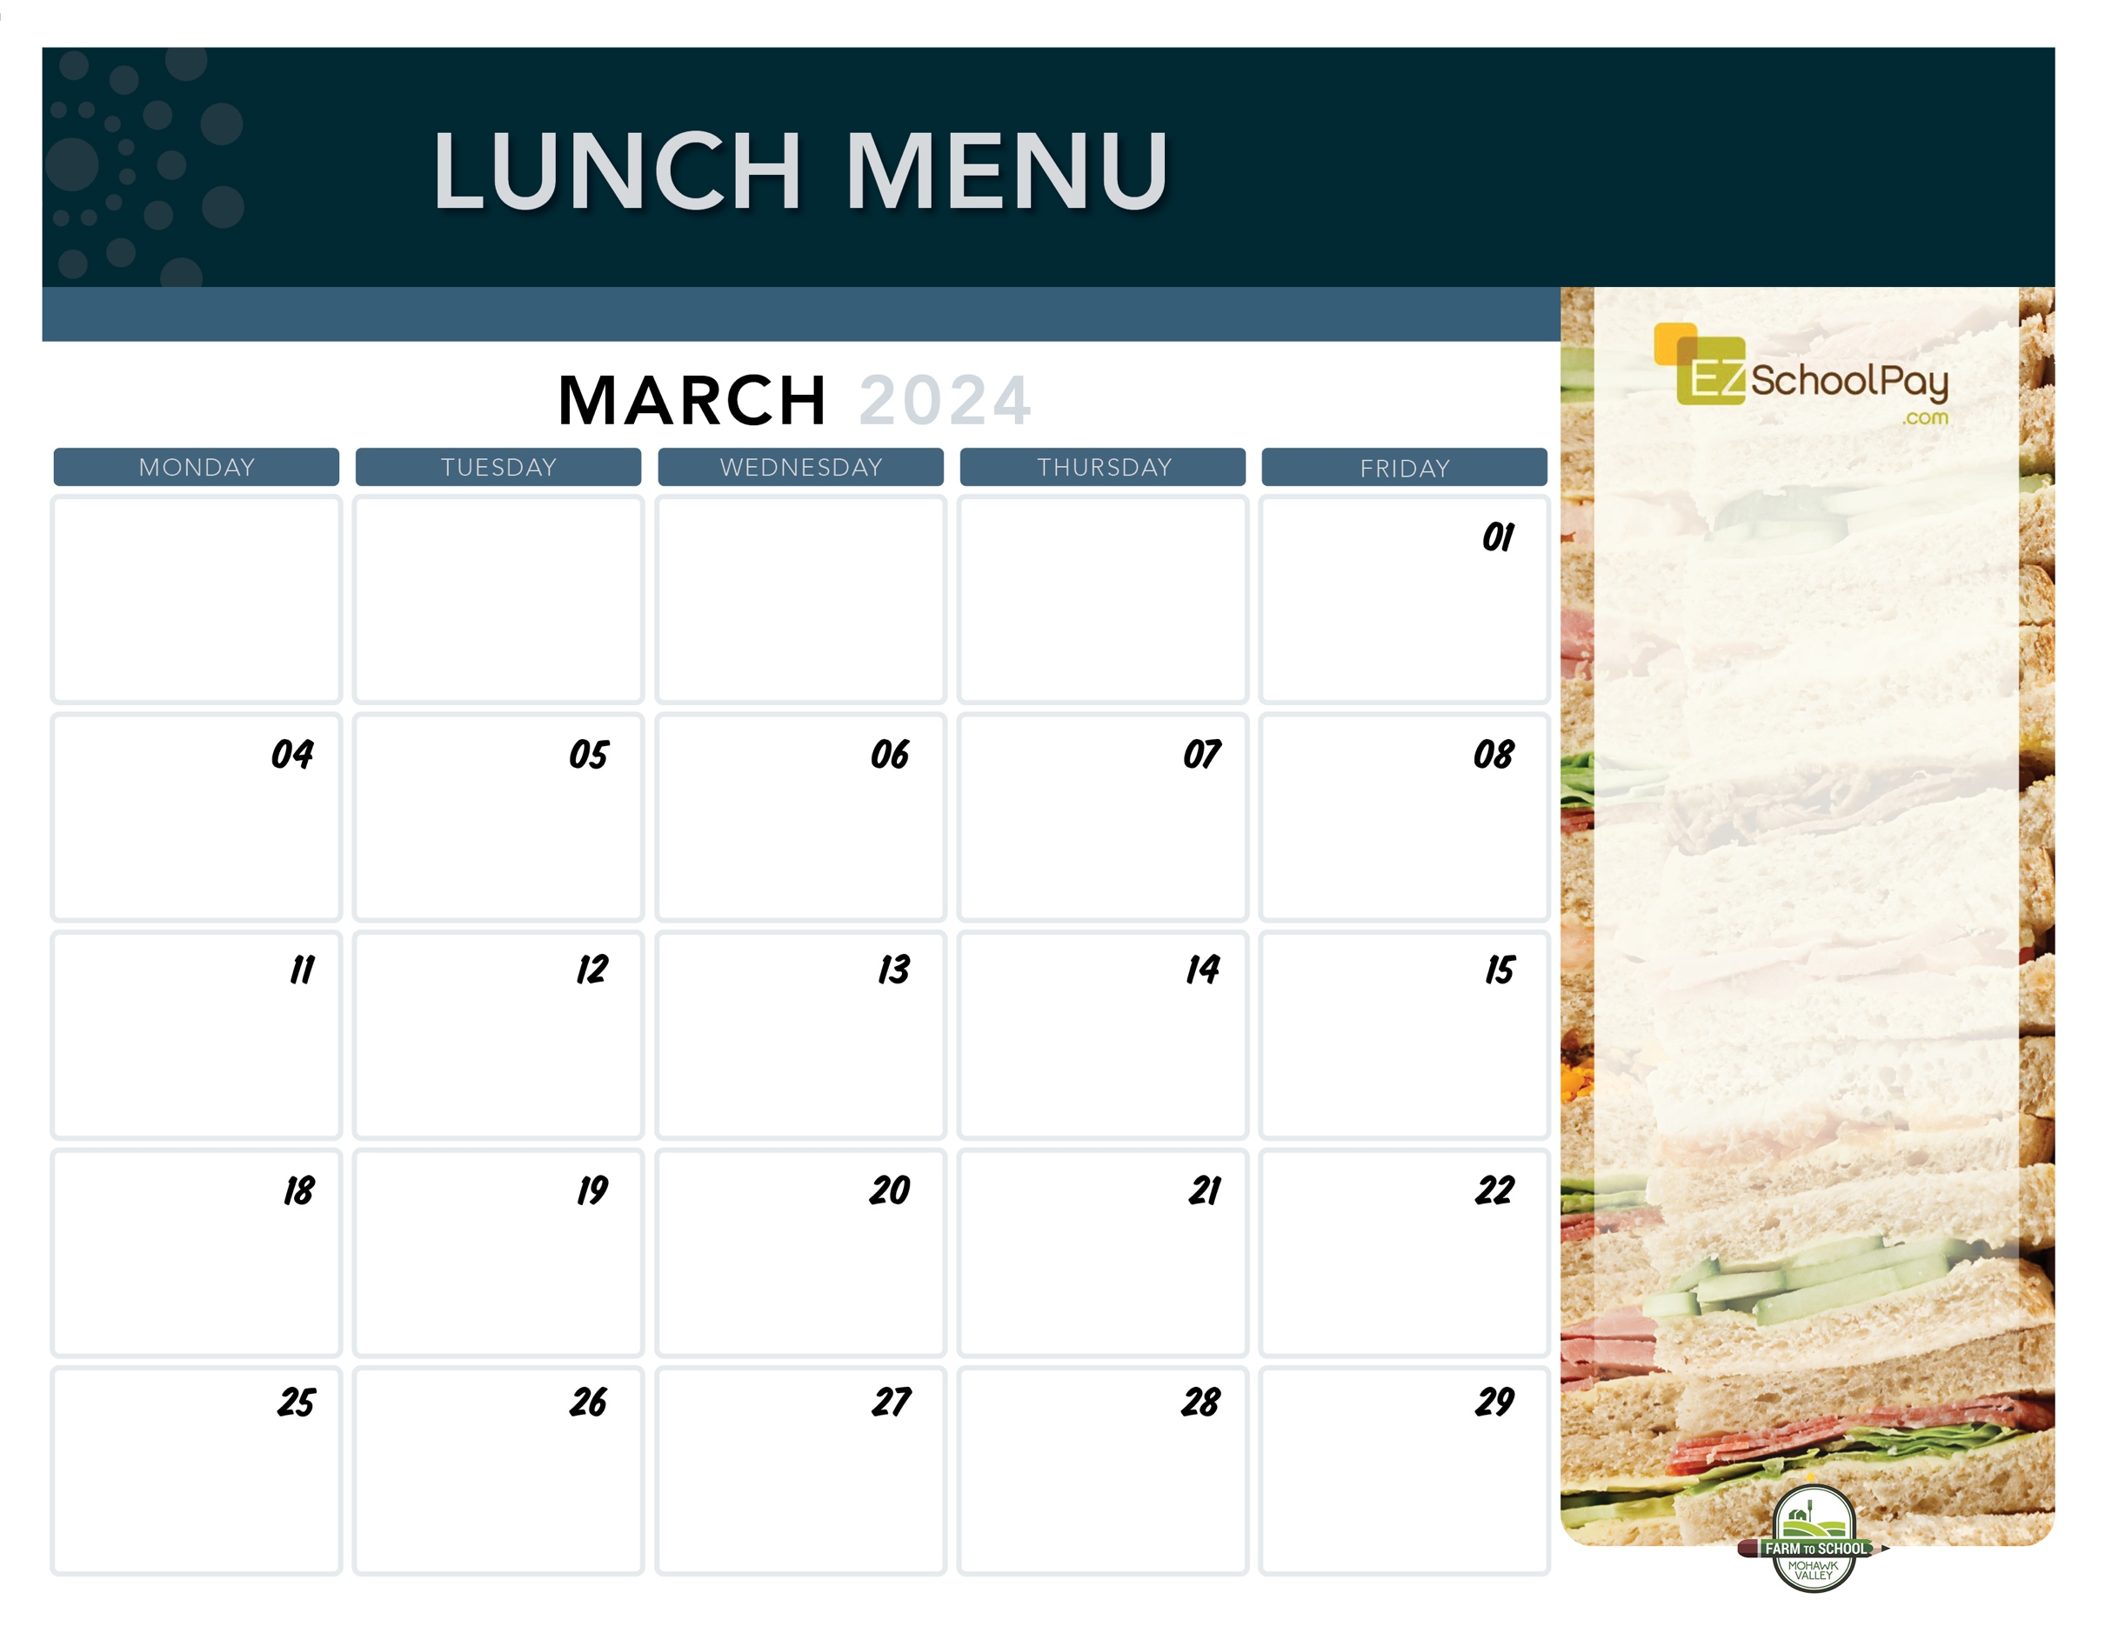­­­

**Parent/Teacher Conference**

**11:30 am Dismissal**

**(No Lunch Served)**

**Superintendent’s Conference Day**

**No School!**

Dip N Sip:

Grilled Cheese Sandwich

Tomato Soup

Turmeric Roasted

Cauliflower

**Parent/Teacher Conference**

**11:30 am Dismissal**

**(No Lunch Served)**

Beef Tacos

Deli Ham Sandwich

Lettuce, Tomato, Cheese Cup

**Corn**

Max Pizza Stix

Deli Turkey Sandwich

**Broccoli**

Cheesy Cheese Pizza

Pepperoni Pizza

Mixed Deli Sandwich Fresh Green Salad

Mozzarella Sticks with Dipping Sauce

Deli Turkey Sandwich

**Corn**

**Dino’s Meatball Sub**

Mixed Deli Sandwich

**Green Beans**

Jello!

Macaroni & Cheese

Mixed Deli Sandwich

**Grape Slushie!**

**Green Beans**

Fish Sticks

Deli Ham Sandwich

**Green Peas**

Nachos with Queso

Deli Turkey Sandwich

**Street Corn Salad**

**No School!**

Cheesy Cheese Pizza

Buffalo Chicken Pizza

Fresh Green Salad

Bologna Sandwich

Boneless Chicken Bites

Buttered Noodles

Tuna Salad Sandwich

**Green Beans**

Chicken Patty

on a Bun

Tuna Salad Sandwich

Broccoli

Boneless Chicken Bites

Dinner Roll

Tuna Salad Sandwich

Broccoli

**Available Daily**

* Entrée Salads
* Party Plate
* Assorted Subs & Sandwiches
* Assorted Fresh Fruit & Fruit Juice
* Vegetable Cruncher Cups
* Ice Cold New York State Milk

**Local Items this Month**

Milk, Yogurt, Meatballs, Peas, Hot Dogs, Corn, Rainbow Carrots, Carrots, Green Beans, Black Beans, Cauliflower, Pears, Miss Milla’s Cookies, Grape Slushie, Corn on the Cob.

**\*Local items are indicated in bold on the menu\***

Chicken Tenders

Goldfish Crackers

Tuna Salad Sandwich

Broccoli

French Toast Sticks

Deli Ham Sandwich

Breakfast Sausage

Hashbrown

Lunch is Free | Menu is subject to change | Allergen information is available upon request information! | Contact [hmielnicki@oneida-boces.org](mailto:hmielnicki@oneida-boces.org) for more information!

Warm Ham & Cheese

on a Pretzel Roll

Deli Turkey Sandwich

**Carrots**

Cheesy Cheese Pizza

Garlic Pizza

Fresh Green Salad

Bologna Sandwich

**Sauquoit Elementary School**