Early Bird Reading
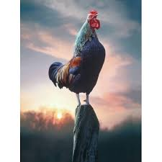
Enjoy Reading
March 1st thru 5th
A
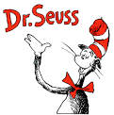
Book

The Lone Jack FRYSC and Mrs. Mills the librarian knows that this year has been very different than years past for our students and parents. Mrs. Mills and Mrs. Sheila will be collaborating on this fun activity this week to celebrate Dr. Seuss week. We would like for our virtual students at home, as well as our in person students here at school, to enjoy Dr. Seuss week. Students, you can get a book and read it to your parents, guardians, or siblings. Let someone video it or take a picture and send it to me here at Lone Jack School Center, and we will post it on our web page. If you video, it has to be a short video, so it will upload. You can email it to me at sheila.fuson@bell.kyschools.us or to Mrs. Mills Class Dojo. This is for grade levels Pre-K thru 5th grades. Also, grades 6th thru 8th grades can make a short video of yourselves reading a book or send a picture to Mrs. Mills or Mrs. Sheila for us to post.

