**[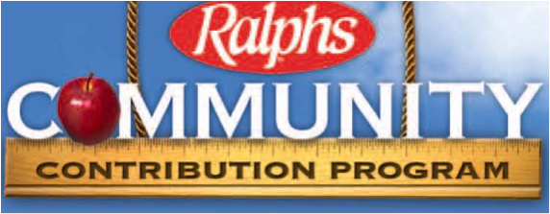](https://www.google.com/url?sa=i&rct=j&q=&esrc=s&source=images&cd=&cad=rja&uact=8&ved=0ahUKEwiFoNa48OzYAhVKzmMKHTrHDr0QjRwIBw&url=http://www.trabucopres.com/2017/09/12/ralphs-and-amazon-smile-programs-give-back-to-tpc-when-you-shop/&psig=AOvVaw2Kk9jEdhgyRWOAmfZQoKJb&ust=1516755237716459)Do you have a RALPHS REWARD CARD?**

**Donate to Sierra Madre Elementary PTA EVERY time you shop!**

**What is Ralphs Community Contribution program?**

Ralphs Community Contribution program gives back to your organization every time you shop at Ralphs. All you have to do is register your Ralphs card with our SME PTA organization number.

**How to Register for Ralphs Rewards or link previous Ralphs Rewards account to SME?**

You can register for Ralphs Rewards at any customer service desk at any local Ralphs store, call customer service at 1-800-443-4438, or register online at [www.ralphs.com](http://www.ralphs.com).

-You must create an online account to enroll in the Community rewards program.

-Once you log in, click on your name in the right hand corner, then click on my account.

-Scroll to Community Rewards and enroll. Sierra Madre Elementary PTA’s organization code is **84690**.

**Reward cards must be used at checkout to make each purchase count.**