|  |  |  |
| --- | --- | --- |
| Viking Head.jpg | 3D Media & Ceramics  2017-2018 | Ms. Elyse Murphy  Email: emurphy@msd134.org  Phone: (208) 585-6657  Teacher Webpage: https://goo.gl/2imbv3  School Website: <https://www.msd134.org/Domain/13> |

Course Description

First semester media will include projects in paper, paint, tape and clay. Ceramic projects will use hand-building techniques, glazing, and wheel opportunities. Strong drawing skills are encouraged for students to plan and execute their 3-D artworks. Second semester will continue ceramic projects and also focus on sculptural techniques such as assemblage sculpture, subtractive sculpture and modeling techniques. In-class participation is important for success and regular attendance is required.

Course Objectives

Students will demonstrate an understanding of materials and equipment used with each clay building technique.

Students will demonstrate an understanding and learning of historical significance of clay, as a medium for functional objects and fine art.

Students will be able to identify and describe the various clay techniques used in their completed artworks.

Students will be able to successfully complete art forms executed in several major clay building techniques.

Students will be able to define and use pottery terms and equipment.

Students will demonstrate an understanding of material and equipment used with various sculpture techniques.

Students will demonstrate an understanding of historical, cultural and social implications of sculpture.

Students will be able to identify and describe various sculpture techniques.

Students will be able to select an appropriate design, techniques and materials for a sculpture following their own design.

Students will prepare completed artwork for display.

Course Units

|  |  |  |  |
| --- | --- | --- | --- |
| **Quarter 1** | **Quarter 2** | **Quarter 3** | **Quarter 4** |
| [Unit 1:](https://docs.google.com/document/d/1BybiTHgjg9Orao2fKfBvdKogafh0sgu0UwhZrH5sg7k/edit) Mark Jenkins Installation Artist- Packaging Tape Sculptures. | [Unit 5:](https://docs.google.com/document/d/17a7E1aa8Rb_whsYaDDAjNXjX51ug4L_Hrc8np7JC6W8/edit) Functional Pottery; slab plates & mugs | Unit 9: Sculpture, ceramic or other material, based on independent artist research | Unit 12: Memory Jug |
| Unit 2: Japanese Tea Bowl/Pinch Pots | Unit 6: Wheel Intro (small groups taking turns throughout this quarter) | [Unit 10:](https://docs.google.com/document/d/1NNi1jhkBK_A7cQpQmbrjqeWgkAzaIiXmF3gyPgFEeqI/edit) Tiles/Greek Bas-relief in clay  (subtractive carving) | Unit 13:Choice Clay Project (end of clay for the year) |
| Unit 3: Oaxacan Folk Art Enclosed Clay Forms | Unit 7: Slab Masks, various cultures of influence | Unit 11: Altered Book Sculpture | Unit 13: Found Object/Shapes Louise Nevelson Installation |
| Unit 4: Coil Rhythm Vessels | [Unit 8:](https://docs.google.com/document/d/1aVN8ti8PBUlgzLur3Zg-atRtYx4281x4KILikCTomsE/edit)Dan the Monster Man projects in paper mache. Based on Dan Reeder from Seattle Washington and his paper mache dragons. |  | Unit 14: Paper Sculpture; handmade paper |

Materials

Please bring laptops, notebook paper, and a pencil to all classes.

Recommended Materials: 1 Sketchbook (around 8x10 in size)

If you are concerned about getting dirty during clay and paint projects, there are limited smocks available, so please bring a big t-shirt to wear over your clothes.

Skyward Grading

|  |  |  |
| --- | --- | --- |
| **Score Method** | **Term Grades**  **(MHS Policy)** | **Grading Scale**  **(MHS Policy)** |
| Total Points | **Fall**  Quarter 1=40%  Quarter 2=40%  End of Course Assessment=20%  **Spring**  Quarter 3=40%  Quarter 4=40%  End of Course Assessment=20% | A=90%-100%  B=80%-89%  C=70%-79%  D=60%-69%  F=Below 60% |

Make-Up Work (MHS Policy)

Papers, assignments, tests, etc. that were announced while the student was in attendance prior to the absence are due to be submitted or completed on the day the student returns to school. A student will be allowed two (2) school days for each day of excused absence to make up material presented during the absence. Make-up time is not to exceed ten (10) days from the time a student returns to school after an absence. Additional time may be granted at the principal's discretion under extenuating circumstances. When a student has been absent for three (3) or more consecutive school days due to illness or excused absence the parent or student may call the Attendance Office to request make-up homework be sent to the office for pick-up. Please allow 24 hours for teachers to respond before coming to the office to pick up work. **In the case of pre-arranged absences, it is the responsibility of the student to contact individual teachers for any make-up work prior to the absence.**

Late Work

All work needs to be turned in on the due date, no matter how done it is. I will grade it and return it, at which point students may then choose to revise, or complete if needed, for a better grade without penalty.

Please talk to me if a circumstance arises that does not fit in this policy or the make-up work policy.

Classroom Rules and Procedures

Be responsible- come to class prepared; clean up after yourself

Be respectful- of yourself, others, the art rooms and materials

Always try your best, have a positive attitude, and be willing to try new things.

There will be specific procedures for each material and process, that we will review as we go!

Discipline

* Minor disruptions or issues will result in verbal reminders and/or a student-teacher conference during class.
* Multiple instances will result in a call or email to parents to help find a solution for the behaviors.
* Safety is paramount, so students will lose privileges with certain art materials if they cannot be responsible with them.
* Major disruptions or issues will result in an immediate conference with administration.

# Academic Integrity (MHS Policy)

All work submitted by a student must represent his/her own ideas, concepts, and current understanding. All material found during research must be correctly documented/cited to avoid plagiarism. Any student caught cheating or plagiarizing on course assignments or exams will lose credit for that assignment or exam. The teacher will notify parents. Students may be subject to disciplinary action, including a parent conference.

# Student & Parent Resources

School Website: <http://mhs.msd134.org/>

Idaho Arts & Humanities Standards: <https://www.sde.idaho.gov/academic/shared/humanities/visual-arts/Visual-Arts-Standards.pdf>

# Other Information

Please see the attached cell phone policy form and syllabus signature form. Syllabus is tentative and may change through the year as needed, but we will get through all of the Idaho Visual Arts Standards for the particular level.

**Middleton High School Art Classes**

**E. Murphy**

**Personal Electronic Devices Policy Form**

(Cellphones/Ipods/EReaders/Etc.)

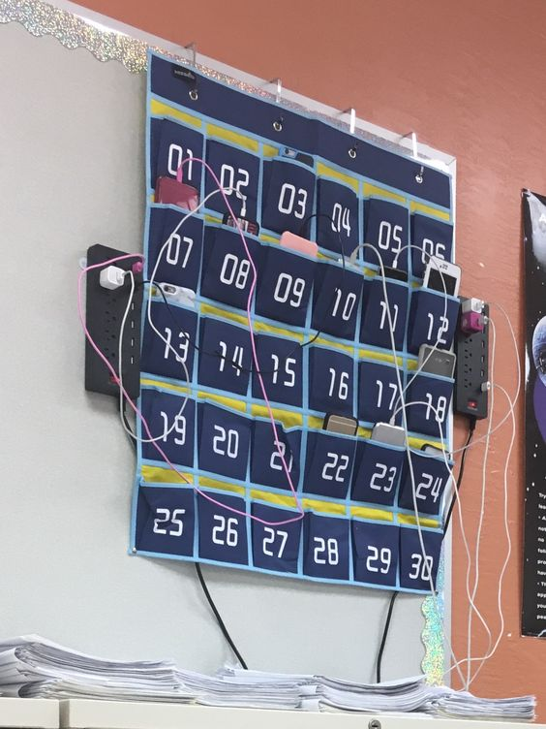

Middleton High School issues laptops (1:1 program) for student use which makes the use of cellphones during class time a non-negotiable, unnecessary accessory. Due to the increasing amount of distractions, behavioral issues, cheating, and non-educational use in the classroom, cell phones **WILL NOT BE** allowed in Ms. Murphy’s classroom. With parent and or guardian permission, a student will be required to relinquish his/her cell phone into a cell phone storage container at the start of class (example pictured). Each number on the container will correspond to a number in the grade book. Students will not be able to access the cell phone storage container except at the beginning and end of class with teacher permission. Ms. Murphy will not have any contact with a student’s phone at anytime unless the phone is to be sent to the office. If a parent and/or guardian chooses not to allow his/her son/daughter to store his/her cell phone in the storage container, cell phones must remain out of sight in the classroom; cell phones which become visible will be sent to the front office. All cell phones that are sent to the front office can only be picked up by a parent/guardian after school.



**I give my son/daughter permission to store his/her cell phone in the classroom provided cell phone holder.**

_________________ Student Name (Printed) _________________ Parent Signature



**I do not give permission for my son/daughter to store his/her cell phone in the cell phone storage container. I understand that his/her phone must remain out of sight at all times and that if it is sent to the office only a parent or guardian can pick it up after school.**

_________________ Student Name (Printed) _________________ Parent Signature

-----------------------------------------------------------------------------------------------------------------------------------------

**Syllabus Signature Form**

**I have read and understand the content, policies, and procedures outlined in Ms. Cooke’s syllabus.**

____________________Student Name (Printed)

_________________________ Student Signature _________________ Date

_________________________ Parent Signature _________________ Date