|  |  |  |
| --- | --- | --- |
| The EAC GEAR UP Times | | |
|  | Safford Middle School GEAR UP | |
| Fall 2015 | |
|  | | |
| National GEAR UP Week! | | |
| During the month of September 2015, our 8th grade students took part in celebrating National GEAR UP Week, the 8th grade had several activities that week. One of the activities the student participated in was the “Dream Wall”, writing their future goals on a call out and putting them on a bulletin board for all to share.  Another day students “Guessed the Bulldog”, they guessed which college their teachers attended then the next day they listened to their teachers tell their stories of how they became teachers and which colleges they earned their degrees.  The last day was the “Door Wars” Activity. During their 3rd hour classes, they were asked to vote on their favorite college and decorate their door to reflect that college. The doors were judged with Mrs. Fertig’s and Mrs. Rubio’s classes winning.  OCTOBER: “ACT Aspire Assessment” – all 8th graders took the test prep assessment which will help prepare them for the college entrance exams. Thank you to the SMS administration and staff for the help administering the assessments. | | |
|  | | |
|  | | |  |  | | --- | --- | | Inside this issue: | | | SCHOLARSHIP INFORMATION |  | | CAREER PATHS |  | | FINANCIAL AID INFORMATION |  | | REQUIRED HIGH SCHOOL COURSES  GUEST SPEAKERS / FIELD TRIP |  | | FROM YOUR GEAR UP COORDINATOR |  | |  |  | |

|  |  |
| --- | --- |
| Scholarship Information **Raise.me:**  Raise.me allows high school students to earn micro-scholarships from colleges for their achievements in and out of the classroom.  Starting in 9th grade, students can be eligible to start earning scholarships for their achievements such as good grades, perfect attendance, leadership roles, participation in sports & clubs, community service, test scores, and more.   * Automatic earnings of grant aid before you even apply to college * Bite-sized goals to help your teen achieve at their highest level * Privacy controls that give students complete control over their information * Timely reminders to keep your teen on track * Early connections to colleges to get the inside scoop and receive invitations to events   5 easy steps the student takes:   1. Create an account as early as 9th grade (or as late as 1st semester Senior year) 2. Add courses, grades, and activities each semester to accumulate Micro-Scholarships 3. Research & follow colleges on Raise.me to find the best fit 4. Submit Micro-Scholarships Senior year to Raise.me colleges where they plan to apply 5. Cash-in Micro-Scholarships at the Raise.me college where your teen has been accepted and will attend.  Career Paths **Agricultural Food & Natural Resources Career Category:**  **Agribusiness Systems-Farming** engaged in as a large-scale business operation including the production, processing, and distribution of | products and the manufacture of farm machinery, equipment, and supplies.  **Animal Systems-animal** systems pathway work to develop better, more efficient ways of producing and processing meat, poultry, eggs and dairy products. They study genetics, nutrition reproduction, growth and development of domesticated farm animals. Some individuals inspect and grade livestock or work in technical sales or marketing.  **Environmental Service Systems**-pathway includes occupations involved in water and air pollution control, recycling, waste disposal and public health issues. Work includes hazardous-waste management, research, and quality control.  **Food Products & Processing Systems**- pathway includes occupations involved in bulk food production, the discovery of new food sources, the analysis of food content, and the development of ways to process, preserve, package or store food according to consumer needs, and. Includes those who monitor compliance with industry and government regulations.  **Natural Resources Systems**-pathway includes occupations that develop, use, maintain, manage, and analyze natural resources. Includes catching and trapping various types of marine life. Work might relate to recreation, wildlife, conservation, mining, logging, or oil drilling.  **Plant Systems**-pathway includes occupations related to growing food, feed, and fiber crops, and the study of plants and their growth to help producers meet consumer demand while conserving natural resources and maintaining the environment. Work might include nutritional analysis or genetic engineering.  **Power, Structural & Technical Systems**-apply knowledge of engineering, hydraulics, pneumatics, electronics, power, structures, and controls to the field of agriculture. They design agricultural structures as well as machinery and equipment. |

|  |
| --- |
| Financial Aid Information |
| **Resources to Help Your Student Find Scholarships**  November 8, 2015 by Isac Amaya Foundation  There are so many different types of scholarships available these days. Believe it or not, you may qualify for a scholarship because you are tall, short, blonde, dark, smart, not so smart, a cat lover (no joke) and or have one of many other characteristics. Often, students don’t apply for scholarships because they assume their grades aren’t good enough or think they won’t meet other qualifications.  Valuable resources like *[Fastweb](http://www.fastweb.com/" \t "_blank)*, *[Unigo](http://www.unigo.com/" \t "_blank)* and the [*Hispanic Scholarship Fund*](http://www.latinocollegedollars.org/)make finding scholarships easy. Students simply create a personal profile for scholarships and daily opportunities and are sent directly to their email. These scholarship-matching websites filter scholarships based on information provided in the profile, such as desired major, school of attendance, ethnicity, and other interests. After that, it’s up to the student to go through each one, make sure they meet the requirements and apply.  Another way students can find scholarships is by going to the scholarship department of the college or university they are attending or hope to attend or by meeting with their high school guidance counselor. Local scholarship organizations often contact schools for help distributing information to students. In addition, colleges and universities often have foundations that provide scholarships and students can apply for multiple opportunities at the same time. [The Maricopa Community College District](https://mcccdf.org/apply-for-scholarships/)is a good example of this.  In Arizona, undocumented students face additional barriers in obtaining money for college since they don’t qualify for institutionalized financial aid. In those cases, private scholarships are the best way to pay for school. Organizations such as the [Isac Amaya Foundation](http://isacamayafoundation.org/" \t "_blank) in Phoenix and [Scholarships A-Z](http://www.scholarshipsaz.org/) in Tucson provide resources specifically for undocumented students. At a national level, a great resource is [TheDream.US](http://www.thedream.us/).  If students dedicate just one hour a day looking for scholarships in their freshmen and sophomore years, and two hours a day applying for them as juniors and seniors, by the time they start college they could earn a good amount of scholarship money to supplement their college savings fund. |
| Required High School Courses |
| **Credit Requirements:**  The below table summarizes the minimum credit requirements for high school graduation in Arizona for the graduating **class of 2013 and beyond**. Please note that school districts and charter schools may, at their discretion, establish additional graduation credit requirements for their students.   * English 4 credits * Math 4 credits * Science 3 credits * Social Studies 3 credits * Physical Education/Health 1 credit * CTE/Vocational Ed. or Fine Art 1 credit * Electives 8 credits   **Total 24 credits**  **GEAR UP - FIELD TRIPS / GUEST SPEAKERS**  Throughout out the fall students have had opportunities to hear from guest speakers in various career professions. Also, attend field trips in career area’s they may be interested in working. Below are some pictures from the various events: Many others on SMS GU web page. |

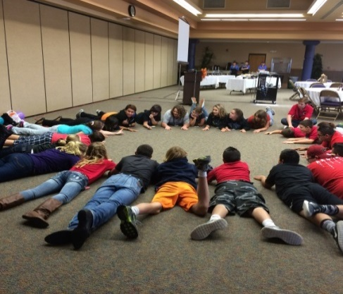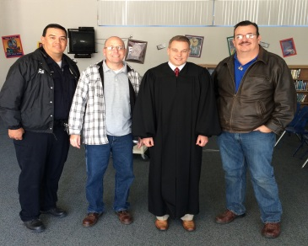

|  |  |
| --- | --- |
|  | Safford Middle School GEAR UP |
| Gaining Early Awareness and Readiness for Undergraduate Programs | |

|  |  |
| --- | --- |
| Safford Middle School  612 W 11th St.  Safford , AZ 85546 | |
|  |  |
|  |  |
|  | Dear Parents/Guardians:  Time seems to be moving quickly, it was just yesterday, when school started and now it will be Christmas soon. During this first semester, I have had the opportunity to meet with each of your students individually and in classes to help them start to plan for high school and life after high school.  Please watch for your invitations to the EAC GEAR UP Parent Nights during the Spring Semesters. These events will provide you with information on your student’s promotion to high school and the requirements at the high school level, as well as providing duel enrollment information and the college admissions process.  Sincerely,  Mary J Wack  EAC GEAR UP Coordinator |
| EAC GEAR UP is a federally-funded program on high school campuses through the direction of Eastern Arizona College, Thatcher Arizona Campus. |