**BERTIE COUNTY SCHOOL DISTRICT SCHOOL BUS DRIVER TRAINING CLASS**

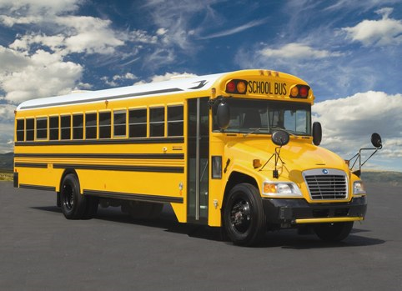

**February 5-8, 2024**

**8am-5pm**

**BCS Bus Garage**

**135 County Farm Rd, Windsor**

**YOU MUST ATTEND ALL THREE DAYS!**

**\*\*A BCS employment application must be completed online prior to attending class\*\***

**For more information or to register, call 794-6005**