**2022 Track and Field Meeting**

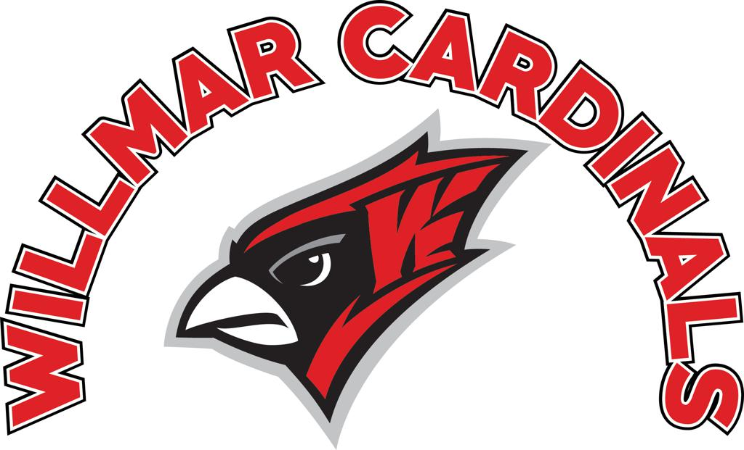

**We are the returning True Team Boys Champions! Our team has had a lot of success. How do we plan to continue that? How do we get another double team win?**

**GRIT:** Track and field requires hard work. Showing up AND SMASHING practices and meets will be the difference maker between average and great. THEREFORE – if you are not at practices you will not be at meets. If you are in school you must be at practice. Each athlete will have one free miss, but after that YOU MUST MAKE UP PRACTICES. Makeups will be available every week twice a week on Wednesdays and Fridays right after our morning practices. If you know in advance that you will be gone, let me know and I’ll meet you in the morning any day of the week.

**HARMONY:** How does it sound if everyone in a band/orchestra/choir decides to do their own thing? The same is true for track and field. We are a unit, and we win True Team State as a unit. Be a good teammate – communicate, include, and respect. No-one expects you to like everyone on the team, but I do expect you to communicate, include, and respect. That brings harmony to a team and its music to my ears!

**RECRUIT! Track is a numbers game. Get your friends out for track and field! This sport makes you better at EVERYTHING ELSE. We’ve lost a lot of numbers over the years. Let Coach Connor know about anyone who has been in track and field before that isn’t participating!**

**Administration Notes**

**Communication**

* Practice info will always be sent out Sunday night.
* The website will be updated on a regular basis once the season begins
* Remind – this app will be used for cancellations, changes, announcements and reminders
* As always – email or text coach Connor with questions or concerns

**Practice**

* Register online!
* You must have an updated sports physical to be with the team

**Busing**

* Only an athlete’s parent or guardian can sign them out to go home with them and not on the bus. They must sign out using the clipboards located at the team camp. An athlete can only go home with someone else if they receive written prior approval from the athletic director. Athletes are expected to stay at the meet until all of their teammates are done competing.

**Middle Schoolers**

* Middle school teammates who are brought up will practice with the high schoolers. The activity bus brings middle school students to the high school and then to the track (once it’s warm enough)

**Uniforms**

* Athletes are expected to wash their uniforms in cold water after every meet and air dry. The cost of a lost or damaged uniform is roughly $150. Warm ups are $200

**Spikes**

* Spikes are available to rent for $10. Bring cash or check (Connor Haugen)

**Meets**

* No athlete should miss a meet without getting approval from Coach Connor. There are very few reasons an athlete should miss a meet.

**Practice Clothing**

* Wear good shoes and appropriate clothes. No shorts or t-shirts in under 60 degree weather!

**What events do we need kids in?**

High jump, hurdles, all boys jumps, and girls sprints.

**Important Dates:**

**March 14th –** practice begins. 3:15 EVERYDAY. We start at the high school until weather allows us to be at the track. Practice schedules/details will be sent out every Sunday.

**March 28-April 1 are Spring Break Practices:** We will have practice during Spring Break. A parent’s note is required to be excused from Spring Break practices. Practices will likely be 9-11.

**Saturday April 2nd –** First meet (indoor CLC) I believe this is a slightly limited meet – 3-6 per event. I would love to take as many kids as we can!

**Friday April 8th –** Alexandria Meet. First meet where we all travel together!

**Tuesday April 12th-** Fergus Falls

**Tuesday April 19th –** Rocori

**Thursday April 21st -** ???? Either fill this with a meet or keep this a one-meet-week

**Thursday April 28th –** Willmar Home Meet

**Tuesday May 3rd –** Alexandria Relays

**Thursday May 5th –** Orono meet OR Sartell Meet

**Friday May 6th –** PROM! Practice in the morning for those attending? We’ll see

**Tuesday May 10th –** True Team Sections at Rockford

**Friday May 13th –** Sartell meet (For everyone NOT at True Team Sections)

**May 16-20 –** Looking for a meet.

**May 21st –** True Team State Stillwater! We EXPECT to go! **NO GRAD PARTIES, SENIORS!**

**May 24th –** CLC (top 3) at Tech

**May 26th –** CLC for everyone else!

**June 1st –** section prelims at Detroit Lakes

**June 4th –** Section Finals at Alexandria. **NO GRAD PARTIES, SENIORS!**

**June 10/11 –** State at St. Michael/Albertville. **NO GRAD PARTIES, SENIORS!**

**June 12 –** ‘banquet’ smores and hotdogs Sunday evening at Coach Connor’s house. Yard games included.

**General Week Flow**

Before and after meets we have pre-meet/recovery practices.

Meet weeks we will have one intense workout. Weeks where we don’t have a meet there will be 2 intense workouts. Speed, tempo, intervals, etc. (usually Mondays, Wednesdays, or Fridays)

Each week we will have 2 morning practices for lifting and team core. **These are essential for team building and training.**

Every Saturday our distance kids will meet at Bramblewood(?) park for a long-ish run or rotating halves and donuts/juice.

**General Practice Flow**

3:15 – practice meeting.

3:25 – Everyone warms up (2 laps, then group into families for active warm up – an idea I stole from Football)

3:45 – Sprints sprint. Distance runs. Throws throw.

4:30/5:30 – Hard days are hard. Easy days are easy. If it’s a hard day our field event kids will do field event steps/practice/drills. It it’s a hard day expect to be done by 5/5:30. If it’s an easy day we’ll be done before that. If you’re in multiple field events our assistant coaches will coordinate where you go on each given day.

**Letterwinner Guidelines – These are subject to change**

An athlete that has fulfilled several of the qualifications stated below is eligible to receive a Track and Field Letter.

* Has competed at the True Team Section/State meet, or the Section/State meet
* Has been at scheduled practices and has a positive attitude
* Has performed at a ‘varsity level’ during the season
* Is a senior, who has participated in their second year or more, and who has fulfilled at least one requirement above

**BE PATIENT –** the track and field season is a marathon EVEN FOR OUR SPRINTERS. You will not become great in one day. It takes time to see results. Work SMART and you will see the fruits of your labor at the end of the season.

**Coach Connor’s Contact info:** 320-333-3022 or haugenc@willmar.k12.mn.us

**Please Fill Out Below:**

**Name:**

**Email:**

**Number:**

**Mom+Dad’s Name:**

**Grade:**

**Other Sports:**

**Event Interests:**

**(IF you are a returner – please fill out PR’s for each event you’re interested in)**