Using i-Ready at Home: Learning Games for Mathematics

We are using i-Ready Learning Games as part of our online instruction. These games help your child build mathematics skills in fun ways. We encourage you to watch your child as they play to learn more about what Learning Games have to offer, and hope your child enjoys practicing mathematics with these fun games!
- Log in to i-Ready through your district’s SSO portal on your computer or iPad®. If using an iPad®, download the latest version of the free i-Ready for Students app through the Apple App Store®.
- Choose Math from the subject selector screen or in the upper left corner of the To Do screen. | 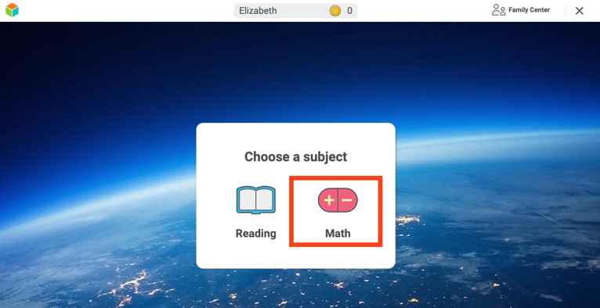  OR  
- Your child will see Learning Games in the bottom navigation bar. Select Learning Games. | 
- Your child will see the Learning Games home screen and can select any game displayed to start playing. | 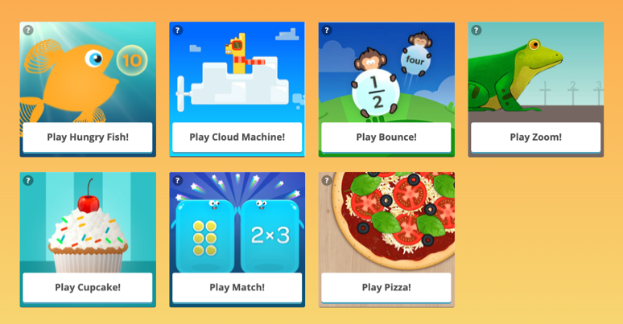
To make sure Learning Games will work on your computer or iPad®, go to cdn.i-ready.com/systemcheck for a system check.
iPad® and App Store® are registered trademarks of Apple, Inc.

