 | 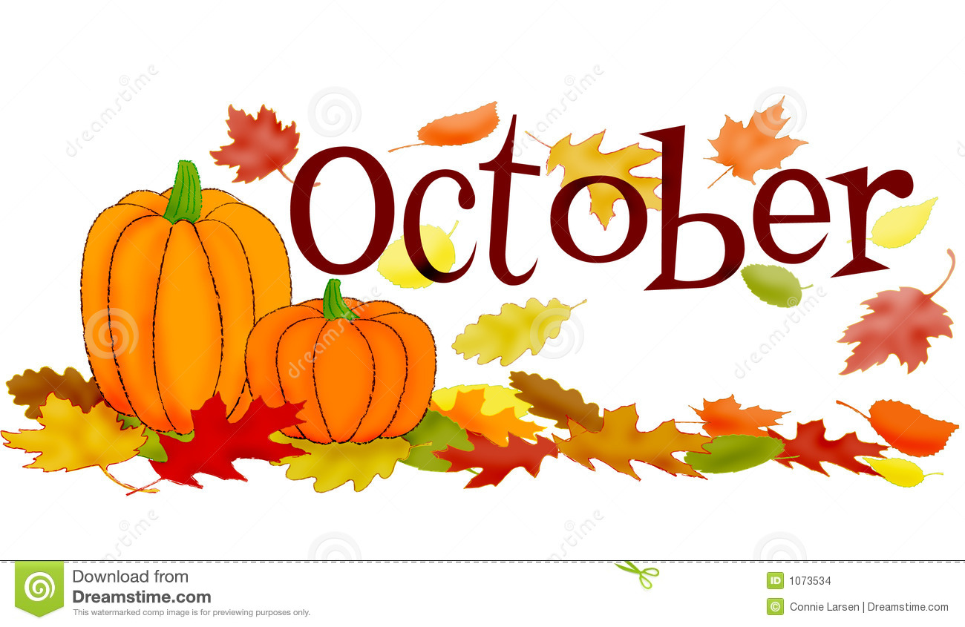
Sun | Mon | Tue | Wed | Thu | Fri | Sat
 | 1  BOOK FAIR ------------------- | 2  ------------------------------------- | 3  ------------------------------------- | 4  ------------------------------------  Early Release 1:00 PM | 5  Book Fair Closes at 2:30 PM  After School Dance 3:30-5:00 PM | 6
7 | 8 | 9 | 10 | 11  Ice Cream Sale | 12  Dress Down - $1 | 13
14 | 15 | 16 | 17 | 18 | 19  Spirit Day  Club Day  Fundraiser Kickoff | 20
21 | 22  Red Ribbon Week ----------- | 23  Read to Achieve (Only for a few students)  “Crazy Sock Day” – Sock it to Drugs | 24  Poster Contest Due (3-5)  “Wear Shades” – Shading out Drugs | 25  Benchmarks  “Red T-shirt Day” | 26  Benchmarks  Early Release 1:00 PM  Fall Pictures  “Dress up Day” – Look your Best For Success | 27
28 | 29  Benchmarks  Schoolwide Assembly  “Dress as your favorite Super Hero” - Stand Up to Bullying | 30  Benchmarks | 31  School Closed | Note: Benchmarks continue on Nov 1-2  Character Trait of the Month: Respect

