Study Guide Name: ___________________________________
Core: ______

Final Exam Review
Ecology, Life’s Structure and Function, From Bacteria to Plants, and Animal Diversity

Ecology – Chapter 1:
1. Describe an organism’s habitat. What does it provide? A place where an organism lives and that provides the types of food, shelter, moisture, and temperature needed for survival.
2. In a forest, there are gray wolves, birds, bushes, and grasses. In addition, there are rocks found throughout the forest as well as lots of sunlight. Water is also an important component of the forest because the plants and animals need it to survive. Identify the different populations, the community, and an ecosystem, based on the information above.
a. What are the populations? Provide a brief description of the term population.
The gray wolves are a population. The birds are a population. The bushes are a population. The grasses are a population. All the organisms that belong to the same species living in a community.
b. What is the community? Provide a brief description of the term community.
The populations of gray wolves, birds, bushes, and grasses together are a community. All the populations of different species that live in an ecosystem.

c. Describe the ecosystem in this scenario. Provide a brief description of the term ecosystem.
The populations of gray wolves, birds, bushes, grasses, rocks, sunlight, and water. All of the living and nonliving factors in an environment.

3. Place the following terms in order from largest to smallest grouping: population, organism,
ecosystem, community
Ecosystem, Community, Population, Organism

4. The study of relationships between organisms and their environment is Ecology.
5. The term for a group of organisms that look alike and can reproduce among themselves is a
species.
6. A limiting factor is anything that can restrict the size of a population.
7. What happens when animals compete for the same food resource? Food may run out and organisms may die.
8. What is a producer? And, what does it eat? An organism that undergoes photosynthesis to make food for other organisms. It contains chlorophyll, takes in sunlight and water.
9. What is a consumer? And, what does it eat? An organism that cannot undergo photosynthesis. It eats producers and/or other consumers.
10. A consumer that only eats plants is called a(n) (carnivore, decomposer, herbivore, omnivore).
11. A consumer that only eats other animals is called a(n) (carnivore, decomposer, herbivore, omnivore).
12. A consumer that eats plants and animals is called a(n) (carnivore, decomposer, herbivore, omnivore).
13. A consumer that only eats wastes and dead organisms is called a(n) (carnivore, decomposer, herbivore, omnivore).
14. What type of symbiosis is it where one organism benefits and one is harmed? (mutualism, commensalism, parasitism).

Ecology – Chapter 2:
15. Food chains overlap to form a food w e b.
16. What does the term abiotic mean? Provide some examples. The nonliving, physical features of the environment. Air, water, soil, sunlight, temperature, and climate.
17. What does the term biotic mean? Provide some examples. The living, or once living features of the environment. Plants, animals,…
18. Summarize the water cycle using the following terms: groundwater, condensation, evaporation, precipitation

19. A diagram that shows the amount of energy that moves from one feeding level to another in a food web is called a(n) energy pyramid.
20. In an energy pyramid, the producer level has the most available energy.
21. In an ecosystem, (carbon, water, nitrogen, energy) cannot be recycled.
22. Photosynthesis uses water, carbon dioxide, sunlight to produce sugar and oxygen.

Ecology – Chapter 3:
23. What is primary succession? What kinds of places does this take place? Succession that takes begins in a place previously without plants (and soil). Hardened volcanic rock, rocky mountainous regions,
24. What is secondary succession? What kinds of places does this take place? Succession that begins in a place that already has soil and was once the home of organisms. Burnt forest, cleared land,…
25. A climax community is the stable end stage of succession.
26. An estuary is found where the fresh water of a river meets the salt water of an ocean.
27. Complete the chart:
Biome | Characteristcs
Tundra | Cold, dry, less than 25 cm of precipitation /year, 6-9 months of winter. Lichens, mosses, grasses, small shrubs. Insects, arctic hares, caribou, snowy owls, ducks, geese, hawks, grouse
Taiga | Long, cold winters, wetter and warmer than tundra, 35-100 cm of precip./year. Cone-bearing evergreen trees. Moose, lynx, shrews, bears, foxes
Temperate Deciduous Forest | Cold winters, hot summers, mild springs and falls, 4 seasons. 75-150 cm of precip./year. Deciduous trees. White-tailed deer, squirrels, rabbits,…

Temperate Rain Forest | 9-12°C (≈50°F), 200-400 cm precipitation per year. Douglas Fir, western red cedar, spruce. Black bear, cougar, bobcat, northern spotted owl, salamanders.
Tropical Rain Forest | Warm, lots of precipitation, 200-600 cm of precip./year. Very diverse; undiscovered plant-life. Ants, insects, macaws, reptiles, amphibians, large mammals.
Desert | Very dry, less than 25 cm of precip./year. Cactus. Kangaroo rats, scorpions, snakes.
Grasslands | Both temperate and tropical, 25-75 cm precip./year, dry season. Grasses and grains. Wildebeests, zebras, kangaroos, gazelles, impalas, cattle, sheep.

Life’s Structure and Function – Chapter 1:
28. What are the 6 steps of the scientific method?
1. State the problem
2. Gather information
3. Form a hypothesis
4. Experiment
5. Record and analyze data
6. State your conclusion
29. A prediction that can be tested is a hypothesis.
30. What type of resource would be the easiest and most efficient to use to identify organisms?
A. Dichotomous key B. Encyclopedia with species names only
31. What is biogenesis? The theory that living things come only from other living things.
32. In the scientific name Mycobacterium tuberculosis, Mycobacterium is the genus, and tuberculosis is the species.
33. The classification system most commonly used today separates organisms into 6 kingdoms.
34. Growth of many-celled organisms is mostly due to an increase in the (size, number) of cells.
35. SpongeBob noticed that his favorite pants were not as clean as they used to be. His friend Sandy told him that he should try using Clean-O detergent, a new brand of laundry soap she found at Sail-Mart. SpongeBob made sure to wash one pair of pants in plain water and another pair in water with the Clean-O detergent. After washing both pairs of pants a total of three times, the pants washed in the Clean-O detergent did not appear to be any cleaner than the pants washed in plain water.
a. What is the independent variable? Clean-O detergent (The variable that you are changing.)

b. What is the dependent variable? The cleanliness of the pants. (What you are trying to measure.)
c. List one constant in this experiment that SpongeBob conducted. Washing the pants 3 times.

d. What was the control in SpongeBob’s experiment? The pair washed in plain water.

36. Why is it important for scientists to follow the steps of the scientific method? It gives scientists an organized method to solve a problem.
37. All living things: (pages 16-19)
- are organized (or are made of cells).
- respond.
- use energy.
- grow and develop.
- reproduce.

Life’s Structure and Function – Chapter 2:
38. The function of the selectively permeable (cytoplasm, cell membrane) is to allow some things to pass through it, but not others.
39. What is the function of the nucleus? How does it compare in size to other organelles? The nucleus controls all of the cells activities. It is usually the largest organelle in a cell.

40. Vaccines are available for all of the following viral diseases except (chicken pox, common cold, polio, smallpox).
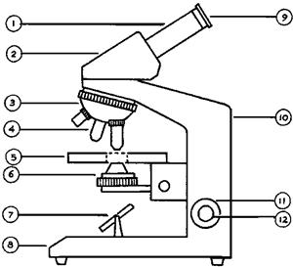
41. How is a plant cell different from an animal cell? (Identify 2 structures that a plant cell has that an animal cell does not have)
Plant cells have chloroplast and a cell wall.

42. If your microscope has an eyepiece with a 15X magnification, and you are using the 20X objective, what is your total magnification?
300X
43. What type of microscope is pictured to the right? (Hint: Think about the type of microscope we use in class.) Compound light microscope

44. How do we carry the microscope properly? Identify the numbers and name of the parts that we hold to when we carry the microscope.
arm and base

Life’s Structure and Function – Chapter 4:
45. Define: asexual reproduction → a type of reproduction in which a new organism is produced from one organism and is genetically identical to the parent organism.
46. What is DNA? Deoxyribonucleic acid; the genetic code of all organisms in the nucleus of a cell; made up of two twisted strands of sugar-phosphate molecules and nitrogen bases.
47. How many individual chromosomes does each human skin cell have? 46 individual chromosomes

Life’s Structure and Function – Chapter 5:
48. What is homozygous? Alleles that are the same; ex. RR

49. What is heterozygous? Alleles that are different; ex. Rr

50. Write an example of a homozygous recessive genotype. Use any letter you wish. rr
51. A (hybrid, purebred) has different alleles for a trait.
52. A dominant trait is represented by a (capital, lower case) letter.
53. A recessive trait is represented by a (capital, lower case) letter.
54. In humans, brown eyes are dominant to blue eyes. Lucy is homozygous dominant for brown eyes (B). She marries a man named Fred, who has the recessive trait of blue eyes (b). Determine the genotypes for Lucy and Fred. Then, form a Punnett Square, in order to predict the probabilities for eye color for their future children.
B
B
Bb | Bb
Bb | Bb

a. Genotype for Lucy: BB Genotype for Fred: bb
b

b. Complete the Punnett Square to show the possible offspring.
b

c. Probability Fred and Lucy will have a child with blue eyes: 0 out of 4 or 0%
d. Probability Fred and Lucy will have a child with brown eyes: 4 out of 4 or 100%
e. Is it possible for Lucy and Fred to have children that all have blue eyes? Why or why not? If Lucy and Fred wanted to have children with all blue eyes, what must their genotypes be? No. All of their children will be heterozygous for brown eyes. They all are carrying a dominant trait. Lucy would have to be Bb or bb.
Bacteria to Plants – Chapter 1:
55. List some foods that are made with the help of bacteria. Cheese, yogurt, sauerkraut,... NOT milk!
56. An antibiotic is a drug used to kill b a c t e r i a.
57. Thick walls produced by some bacterial pathogens are called (endospores, viruses).
58. One type of bioremediation uses bacteria to break down wastes and pollutants into simple harmless compounds.
59. What is a saprophyte? An organism that uses dead organisms as a food source and helps recycle nutrients so they are available for use by other organisms.
60. Briefly describe the structure of a bacterial cell. Prokaryotic, three basic shapes (round, spherical, and rod); smaller than plant and animal cells; one-celled organisms; contains cytoplasm surrounded by a cell membrane and a cell wall; no membrane-bound nucleus or organelles.
Bacteria to Plants – Chapter 2:
61. All protists have a nucleus and are (prokaryotic,eukaryotic).
62. What are cilia? in protists, short, thread-like structures that extend from the cell membrane of a ciliate and enable the organism to move quickly.
63. Saprophytes are organisms that obtain food by feeding on dead or decaying organisms.
64. Hyphae → a mass of many celled, thread-like tubes forming the body of a fungus.

65. (True, False) do not contain chlorophyll
(True, False) make their own food
(True, False) reproduce by spores
(True, False) decompose organic matter
66. Protists can be animal-like, plant-like, and fungus-like.

Bacteria to Plants – Chapter 3:
67. Plants probably evolved from green a l g a e.
68. What is the major function of leaves? Make food!

69. (Angiosperms, Gymnosperms) are the most common type of plants on Earth.
70. What adaptation do plants have that help them survive on land? Explain.
1. Cuticle - to help slow water loss.
2. Cellulose - to provide structure and support.
3. Reproduction - water resistant spores or seeds in cones or in flowers that develop into fruit.
4. Vessels that help distribute materials throughout the plant.
71. Life on land offers the following advantages:
a. More sunlight.
b. More carbon dioxide.
72. The tube-like structures in plants that move materials throughout the plant are called
v a s c u l a r tissue.
73. Photosynthesis occurs in what layer of a leaf? Palisade layer
74. What is a Rhizoid? Thread-like structures that anchor nonvascular plants to the ground.

Bacteria to Plants – Chapter 4:
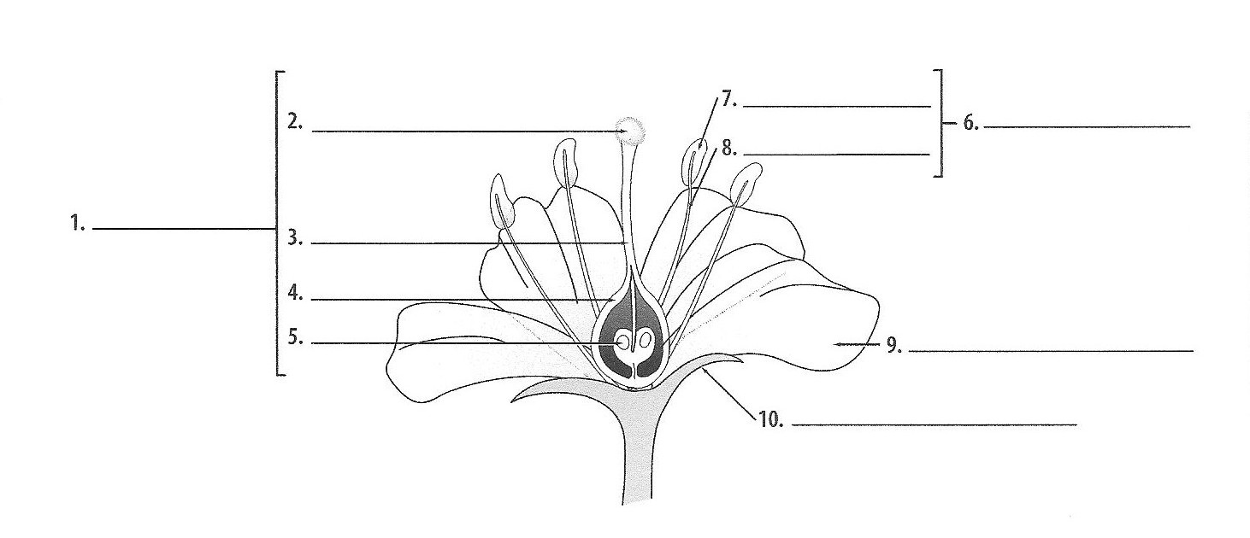
75. Label the parts of the diagram:

Anther
Stamen
Stigma
Filament

Pistil
Style

Ovary
Ovule
Petal

Sepal

Bacteria to Plants – Chapter 5:
76. As much as 90% of the oxygen in our atmosphere comes from what plant process?
Photosynthesis
71. What is produced in photosynthesis? Glucose/sugar or f o o d and oxygen
72. Respiration is the process in which organisms break down food to release e n e r g y.
73. Why do some plants have a green color? It is due to green light energy reflecting from chlorophyll.
80. What is phototropism? When a plant responds to light; ex, a plant leaning toward sunlight.

Animal Diversity – Chapter 1:
81. What is the major difference between a vertebrate and an invertebrate?
Vertebrates have a backbone, Invertebrates do not.

82. What are the characteristics that all animals share?
1. Animals are made of many cells.
2. Animal cells have a nucleus and organelles.
3. Animals depend on other living things for food.
4. Animals digest their food.
5. Many animals move from place to place.
6. Animals reproduce.
83. What type of symmetry do most sponges have? (radial, asymmetrical) symmetry
84. Heartworm is a disease caused by (flatworms, roundworms).
85. What is the purpose of tentacles in cnidarians?
To help bring food to their mouths.
86. Circle one: (Jellyfish, Roundworms, Sponges) are sessile.
87. Roundworms have two body openings a mouth and an anus.
88. Jellyfish are (cnidarians, mollusks, arachnids).
89. Sponges reproduce asexually by budding.
90. Roundworms are (cnidarians, nematodes, planarians).
91. Markings that help an animal hide from its predators are called camouflage.
92. Describe radial symmetry: when animals have body parts arranged around a center point.

93. Worms have bilateral symmetry.

Animal Diversity – Chapter 2:
94. The m a n t l e covers organs of mollusks.
85. Echinoderms use t u b e f e e t to move and open shells of mollusks.
96. Which of the following has a closed circulatory system? (earthworm, octopus, slug, snail)
97. Write the sequence for incomplete metamorphosis.
egg nymph adult
98. The largest group of animals would be (arthropods, cephalopods, gastropods).
99. What is molting? shedding and replacing an arthropods exoskeleton.

