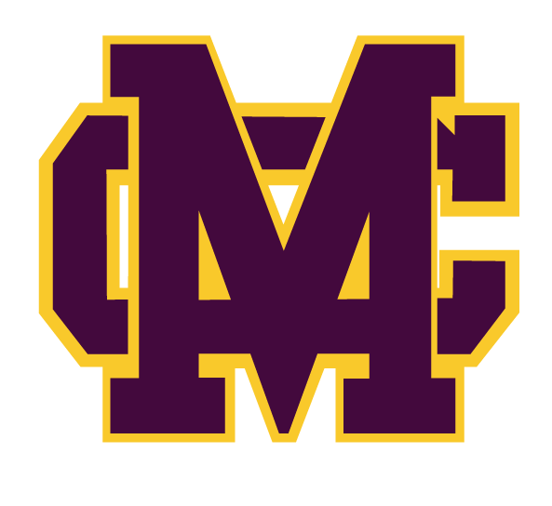**20/20 INSTRUCTIONS:**

1. Designate 20 or more **out of town friends and family** who you feel will donate $20.00 or more to our football program. We will be selling Gold Cards in the community in May/June and Wingfest Tickets in July/August, so **OUT OF TOWN/STATE friends and family** will work best.
2. **Address 20 envelopes** to the out of town friends & family you selected.
3. If you do not have 20 out of town contacts then bring as many as you have.
4. **Put a stamp on the envelope**.
5. Have the player **write a personal note** on the 20/20 letter.
6. Turn in addressed, sealed and stamped envelopes in to Coach Putnam by Friday **April 15th**, 2022.
7. Have player make a phone call the week of April 25-29 and ask if they have received their letter and would be willing to help.

* This is usually one of our largest fundraisers each year raising **$10,000+ per year**. Please take the time to address the envelopes.
* Each player that receives $300.00+ back in the mail will receive an MCHS Football hat.
* All money raised will go toward the MCHS Football Program.

**Thanks and Go TIGERS!!!**