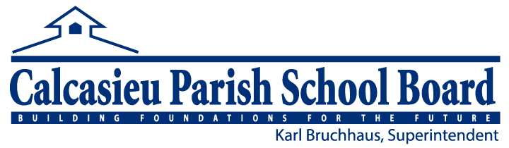**Community Eligibility Provision**

Dear Parent or Guardian:

We are pleased to inform you that all Calcasieu Parish Public Schools will be participating in the Community Eligibility Provision (CEP) for School Year 2023-2024.

**What does this mean for you and your children?**

Great news for you and your students! All enrolled students are eligible to receive a healthy breakfast and lunch at **no charge** to your household each day of the 2023-2024 school year. No further action is required of you. Your child(ren) will be able to participate in these meal programs without having to pay a fee or submit a meal application.

To see daily menus, visit the School Nutrition Program website at [www.cpsb.org](http://www.cpsb.org) or the CPSB School Nutrition Program Facebook and Instagram page.

If we can be of any further assistance, please contact the School Nutrition Program office at 337-217-4360.

Sincerely,

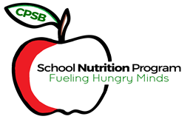

Jacqueline Richard MS, RD, LDN, SNS

Calcasieu Parish School Nutrition Program Director

3310 Broad St.

Lake Charles, LA 70615

This institution is an equal opportunity provider.