WebLink ID

ID System

Quick Reference Guide

Southern Visuals – Kurt Cazayoux – 337.739.4505

Logging into the ID system

Web Address
cpsb.weblinkid.com

You will want to use Google Chrome or FireFox web browsers

LOGIN: username and password are the same and unique to each school
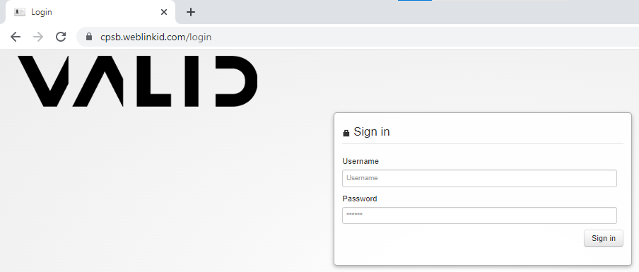
NAVIGATION: Choose between STUDENT or STAFF site
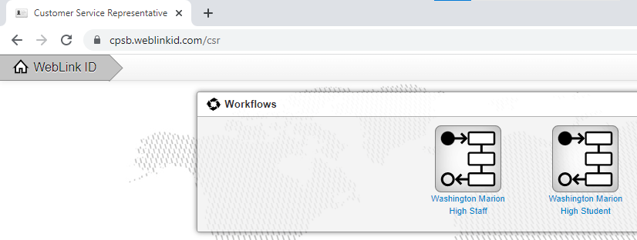
Click on the appropriate site

SEARCHING: Type in the first name, last name or student ID number of the person you are searching for in the search box, then click on the SEARCH button.
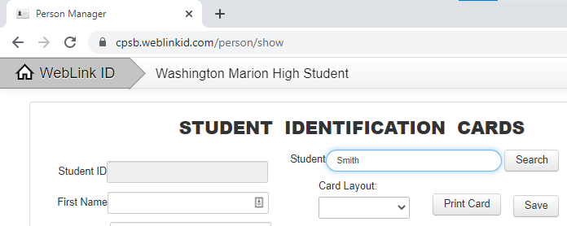
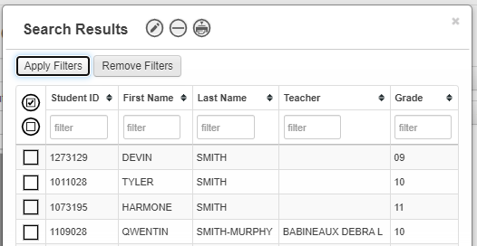
If the system found more than one record, double click the current student in the search result box.

From your data screen, you can change any
of the information. Please note that if you
change the name, grade or teacher, the system
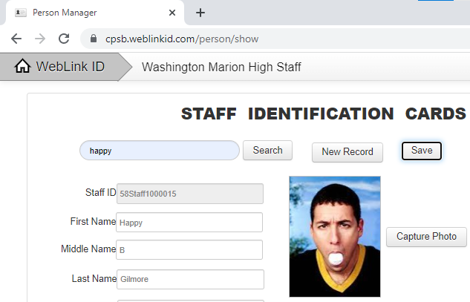
will change it back at midnight. Once you have
finished changing any data, click on the save
button to save the changes to the record.

TAKING A PHOTOGRAPH: Click on the CAPTURE PHOTO button.

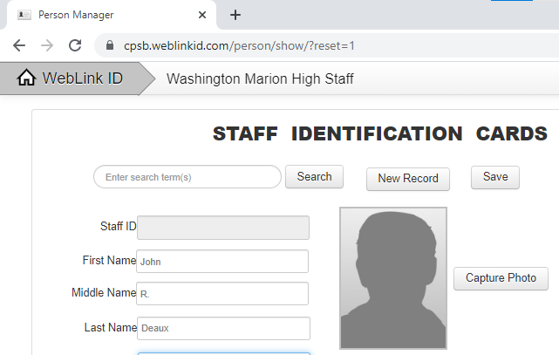
This will initialize the camera software (Image Capture Plus). Be sure that your camera is on.

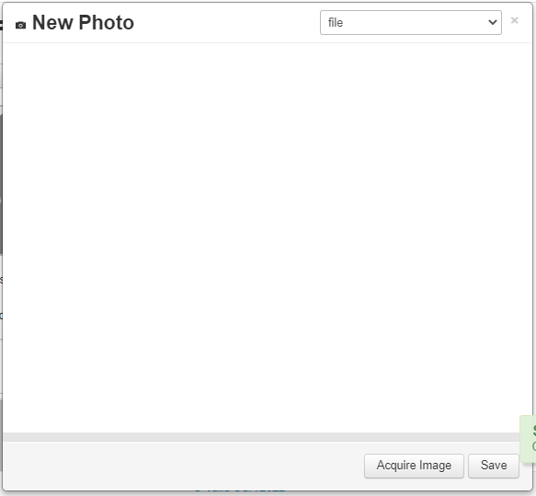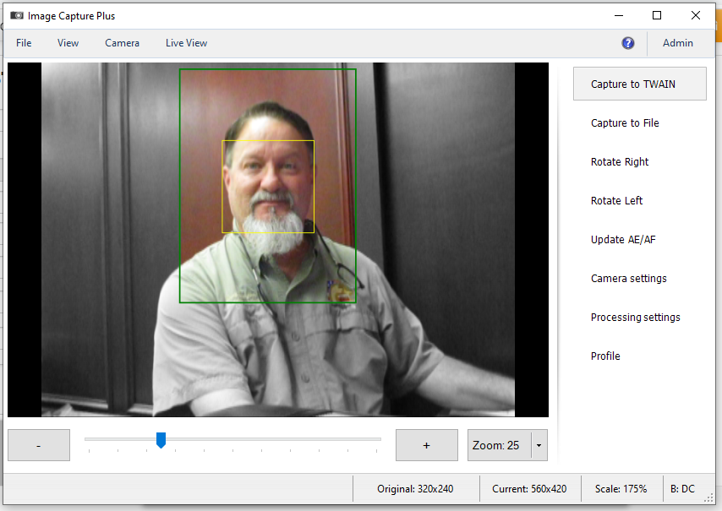
The capture type is TWAIN and the devise is IMAGE CAPTURE PLUS.
Click on the AQUIRE IMAGE button and a live shot of the person you are taking a picture of will appear. Click on the CAPTURE TO TWAIN button to take the photo.
The “Image Capture Plus” camera software has an auto face finding feature. Sometimes it does not find the persons face. If it can not find the person’s face, the following screen will appear and allow you to find the face manually. Just drag the yellow square to the center of the person’s face then click the SAVE button.
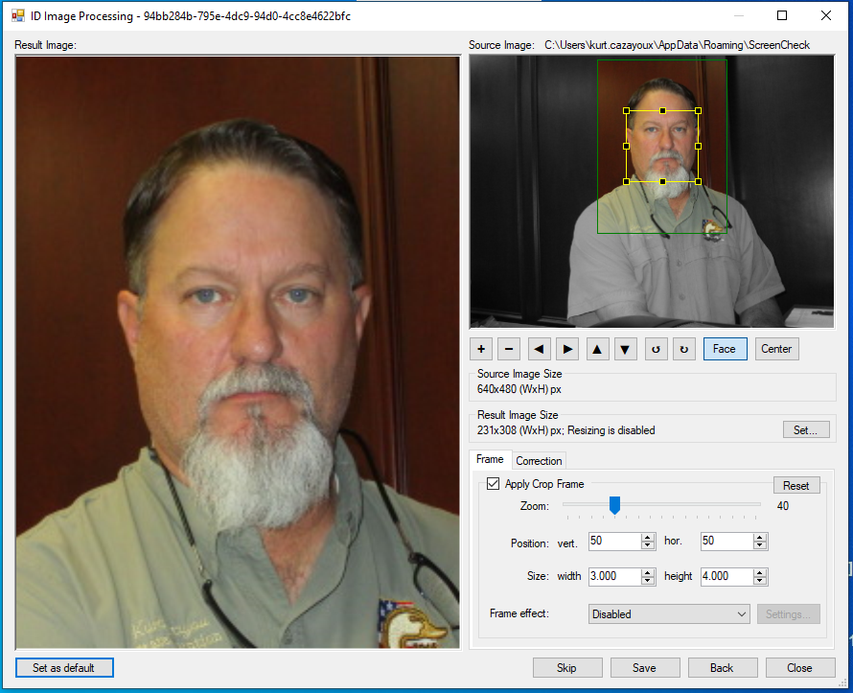
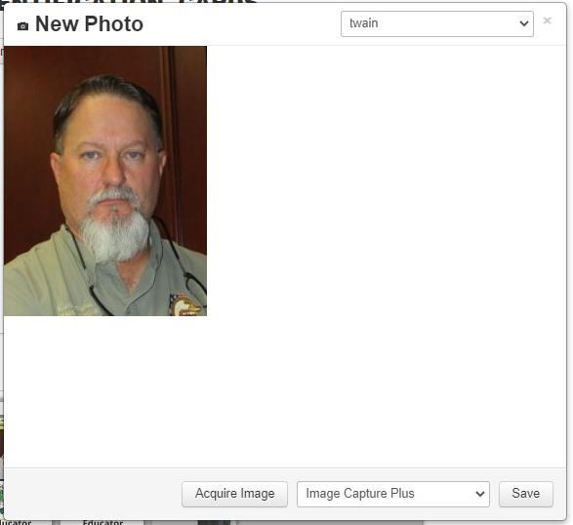
From this screen you can crop the image. Click and drag a box around where you want the photo to be cropped. Then click the SAVE button.
PRINTING THE CARD: Choose the card layout you want printed by click the drop down arrow.
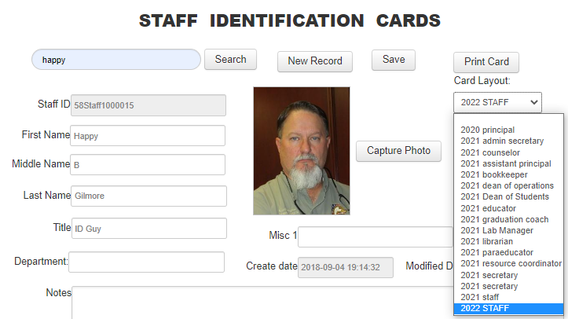
Next, click on the PRINT CARD button.
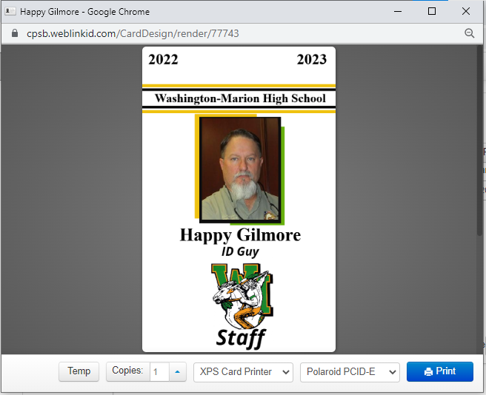
You will then see a preview of the card to be printed. If everything looks correct, click on the PRINT button to print that card.

NAVIGATE: To move between the student and staff sites, click on the blue button at the top right of the screen, then choose your destination.
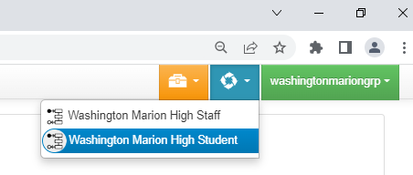
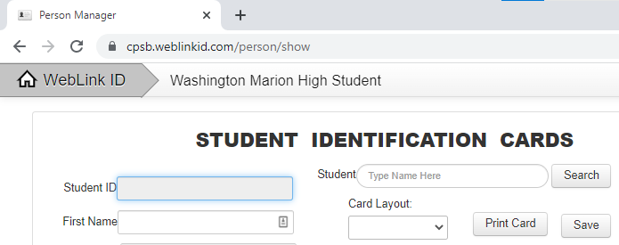

LOGGING OUT: Click on the green button at the top right (contains your username)
Then click on SIGN OUT.
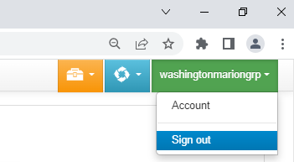

BATCH EDITING: If you wanted to batch change one field on many records, you can the batch edit function.
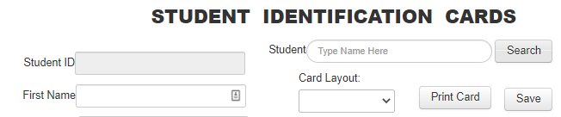
First, click on the SEARCH button (without typing in any search criteria)
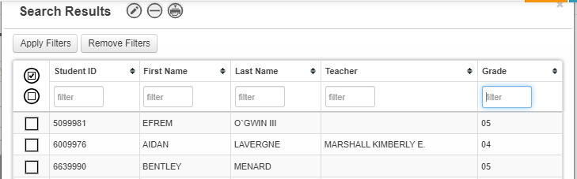
The search results window will allow you to filter the records down to just the ones you want to edit.
Type in some information in the filter box below the field name. (EX: Grade = 00)
Then click on the APPLY FILTERS button (you can use multiple filters at one time)
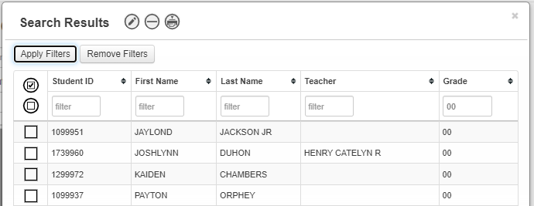
This will show you the results of your filtered search.

At the bottom of the search results window, it will show you how many records are in the batch.
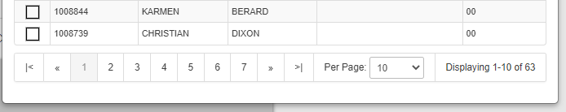
Next you will need to select the record you want to edit. This is typically all the records that cam up in the filtered search. Click on the box with the check mark at the top left. This will select all the records that are displayed only. If your search results are more than the number displayed, change the PER PAGE number to display more records. If you don’t display all the records in the search results, then you will have to batch edit each page of records separately. (try to display as many as possible)
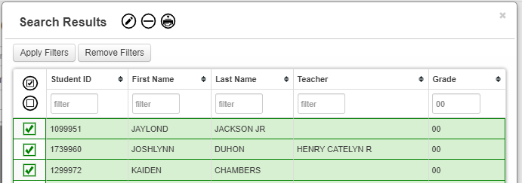
Click on the CHECK MARK to select all the records.
To edit the batch of selected records, click on the EDIT THE SELECTED RECORDS icon at the top.
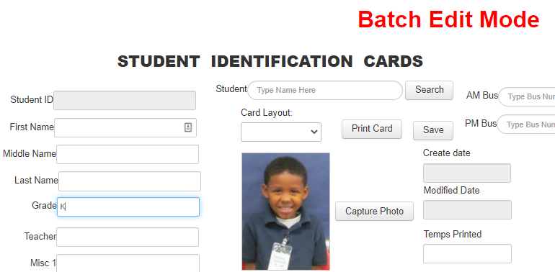
This will take you to the BATCH EDIT MODE screen

Type in the information that you want to change then hit ENTER. ( EX: Grade = K -changing it from 00 )
Remember, if you change name, grade or teacher, it will change back at midnight.

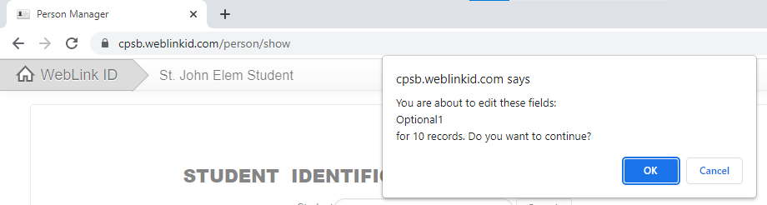

You will get a warning letting you know what you are about to do and to proceed. Click OK.
The system will then make the changes you requested to that batch of records.

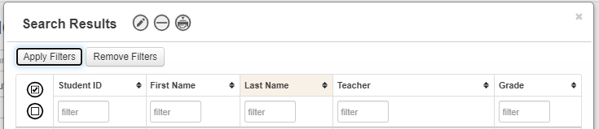

You can also send a batch of records to the print queue in the same manner. Just click on the ADD SELECTED RECORDS TO THE PRINT QUEUE icon at the top of the search results window.

BATCH PRINTING: Click the ORANGE button at the top right of the screen, then click on PERSONS.
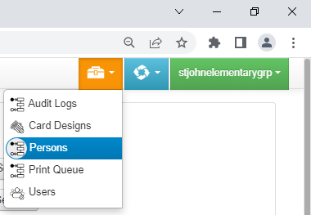
Determine your batch/search filter: (Optional 1 = Grade & Status = Homeroom Teacher)
Next, click on the APPLY FILTERS button
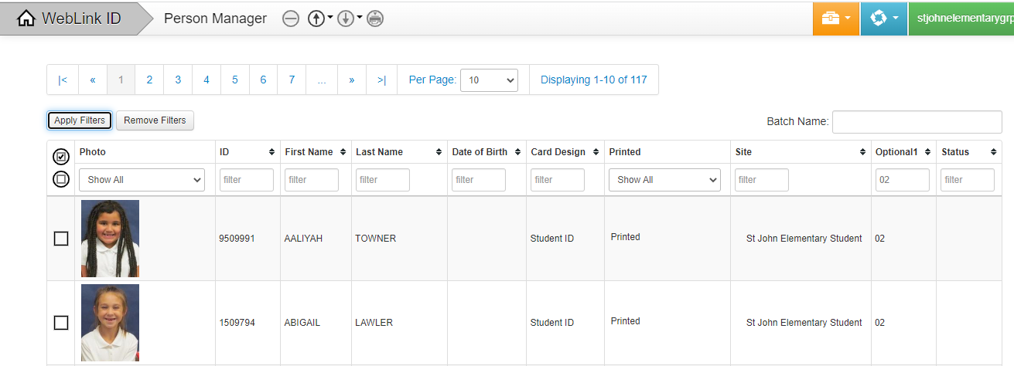
At the top, it will tell you how many records it found in the filtered search and how many of those records are being displayed. Change the display to show more than the number in the search result.
You may have to send more than one group to the print queue, if there are more than 100 records.
Click on the CHECK MARK to select all the displayed records, then click on the ADD SELECTED RECORDS TO THE PRINT QUEUE icon at the top of the search results window.
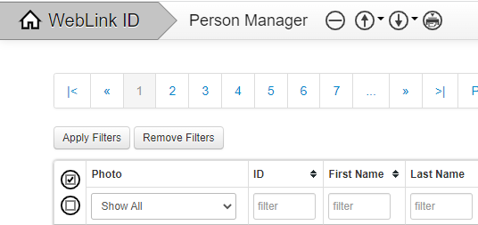
This will send all the records to the PRINT QUEUE (not to the printer).
To print out the records that you have sent to the PRINT QUEUE, click on the ORANGE button then the PRINT QUEUE.
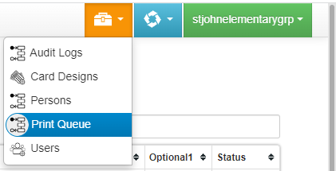
This will display all the record you that you sent to the PRINT QUEUE.
Change the displayed record count to 50 records per page. You will not want to print more than 50 cards at a time. If your batch of records to be printed is larger than 50, you will send batches of 50 to the printer several times.
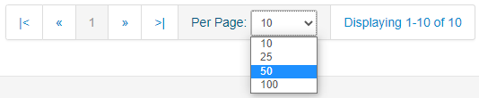
Click on the CHECK MARK to select all the records to be printed, then click on the PRINT THE SELECTED RECORDS icon at the top to print out the batch of cards.
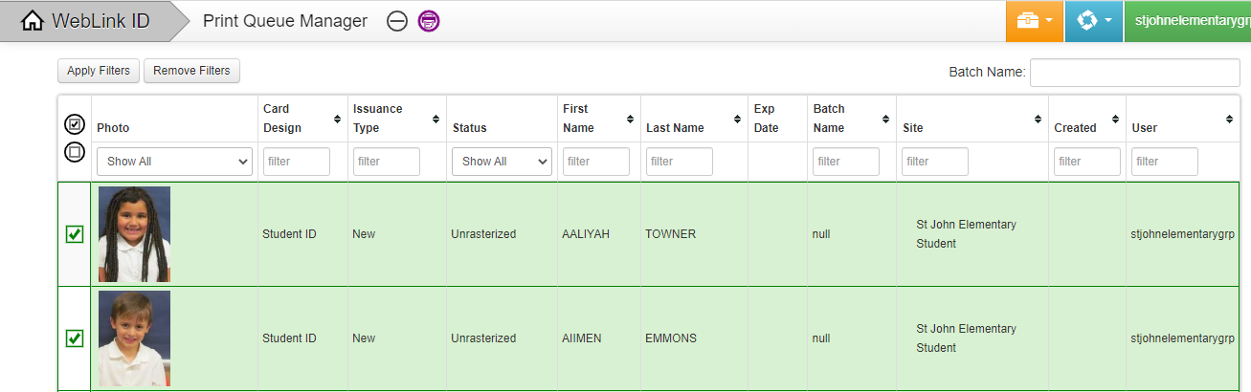
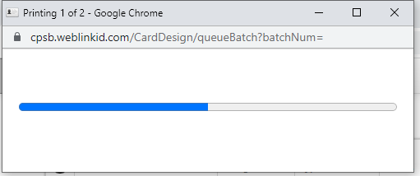 Your cards will start printing.

Southern Visuals

ID Supplies and Lanyards: Contact Scot Hair
Email: southviz@aol.com or kurtcazayoux@gmail.com
Phone: 337-234-2792 Fax: 337-234-2793

Training, Repair or Tech Support: Contact Kurt Cazayoux
Email: kurtcazayoux@gmail.com
Cell #: 337-739-4505

MIS Department will provide additional Ribbon, Temp ID Sticker Rolls and Clips as needed; however, additional ID Cards will need to be purchased at the school level.
If your school wants to use lanyards instead of the provided clips, they will need to be purchased at the school level.
To receive quotes on additional cards or lanyards, please contact Scott at Southern Visuals.

EDITING A CARD DESIGN: Navigate to the card designer by clicking on the ORANGE button at the top and click CARD DESIGN.
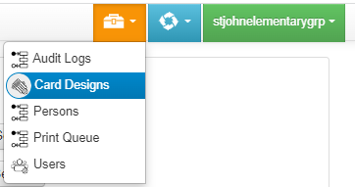

Next, double click the card design that you want to edit. You can create a new card design by editing a current card design and click on SAVE AS and giving it a different name.

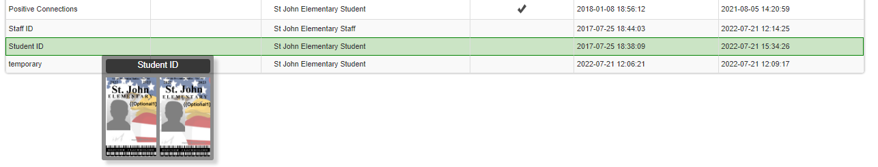
If you want to view the entire card design, you can make the screen view larger or smaller by holding down the CTRL key and pressing the + or – key on your keyboard.
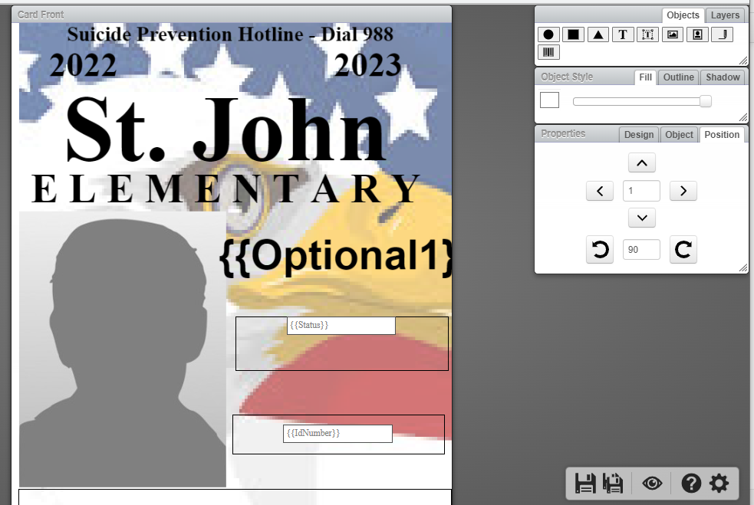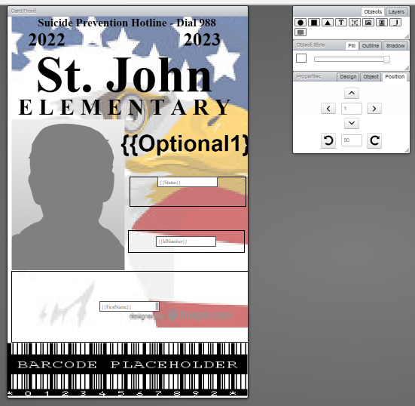

OBJECTS are all the items/fields that you can place on the card design. If you place your cursor over the object icon, it will tell you which object that it represents. To put the object on the card design, click and drag it onto the card side that you want it placed.
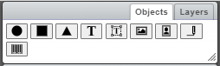

The objects are as follows: Circle – Square – Triangle – Text – Bounded Text – Image – Photo – Signature – Bar Code
To edit any item already on the card design, just single click on that object.
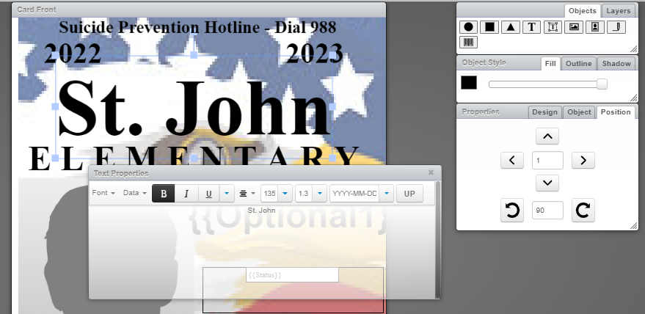

This brings up the object’s properties window. From this window we can change what we want in the (text) object and how we want that object to look.
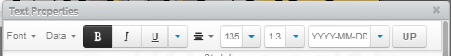

In the (text) object’s property window, you can change the following aspects:
Font type – the type of font that is displayed
Data – choose the database field from which the (text) will come from
BOLD – ITALICISE – UNDERLINE – JUSTIFICATION – FONT SIZE – LINE SPACING
YYYY-MM-DD - this is the format if a date is chosen in the DATA option
In the open area below the different properties, you can type the (text) that you want displayed.
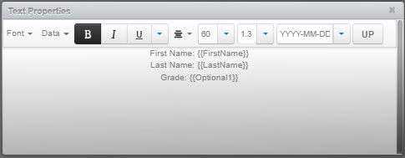
If you choose a DATA field from the database as your text, then that field will be automatically displayed in the box. The text field will have {{brackets}} around the data field name.
The database fields are as follows: (description = field name)
Student ID = idnumber First Name = Firstname Last Name = Lastname
Middle Name = middlename Grade = Optional1 Teacher = Status
Misc 1 = Optional3 Misc 2 = Optional4 LA/ER = Optional5
Temps = Optional 6 Notes = Notes1 Modified Date = Modified
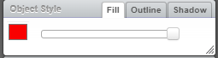
The box to the right labeled “OBJECT STYLE” is where you change the objects color.
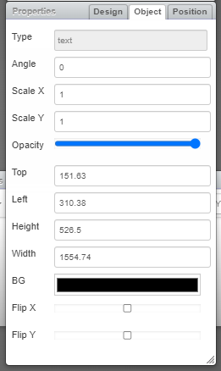
The box below the object style box is the OBJECT PROPERTIES box.
(click objects tab)
You can further fine tune your (text) object with these settings. For example, the “BG” setting is where you can set the BACK GROUND color of the text box on the card design.
You can change the ghosting of the object using the opacity setting. Opacity set all the way to the left makes the object transparent.
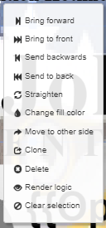

If you right click on top of the (text) object, this will give you additional options for this object.
You can layer your object by moving them FORWARDS or BACKWARDS.
You can CLONE an object and MOVE TO OTHER SIDE of the card (copy and paste).
You can also delete and object from the card design.

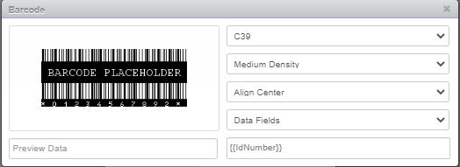
The BARCODE properties box is a little different.
The first option is the barcode type. This must be to “C39”.
The next option is the bacode density. This must be set at “MEDIUM DENSITY”.
Set the barcode alignment to “ALLIGN CENTER”.
The next field is the DATA FIELD and it is where the number that makes up the barcode will come from. Than data field needs to be set to the “IdNumber” database field.

To place a background color on your card design, drag the square box object to your card design.
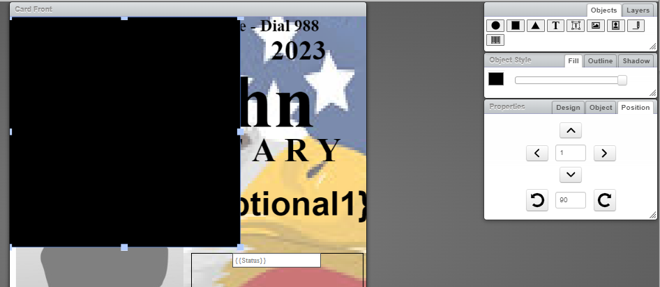
Change the color of the box in the OBJECTS STYLE box on the right. Then make the colored square as large as possible by clicking and dragging the small gray squares found around the square color box.
IMPORTANT: do not put a background behind your barcode
Once you have your color square resized and placed on your card design, right click on the square an click MOVE TO BACK.
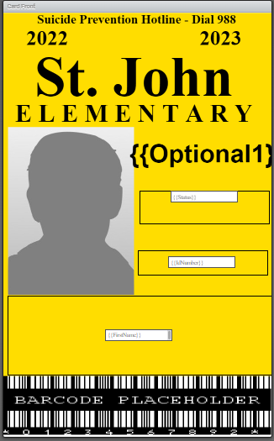

Finishing up your card design.
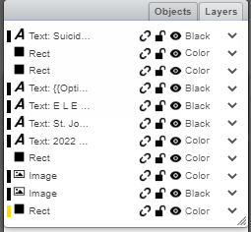
Click on the LAYERS tab in the box at the top right.

This helps the system to communicate to the printer exactly how to print the card design.
For each object, you will need to tell it if the text is black or color. The default is set to black.
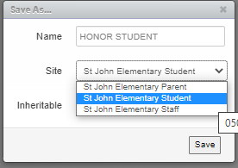
If your text object is color, click the drop down arrow and choose COLOR.


SAVE or SAVE AS

At the bottom right corner of the scree is the save box.
If you started a card from scratch, click on the SAVE button (the first icon) and give it a name. Next, choose which site gets to use that card design (student or staff)
If you started with a card design already created and want to UPDATE the design, click on SAVE.
If you started with a card design already created and want to save it as a different design, then click on the SAVE AS button (the second icon). Then, give it a new name and choose who gets to use it.

STATE MANDATE: The suicide prevention hotline must appear on all student ID cards.
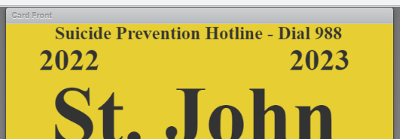
This is best done by placing a text box at the top of the ID card design. This will print where the suicide prevention hotline is above the hole in the card.

