**Restoring grades for students that are grey in your gradebook.**

1. 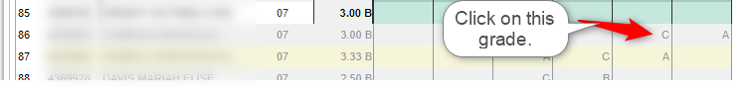Select one of the grades that are grey.

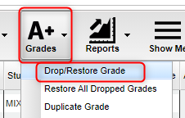

1. Click the Grades tab then Drop/Restore Grade.
2. You will get this message. Select YES.

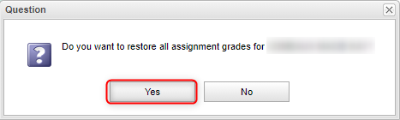

You can now edit these grades as needed.