**Posting Attendance for COVID**

**Positive Student: (must have documentation of a positive test result from a doctor )** Use an 05 code until you receive this positive test result.

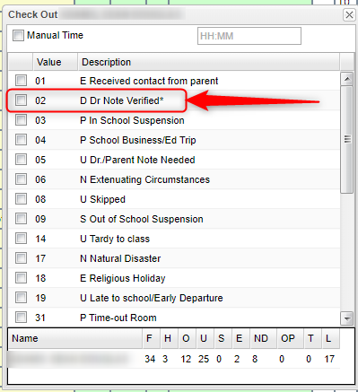Usecheck out code **02- D Dr. Note Verified** with **Health Code – U071 2019-NCOV Acute Resp…**

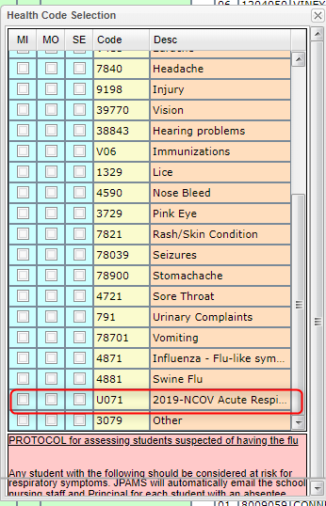

**Direct Contact Student**: Attendance clerk has been notified by the school or the parent.

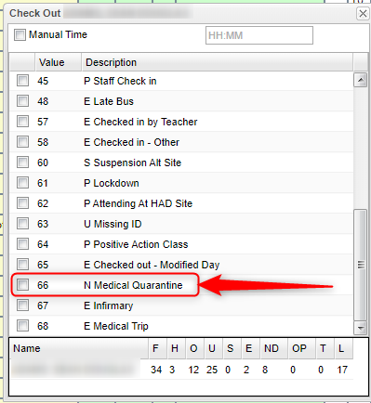Use check out code **66- N Medical Quarantine** with **Health Code – U071 2019-NCOV Acute Resp…**

