Test Scores By Level

**This program will provide for the user student test scores grouped around the "test achievement" levels.**

Go to **Grades > Lists > Test Scores By Level**

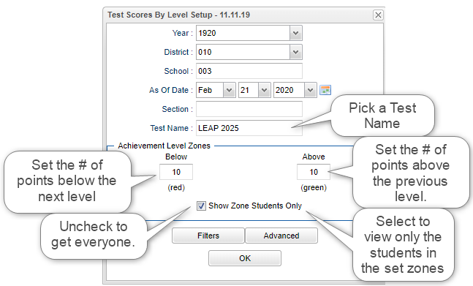**Set up box:**

**Year** - Defaults to the current year. A prior year may be accessed by clicking in the field and making the appropriate selection from the drop down list.

**District** - Default value is based on the user's security settings. The user will be limited to their district only.

**School** - Default value is based on the user's security settings. If the user is assigned to a school, the school default value will be their school site code. The user will not be able to change this value. If the user is a supervisor or other district office employee with access to the Student Information System, they will be able to run programs for one school, a small group of schools, or all schools in your district.

**As of Date** - This choice will list only those students who are actively enrolled as of the date selected in the date field.

**Section-**Section number from the master schedule.

**Test Name** - Select test name to view.

**Achievement Level Zones**:

**Below (Red)** - Enter a point differential below the next achievement level. This will shade the value red on all achievement level differentials having a value within the zone. A value of zero will disable this color.

**Above (Green)** - Enter a point differential above the previous achievement level. This will shade the value green on all achievement level differentials having a value within the zone. A value of zero will disable this color.

**Show Zone Students Only** - Select to view only students included in the above set zones for the selected test. Leave unchecked to select all students.

[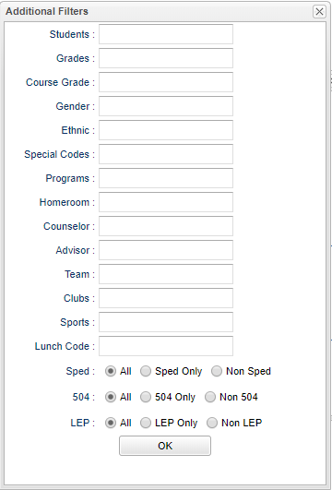](https://wiki.edgear.net/wiki/w/index.php?title=File:Testscoresbylevelfilters.png)**Additional Filters**: (Suggested to leave blank.)

**Student** - Select the student(s) for filtering.

**Grade** - Select the student(s) grade(s) for filtering.

**Course Grade** - This option limits the courses to a specific set of course grade levels to process.

**Gender** - Select the student's gender for filtering.

**Ethnic** - Select the student's ethnicity for filtering.

**Special Codes** - Select the student's special code(s) for filtering.

**Programs** - Select the student's program(s) for filtering.

**Homeroom** - Select the student's homeroom teacher for filtering.

**Counselor** - Select the student's counselor(s) for filtering.

**Advisor** - Student's assigned advisor name.

**Team** - Select the student's team(s) for filtering.

**Clubs** - Select the student's club(s) for filtering.

**Sports** - Select the student's sport(s) for filtering.

**Lunch Code** - Select lunch status (Free, Reduced, or not Eligible)

**Sped:**

**All** - Select this to show all students.

**Sped Only** - Select this to show Sped only students.

**Non Sped** - Select this to show Non Sped students

**504:**

**All** - Select this to show all students.

**504 Only** - Select this to show 504 only students.

**Non 504** - Select this to show Non 504 students.

**LEP:**

**All** - Select this to show all students.

**LEP Only** - Select this to show LEP only students.

**Non LEP** - Select this to show Non LEP students.

**OK** - Click to continue.

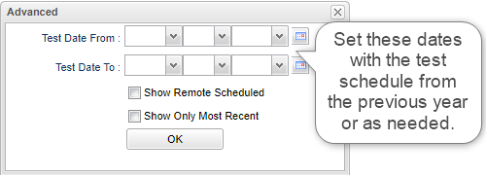**Advanced**:

**Test Date From** - Limits view of test by administration test date.

**Test Date To** - Limits view of test by administration test date.

**Show Remote Scheduled** - Display remotely scheduled and non-remotely scheduled students.

**Show Only Most Recent** - Reports only the students most recent test score for the selected test.

**OK** - Click to continue.

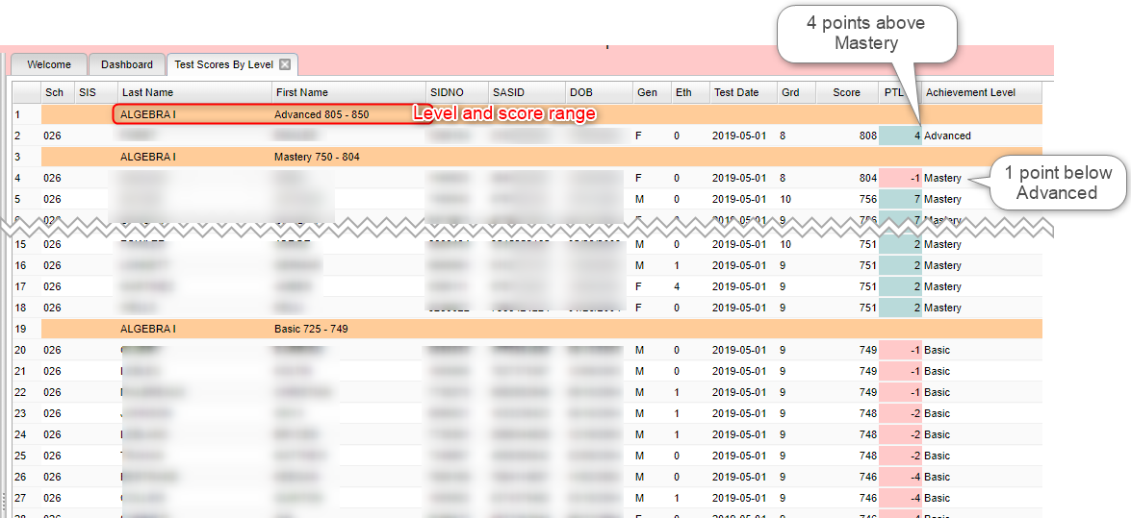**Report**

**Column Headers**

**Sch** - School site of enrollment.

**SIS** - Student's SIS school identification number.

**Last Name** - Student's last name.

**First Name** - Student's first name.

**SIDNO** - Student's school identification number.

**SASID** - Student's state assigned identification number.

**DOB** - Student's date of birth.

**Gen** - Student's gender.

**Ethnic** - Student's ethnicity.

**Test Date** - Test administration date.

**Grd** - Test grade.

**Score** - Scale score.

**PTL** - Potential points to reach next closest achievement level.

**Achievement Level** - Assessment achievement level.