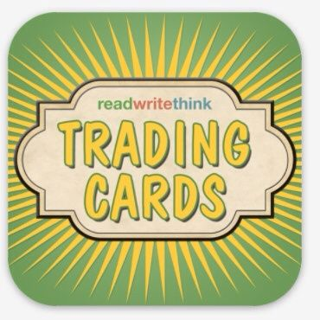**Trading Card Activity**

**Student Task Card**

***Trading Card Setup:***

**GL**

* **Open Trading Card App on Ipad**
* **Click “Create New User” & *WAIT* for teacher instructions for Username**
* **After Username is created, click on it to begin Trading Card**

***Creating the Trading Card:***

**GL**

* **Click “Create New Card”**
* **When it prompts “Type Card Title” type in name of character/place/etc. followed by group leader name**
* **Click type of card from list displayed.**
* **Click on “Source”—type the title of the book/story and the author here; Give Ipad to Reader**

**R**

* **Click on “Setting”—read guiding question to group; Discuss with group (limit discussions to 2 min. for each blank)**
  + - ***NOTE: After Reader reads each question, Leader & Photographer should be looking through story/book for answers if necessary. ALL group members should be involved in discussing answers to questions on cards.***

***KEY***

**GL = Group Leader**

**R = Reader**

**T = Typist**

**P = Photographer/Artist**

***Creating the Trading Card (continued):***

**T**

* **Type group answer in the blank**
* **Continue discussing/filling in information for each category like the step above**

**(R reads question & T types in question)**

* **Complete front & flip card to back**
* **Change group jobs as follows: *Typist & Reader switch jobs***
* **Complete back of card deciding on answers as a group**

**GL**

* **When finished, read entire card to make sure there are no errors. Flip card to front side.**

**P**

* **Take a picture representing your character/place/event/etc. using camera button on front of Trading Card**
  + - **Picture can be from book, or drawn by hand, or can be from somewhere in the room. Ask group for ideas & be creative!**
* **Click on “Card Design” & Change color/border on card if you wish.**

***Publishing Your Work:***

**P**

* **Click “Share It!” and send through email to** [**Jessica.dwight@cpsb.org**](mailto:Jessica.dwight@cpsb.org) **or Save to Camera Roll (listen to teacher instructions)**

***KEY***

**GL = Group Leader**

**R = Reader**

**T = Typist**

**P = Photographer/Artist**