The Berry Bulletin

Parent Issue 4

December 1, 2023

Learn • Lead • Achieve

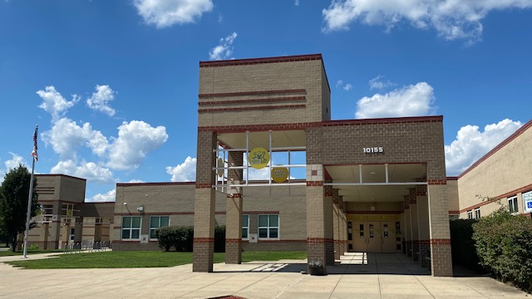

“

Whenever the calendar flips to December, I am often in disbelief. However, I also find myself in reflection and filled with appreciation for the gift of time and the many lessons each year brings. Days, months, and even years truly pass so quickly. I hope you can spend the next month sharing in the joy of the holidays with family and friends and close out 2023 with a sense of gratitude.

November was an exciting month as we honored our Veterans, held 3 separate Awards Celebrations, celebrated National Parent Involvement Day, and celebrated our students at the 31st Annual Community Arts Show. We also collected **323lbs** of non-perishable food items during our Thanksgiving Food Drive. This afforded 15 families to be provided with food to help during the Thanksgiving holiday. THANK YOU!

Student recognition continues to be a priority. Our daily Positive Office Referrals, DOJO points, and Monthly Core Essential awards are just 3-ways students are feeling seen, heard, and appreciated for their honorable efforts each day.

The connection of home, community, and school energizes our mission and solidifies our student’s investment in their learning. Thank You for all of the families that are able to participate in our events. I do my VERY best to prioritize opportunity for family participation while remaining committed to safety, operating schedules, and resources. Much time, work, and considerations go into ANY event we hold no matter how big or small. In the end, I take pride in the many opportunities we offer.

**December reminders**:

**Be sure to check out our Berry Spirit Wear sale going on now through December 8th**

10% of all proceeds go back to the Berry PTO!

* **Sale Dates**: November 6th - December 8th
* **Savings**: 20% discount sitewide
* **Shipping**: Free shipping over $75
* **Store Link:** [https://1stplace.sale/44428](https://nam12.safelinks.protection.outlook.com/?url=http%3A%2F%2Fclick.email.1stplacespiritwear.com%2F%3Fqs%3D3091f932bda6ada188e087b01bf8c0b5b70971948174fe783a40121c72ed3fed16cdf09c2b678bef54a91238de9a9eea31aaf32d34692826&data=05%7C01%7Clmclaud%40ccboe.com%7C03e2f54b51744c07691808dbdd381b43%7C8e3adb7e3a2940c383dded0fc33b46c3%7C1%7C0%7C638347005311849569%7CUnknown%7CTWFpbGZsb3d8eyJWIjoiMC4wLjAwMDAiLCJQIjoiV2luMzIiLCJBTiI6Ik1haWwiLCJXVCI6Mn0%3D%7C3000%7C%7C%7C&sdata=erIAqy7x3tCuEj9LlmuA6LKeVeY5k7aD%2FOosr32zEwE%3D&reserved=0)

Our Reading for Education fund raiser continues all year long. This is a great way to push a fundraising effort out to other family and friends. We are still seeing donations come in for teachers and for our school. Consider re-sending the link to family/friends you feel may be interested.

**The Reading for Education fundraiser is 100% online so there is NO face-to-face selling, handling money, or delivering products.**

**Here is all you need to do to participate:**

**1. Go to** [**https://www.rfe.net/sid.t?0000290351**](https://www.rfe.net/sid.t?0000290351%20) **to sign up.**

**2. Send form emails inviting family, friends and co-workers to support your child.**

As always, it is a privilege to be your Principal at Berry Elementary. We have a very special community, and I am so proud. Sincerely,

Ms. McLaud

Sincerely,

Ms. McLaud

**12/4 2nd Grade to Science Center**

**(Mr. Young and Ms. Stephens)**

**12/5th and 8th**

**1st Grade In-House Field Trip**

**(Bird Clues)**

**12/6 Early Dismissal Day**

**12/11 Interims Posted**

**12/14 Picture Re-takes**

**12/15 Berry PTO presents**

**WINTER WONDERLAND CARNIVAL**

**Mrs. Warman-Johnson will also have the Book Fair Open for all Families 5:00PM-8:00PM.**

**Decemberber**

**Principal’s Message**







**See Attached Flyers for:**

**Book Fair Family Nights *and* the Humane Society donation drive.**

**Students may also participate in the same daily “Spirit Days” as the teachers. See attached calendar.**

**One School**

**One Community**

**December Acknowledgments**

**Holidays Around the World**

**December Core Essential: Generosity**

**Winter Break:**

**December 23rd – January 1st**





**November Highlights @ Berry Elementary!**

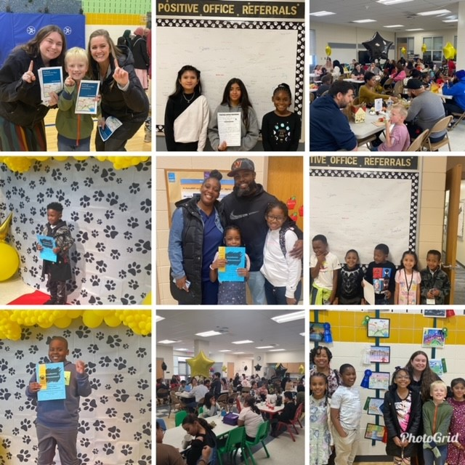

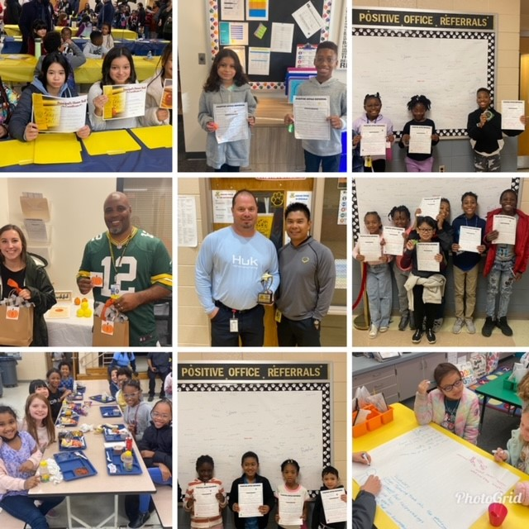

|  |  |
| --- | --- |
|  |  |
|  |  |

Thank You Parent Volunteers for taking the lead for our MESA Team!

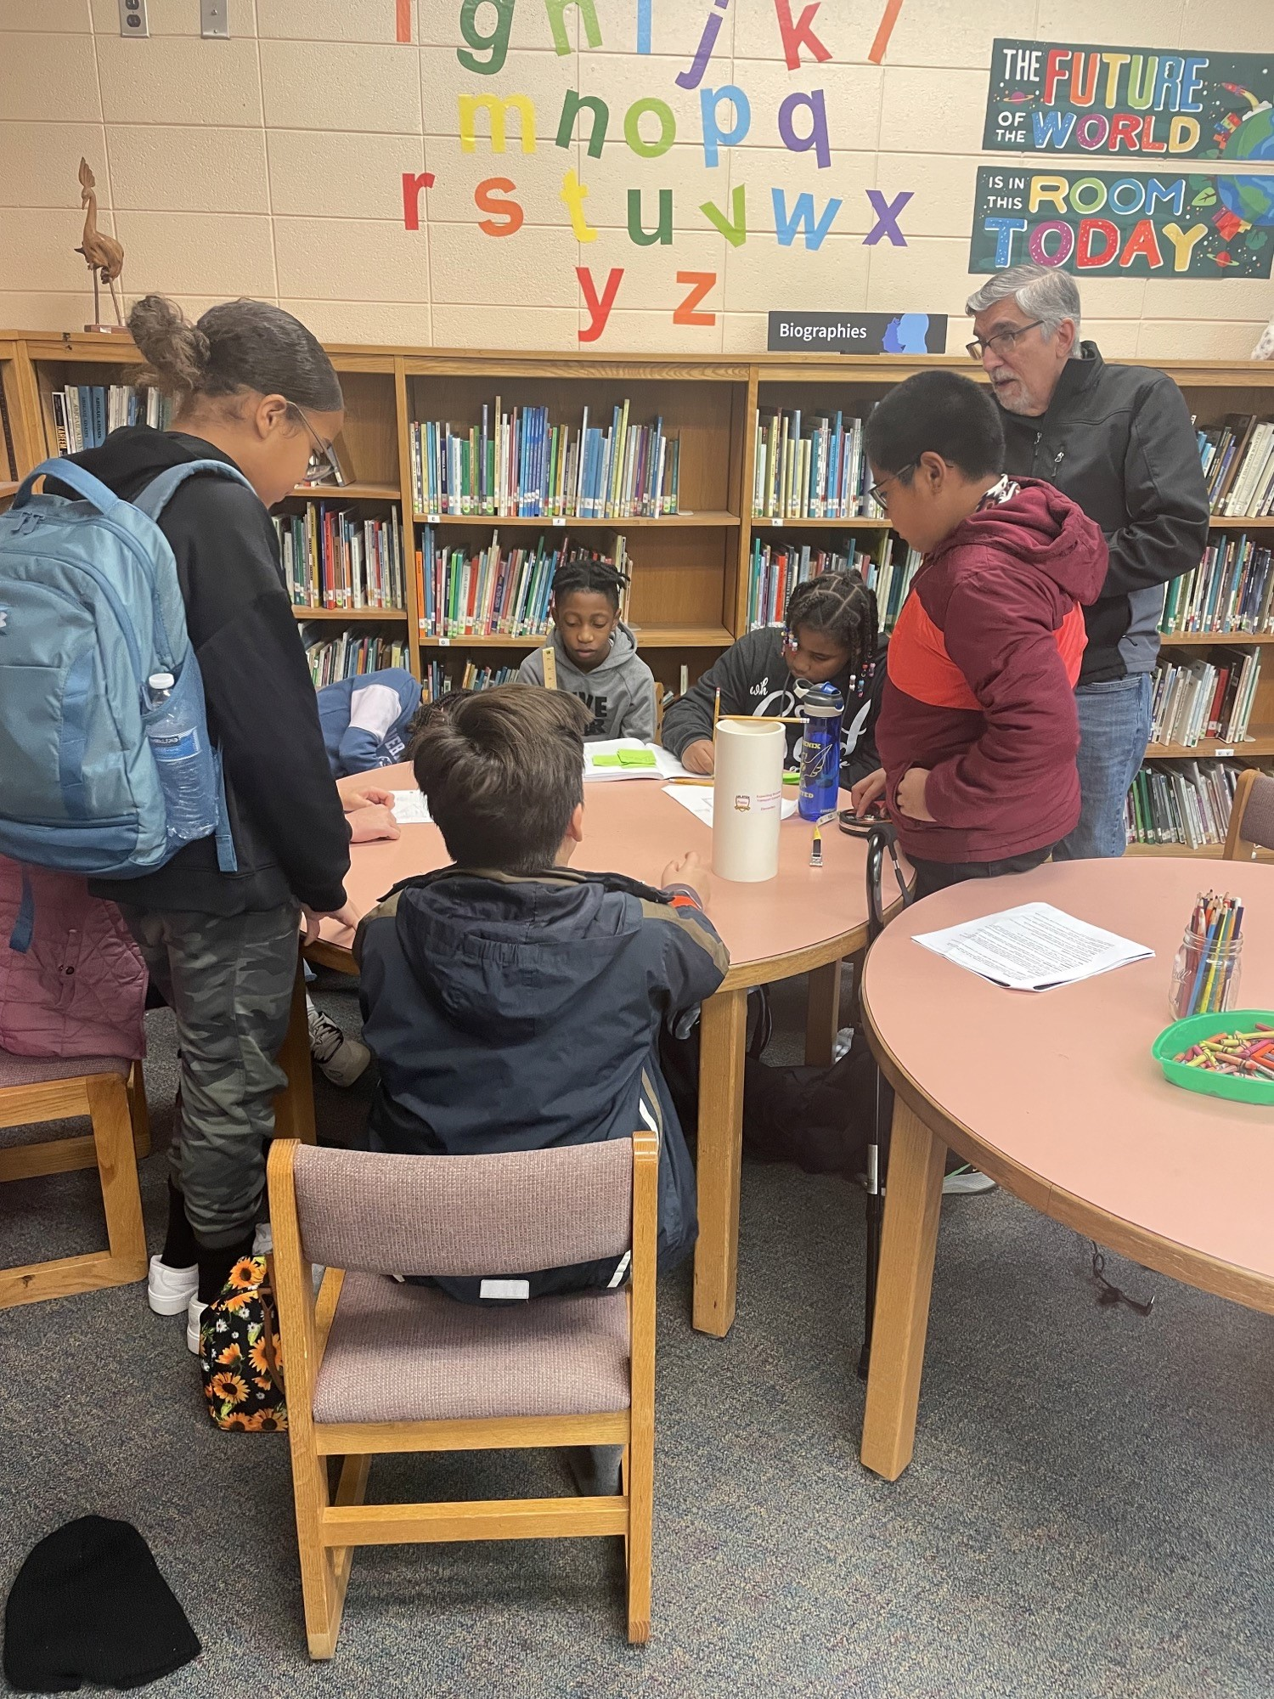 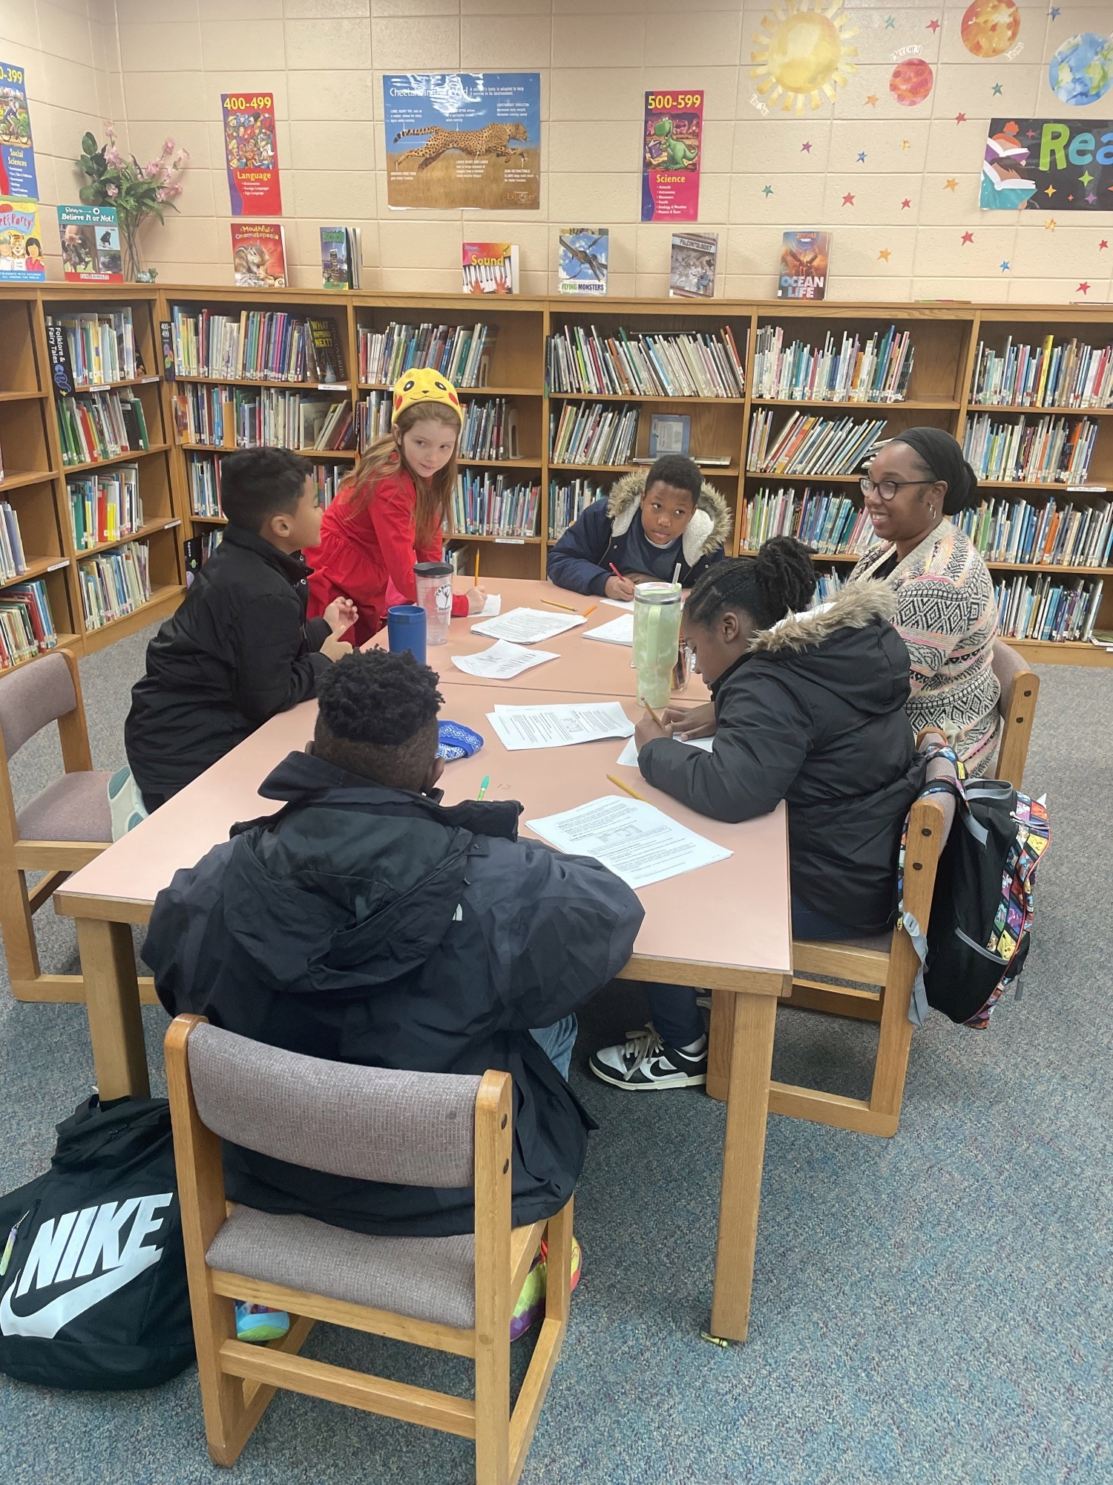

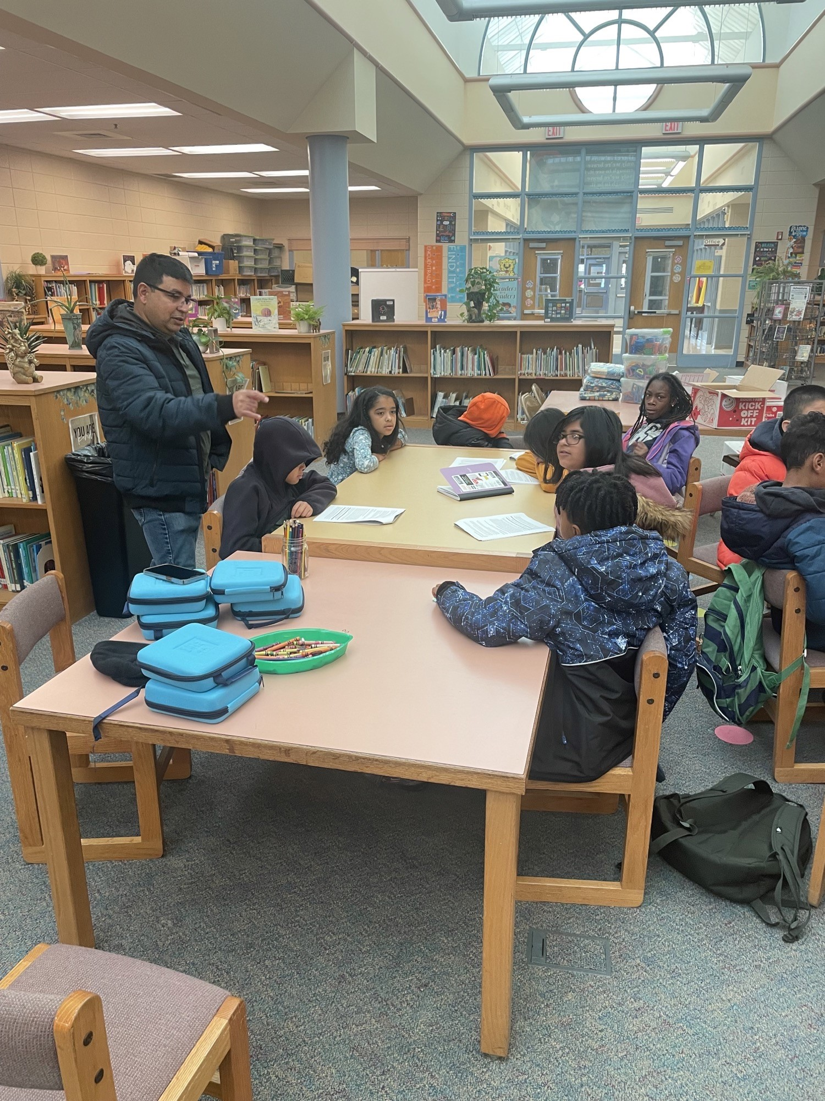

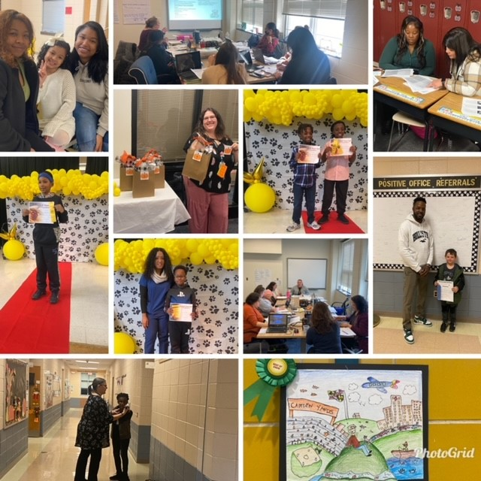

|  |  |
| --- | --- |
|  | |
|   **Learn • Lead • Achieve** |  |
|  |  |
|  | |

**For more pictures and updates,**

