**Naviance: SuperMatch College Search**

SuperMatch College Search is a useful tool for comparing students directly with past Washburn High School students. The advantage to this is you can see how fellow Millers fared in their admissions decisions.

1. **Log into your Naviance Account**
   1. Click on Naviance on your school’s website.
   2. Enter your user-name and password
      1. If you can’t get in, e-mail your counselor to get access.
2. **Click on the Colleges Tab** located on the top of the page.
3. **Click on SuperMatch** located at the top right of the page.

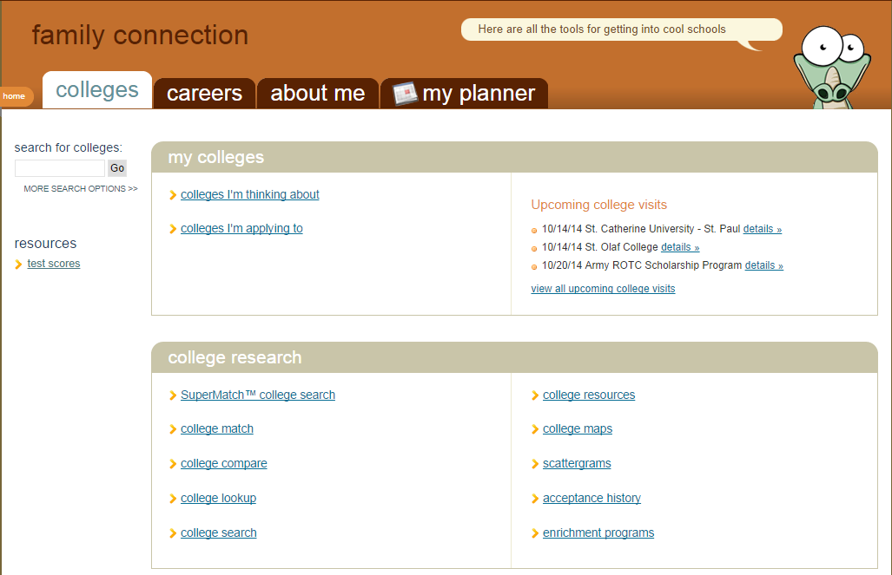

1. **Add your filters.** This narrows the number of schools. The counseling team highly suggests you add your ACT and current GPA to get a good sense of academic fit during your search. (See next page for a list of filters available on SuperMatch)

Here is an example of the search result list…

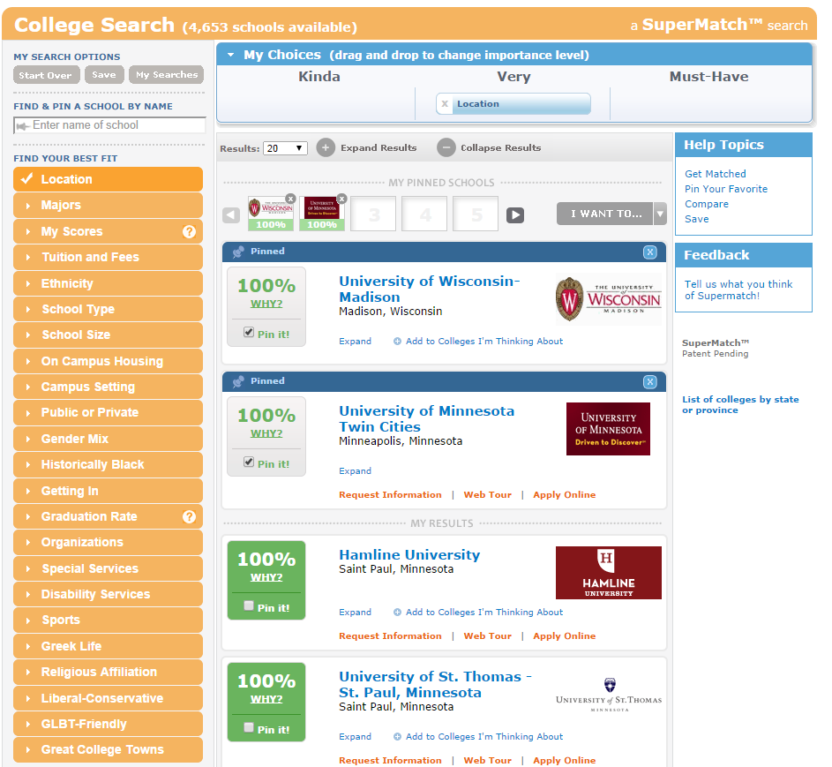

1. **Learn more about schools as you go**. As you add filters, the schools will change and will show you how well you are matched.
   1. **Click “Why?”** to find out details of your match.
   2. **Click on the college or university name** to explore the institution
   3. **Click “Expand”** to see a snapshot of the college.
   4. **Click “Pin It!” for schools that you like.** They show up at the top.
   5. **Compare schools you like!**
   6. **Add to Colleges I’m Thinking About** to get updates about visits to Washburn!

**TIPS FOR SUCCESS**

* **Start broadly**- the more specific you get, the fewer schools there will be to research.
* **Use Scattergrams** to determine if you are a fit for a school.
* Be prepared to **look at schools that don’t match 100%**
* **Save your searches** so you can return to them!

**Naviance: College Scattergrams**

Scattergrams are great way to determine where you fit in a particular college’s application pool. This document will show you how to find them and use them effectively in your college search.

1. **Log into your Naviance Account**
   1. Click on Naviance from your school’s home page.
   2. Enter your user-name and password
      1. If you can’t get in, e-mail your counselor to get access.
2. **Click on the Colleges Tab** located on the top of the page.
3. **Click on Scattergrams** located at the middle right of the page.

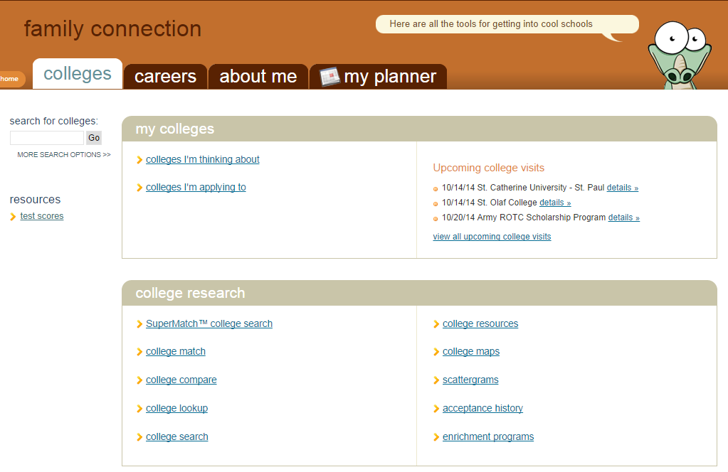

1. **Enter the university or college of interest**
2. **Change the test type to the ACT or SAT** depending on your best score.

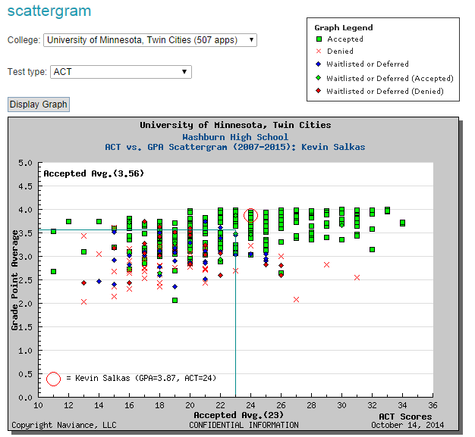

**HOW TO READ A SCATTER GRAM**

1. **Read the Graph Legend** – Each symbol represents a student applicant.
2. **Find the Red Circle** - This is you, the prospective applicant.
3. **Find the Blue Lines** - The point at which they meet is Washburn’s average accepted student.
   1. **Reach Schools** – The red circle is *inside* the blue lines, *typically* surrounded by more red X’s

than green squares.

* 1. **Target Schools** –The red circle is *right near* the blue lines, *typically* surrounded by more

green squares and diamond shapes.

* 1. **Likely Schools** – The red circle is *outside* the blue lines, *typically* surrounded by mostly

green squares

**NOTE**: Scattergrams do not represent holistic admissions processes which may include many alternate factors including involvement, recommendations, interviews, and personal challenges. They are meant to be an orienting tool for starting your search.

**IF THERE IS NO SCATTERGRAM**

1. Check that there are enough applicants from past years.
2. Check that you have picked the right test!
3. Go directly to the college’s undergraduate admissions website.