**Signing Up for a College Visit in Naviance**

Often in the fall college representatives come to our high school. This document has instructions on how to sign up to see a college through Naviance. If you follow it from beginning to end, you should be able to easily get yourself on the list of attendees and get a pass to see colleges you might be interested in!

1. **Log into your Naviance Account**
   1. Find Naviance on the school’s website.
   2. Enter your user-name and password
      1. If you can’t get in, e-mail your counselor to get access.
2. **Click on the Colleges Tab** located on the top of the page.
3. **Click on “View All Upcoming College Visits”** located at the top right of the page.

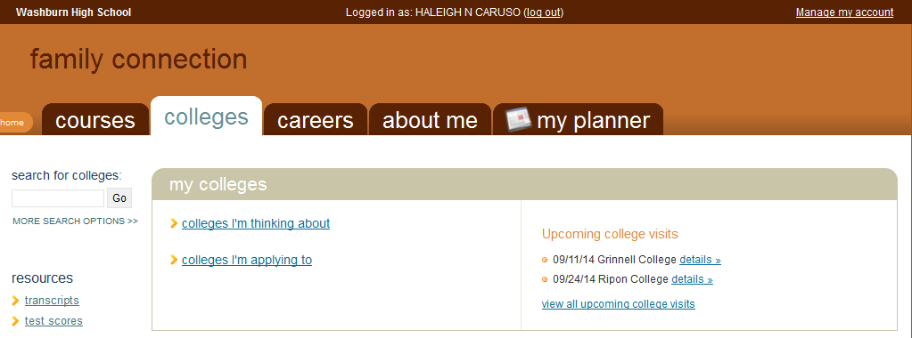

1. **Click on “Sign Up”**
2. Then **Click “Sign Me Up” 🡪 YOU’RE DONE!**

Once you have added yourself to the list, **you need to come get a pass from the CCC which must be signed by your teacher to indicate they approve your visit with the college representative**. If not, you will be marked as absent from class.