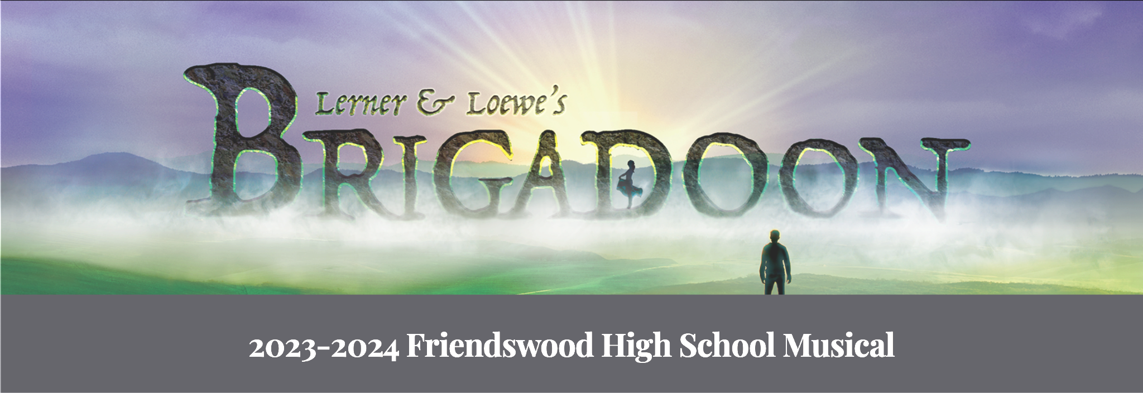

Cast
Tommy Albright |  | Jimmy Perry
Fiona MacLaren |  | Julia Houting
Jeff Douglas |  | Beau Laviolette
Harry Beaton |  | Brendon Romell
Meg Brockie |  | Caroline Krebs
Charlie Dalrymple |  | Thatcher Chase
Mr. Lundie |  | Jacob Mayfield
Andrew MacLaren |  | Sammy Davies
Jean MacLaren |  | Jai Foster
Mrs. McGregor |  | Claire Gibson
Angus MacDuffie |  | Connor O'Rear
Archie Beaton |  | Andrew Jennings
Jane Ashton |  | McKenna Fritts
Stuart Dalrymple |  | Elijah Meaux
Maggie Anderson |  | Claire Howard
Frank |  | Aidan Slack
Sandy Dean |  | Dylan Garcia
Kate |  | Avery Buras
Fishmonger |  | Sofia Medina
Sword Dancer |  | Carter Payne

Continued on Next PAge: Ensemble & Crew

Ensemble

Aliz Kidd | Ella Chandler | Madelyn Rempel
Annily Karg | Hailey Setoudeh | Maggie Seaforce
Ashe Wainscott | Hannah Brueggeman | Mahrosh Saqib
Avery Hunter | Ibrahim Favad | Matthew Rapp
Beth Seifert | Jordyn Hunter | Mia Standley
Brie McDowell | Katy Slack | Molly Fruehan
Caitlyn Norris | Kenzie Brown | Morgan Armstrong
Charlene Chapman | Kyleigh Chilton-Fernandez | Paige Garcia
Daisy Harris | Landon Baker | Priscila Nieves
Dillon Davis | Lexie George | Ralyn Dye
Elizabeth Burke | Liv Knutson | Roxie Harris
Elizabeth Cabrera | Logan Holbrook | Samantha Sims

CREW
Set | Sound
(Head) Kyle White | (Head) Reece Dealmeida
Grant Sanders | Alec Sheard
Alex Trieu
Llogan Helgeson | Lights
Aero Anderson | (Head) Sean Pastalaniec
Sergio Cruz
AJ Shepler | Costume
Sy Huelsman | (Head) Kailee Torres
Hudson Hawkins | Sara Cantos
 | Allie Reed
Stage Manager | Harper DeHart

