2024  Gwinnett County Public Schools  Charter School Application Guidance  For Proposed School Openings 2025-2026  Division of School Improvement and Operations | 

Gwinnett County Public Schools embraces the opportunity to provide its students the choice of educational experiences that align with the mission and vision of the Board of Education.

Vision
Gwinnett County Public Schools will become a system of world-class schools where students acquire the knowledge and skills to be successful in college and careers.

Mission
The mission of Gwinnett County Public Schools is to pursue excellence in academic knowledge, skills, and behavior for each student, resulting in measured improvement against local, national, and world-class standards.

The guidance in this document is in compliance with Charter School Act of 1998 which outlines the purpose of the law:

It is the intent of the General Assembly to increase student achievement through academic and organizational innovation by encouraging local school systems to utilize the flexibility of a performance based contract called a charter.

GCPS’ Program Development and Improvement coordinates the charter activities in the district including serving as the liaison between the applicants and the local and state boards of education and the central office support staff. The Director of Program Development and Improvement may be reached by phone (678.301.7120) or by email (emily.coady@gcpsk12.org).

Please follow the directions and suggestions in this document completely in order for your application to receive a fair and comprehensive review of what your charter school intends to be. The review process can only evaluate what your application effectively communicates in the submitted document.

This document is aligned to the requirements of the Georgia Department of Education, Charter School Division as posted on the website. Link to the GADOE Charter Schools Division web address: http://www.gadoe.org/External-Affairs-and-Policy/Charter-Schools/Pages/default.aspx
Please review all materials on the GADOE website to assure your charter school application meets state requirements in addition to those outlined in GCPS application addendum.

Charter School Application Guidance
Table of Contents

Page
Charter School Expectations 3
Timeline for Charter School Applications for School Year 2025-2026 5
Charter School Application Requirements 6
Special Education Services Guidelines for Charter Schools 9
Charter School Application Template
{Cover Page, Application, Assurances, Exhibits, and GCPS Addenda (additional
requirements of Gwinnett County Public Schools) including the Government Matrix
and Budget Pages as required by the Georgia Department of Education (GADOE)} 13

Charter School Application Budget Template Directions and
Budget Page(s) Template included from the GADOE Website 14-29

Roles and Responsibilities Chart 30-34

Gwinnett County Public Schools
Charter School Expectations

Gwinnett County Board of Education has high expectations and accountability for all schools and entities that are part of the Gwinnett County Public Schools governance. The following information defines the role of charter schools within GCPS as well as the expectations of its leaders, teachers, parents, students and supporters. Charter schools are most likely to be approved if they provide academic and organizational innovation in the public’s interest and are supported by a sound business model with demonstrated capacity to implement the plan.
Applications for charter schools authorized by GCPS will be evaluated to determine the degree to which the application meets requirements and following characteristics.
- The GCPS charter school’s philosophy aligns with the mission, vision and core beliefs of the Gwinnett County Board of Education.
- A GCPS charter school is in the public interest and provides an innovative educational experience of high academic quality and expectations not found in another district school.
- The charter school equitably serves students who choose to attend and reside in the GCPS school district attendance area in the designated grades. The student enrollment is representative of the diversity of the GCPS student population.
- The charter school governance is provided by members of the community who demonstrate competency in public, private or charter school management, financial or business acumen, human resource leadership, legal training and experience, and/or resource procurement and oversight.
- Charter school leaders and administrators are partners with the GCPS district leaders to provide instructional services to students, fiscal stability, professional learning, a safe and secure environment, federal and state mandated legal compliance and accountability for results.
- Charter school students are expected to achieve at a higher standard of academic performance than students from other schools within the district as evidenced by the results of the charter’s academic performance goals and annual measurable targets.
- Charter school teachers provide consistently engaging learning experiences that effectively demonstrate researched-based instructional strategies, comprehensive knowledge of the content and pedagogy in assigned teaching areas, ability to develop relationships with students and parents that enhance student learning, and appropriate assessment of student progress.
- The charter school calendar and daily schedule provide for unique opportunities for increased time for learning.
- Charter school community support is based on community needs, interest and sustained engagement of parents and other stakeholders in the development and implementation of the school plan resulting in improved academic achievement.
- The charter school business plan is based on a realistic and manageable multi-year budget. The budget is balanced with projected revenues based on existing state charter school funding law and projected expenditures based on realistic anticipated student enrollment. The plan reflects an understanding of flexible school finance, funding, and relevant school law, sound accounting practices, and demonstrated capacity of administration to successfully implement the plan.
- Charter school leaders understand and have the plan, capacity and resources to meet the needs of individuals who qualify for protection and services identified in all applicable federal and state laws.
- The charter school facility and site provide a safe, secure, orderly, and healthy environment conducive for student learning.
- Charter school students have access to and use technology appropriately to engage in learning beyond the traditional classroom walls and facilitate the development of skills necessary for successful life-long learning.
Applicants are expected to be familiar and comply with Georgia law, rule, guidelines and guidance related to charter schools as outlined on the following website.

http://www.gadoe.org/External-Affairs-and-Policy/Charter-Schools/Pages/default.aspx
The application review by the GCPS Charter Review Committee is rigorous in applying the criteria for application requirements and alignment to the characteristics delineated above. The review committee cannot assume any information not detailed in the application, so be careful to provide specific and sufficient detail in response to all requirements. The review team will be trying to ascertain that the applicant has deep knowledge of how to develop, implement and sustain a school that will increase student achievement and provide an innovative educational opportunity for students.

Charter School Application Deadlines

A Letter of Intent must be submitted to GADOE and copied to GCPS no later than Wednesday, November 1, 2023. Please review charter school application requirements on the Georgia Department of Education, Charter School Division website as well as GCPS’ requirements included herein and in the GCPS charter school application. Original and 20 additional copies of your completed application and USB drive must be delivered to the lobby of the Instructional Support Center, ATTN: Dr. Emily Coady, 437 Old Peachtree Rd., Suwanee, GA, 30024, from Wednesday January 3rd through 4:00 P.M. on Wednesday, January 17, 2024. No mailed or faxed copies will be accepted. The original and all copies must be bound individually by a binder clip. Applications submitted later than 4:00 P.M. on January 17, 2024, or that have not been submitted correctly, will not be accepted in this charter school application review cycle.

Timeline for Charter School Applications
for Schools Opening 2025-2026

Wednesday, November 1, 2023 | Letters of Intent must be received by November 1, 2023, by the GA DOE and GCPS
Wednesday, November 8, 2023 | An information session will be held for all charter applicants on Wednesday, November 8, 2023, at 2:00 p.m. at the GCPS Instructional Support Center in Building 100 in Room 1.726. This session will be coordinated by the Office of Program Development and conducted by key district staff. The applicant, the head of the school (if designated), the budget officer, and at least two members of the governing board should attend.
Wednesday, January 3, 2024 – Wednesday, January 17, 2024 | GCPS will accept petitions from applicants from Wednesday, January 3rd through Wednesday, January 17th, 2024.  Original and 20 additional copies of the completed application and USB drive must be received by 4:00 p.m. on Wednesday, January 17, 2024. The original must be in a separate folder. The original and all copies must be bound individually by a binder clip. Petitions that are not submitted by 4:00pm or that are not submitted as outlined above will not be accepted in this charter petition review cycle.  ATTN: Dr. Emily Coady  Gwinnett County Public Schools  Instructional Support Center  437 Old Peachtree Rd., NW  Suwanee, GA 30024
January – March 2024 | GCPS Charter Review Committee may request by email or in writing clarifying information from the applicant. These clarifications must be submitted by email or in writing and will become part of the application submitted to GADOE Charter Division. GCPS also reserves the right to request revisions to the Charter application before sending to DOE.
Thursday, March 21, 2024  (tentative date - GCBOE meeting dates are not yet set for 2024) | Gwinnett County Board of Education Action
Monday, March 25, 2024  (tentative date) | Certified letters sent to all applicants with Board decision and information from review of applications.
Monday, March 25, 2024  (tentative date) | Charter applications and Board decision with reasons submitted to GADOE, Charter Division.
First Come-First Serve Basis | Georgia Board of Education action

Charter School Application
Requirements

Unless otherwise mandated by the forthcoming GADOE Charter School Application Guidance, the following are application requirements.
- Each page is consecutively numbered (including exhibits).
- Number and tab all exhibits consecutively.
- Do not enclose application in notebook, binder, or folder.
- The original signatures must be in blue ink. Stamped signatures will not be accepted.
- Applications must not exceed 75 pages exclusive of GCPS addendum requirements and exhibits. The petitioners are encouraged to answer each requirement clearly, concisely and thoroughly. (Note: GA DOE requirement of 11-point Times New Roman font and one-inch margins with a header showing at the top with charter school name and school system name and footer showing consecutive page numbers.)
- Application Package must also include a single USB drive that includes a:
- Microsoft Word version of your Charter Application Cover Page (page 14 of GCPS Application Packet)
- Microsoft Word version of your Charter Application and Exhibits
- PDF Version of your signed Charter Application in the following order: Charter School Application and Exhibits (including signed Affidavit and Assurances)
- PDF version of your Locally-Approved Charter School Partners Roles and Responsibilities Chart (also included in Application as Exhibit 6)
- Excel version of your completed Budget Templates

At the time of GCPS Board decision, Program Development will forward the application as submitted to the Charter School Division of the Georgia Department of Education as required in Charter School Petition Guidelines. Any clarifying documents or requested revisions will be forwarded.

Information Session

An information session will be held for all charter applicants on Wednesday, November 8, 2023, at 2:00 p.m. at the GCPS Instructional Support Center in Building 100, Room 1.726. This session will be coordinated by Director of Program Development and Improvement, Dr. Emily Coady (678-301-7120) and conducted by key district staff. The applicant, the head of the school (if designated), the budget officer, and at least two members of the governing board should attend.

Accreditation

GCPS recommends that approved charter schools plan to seek accreditation with AdvanceEd in order to provide students with a seamless transition to quality educational opportunities of choice upon leaving the charter school.

Important Laws

The following are important laws of which knowledge is essential in preparing a charter application that meets all federal and state laws. The charter school’s legal counsel should read and assure compliance.
  Americans with Disabilities Act (ADA) of 1990
  Section 504 and the Rehabilitation Act of 1973
  Individuals with Disabilities Act (IDEA)
  Every Student Succeeds Act (ESSA)
  Fair Labor Standards Act
  Equal Pay for Equal Work Act of 1963
  Title VI and Title VII of the Civil Rights Act of 1964
  Age Discrimination Act of 1967
  Occupation Safety and Health Act of 1970
  Title IX of the Education Amendments of 1972
  Workers’ Compensation, O.C.G.A. § 34-9-81.1
  Unemployment Compensation
  Federal Educational Rights and Privacy Act (FERPA)
  Charter Schools Act of 1998
  Official Code of Georgia Title 20: Georgia School Laws

Insurance Coverage

Charter School applicants shall include assurance of procuring the following insurance coverage in the GCPS application assurance section.
- Property Insurance (including Boiler & Machinery) – Full replacement cost
- General Liability (including coverage for Sexual Abuse & Molestation) - $1,000,000
- Automobile Liability - $1,000,000
- Workers’ Compensation/Employers Liability – Statutory/$1,000,000
- Fiduciary Liability - $1,000,000
- Crime Bond (Fidelity Bond) - $500,000
- Educators Legal Liability - $1,000,000
- Directors & Officers Liability - $1,000,000
- Cyber Liability (for online schools only) - $1,000,000
- Student Accident Insurance (optional, but recommended)
- Umbrella Liability (to include all liability policies except Fiduciary)- $1,000,000

Insurance certificate(s) evidencing the listed coverage must be provided prior to commencing services; renewal certificates must be submitted each year prior to coverage expiration.
Please ensure the following required statement is included in each of the charter school’s insurance policies:
- Pursuant to O.C.G.A. 20-2-2065(b)(5), the Gwinnett County Board of Education and Gwinnett County Public Schools are to be included as additional insured on General Liability, Automobile Liability, and Umbrella Liability policies.
- The charter school shall hold harmless and indemnify Gwinnett County School District, the board of education, its members, officers and employees for every liability, claim or demand upon the charter school. The charter school application shall include a signed statement evidencing the agreement to defend and indemnify these parties in any action arising from the charter school’s activities.
The insurance types and limits listed above are intended to represent minimum limits only. This should not be considered an exhaustive list of appropriate policies as these may not be sufficient to address every potential situation or claim.
Technology
GCPS recommends charter school applicants include in their application the FCC Form 479 for Children’s Internet Protection Act (CIPA) Compliant Internet Filtering. The form would strengthen the charter school agreement to provide appropriate internet filtering. GCPS Charter School Application references this in Question 54. Attached below is the link to directions and the form.

FCC Form 479 Instructions

https://www.usac.org/wp-content/uploads/e-rate/documents/Forms/479i.pdf

FCC Form 479

https://www.usac.org/wp-content/uploads/e-rate/documents/Forms/479.pdf

Gwinnett County Public Schools
Special Education Services Guidelines
for Charter Schools

The following description of SST, Section 504, and Special Education services should be used as the content for the Charter School Application section related to STATE AND FEDERALLY MANDATED SERVICES. The charter school shall provide all federally mandated services for students enrolled in the charter school. If the Charter School wishes the support of GCPS for Special Education services, the following information must be included in the application.

Any request for revision, deletion, or addition to these guidelines for services should be discussed with the GCPS Executive Director of Program Development prior to submission of an application that contains such revisions.

- The Charter School shall adhere to all provisions of federal law relating to students with disabilities, including the IDEA, Section 504 of the Rehabilitation Act of 1974, and Title II of the Americans with Disabilities Act of 1990, as applicable.
- The Charter School shall be obligated to provide a continuum of state and federally mandated services to disabled students to the same extent as all schools in GCPS and allocate sufficient monies in the annual operating budget to provide those services.
- The Charter School shall require its instructional support teachers and special education teachers to attend GCPS’ special education professional development programs to the same extent required of other schools in the School System. Charter School special education personnel are invited and encouraged to participate in GCPS staff development offered by the Special Ed Department (Annual SST and 504 training, Special Ed AP monthly meetings, New Special Ed Teacher Induction, and the Teaching and Learning Conference).

Student Support Team (SST)

- The Charter School shall identify a Student Support Team (SST) in accordance with state guidelines and local school board policies.
  - Gwinnett County Public Schools (GCPS) shall provide training for SST.
  - A GCPS psychologist will attend SST meeting according to established schedule.
  - GCPS will provide SST referral forms and SST forms for use by CS SST.
  - The Charter School SST/504 chairperson will be invited to participate in workshops, in-service programs and training conducted by GCPS.

  - The Charter School shall provide additional systematic interventions and appropriate progress monitoring in accordance to the Response to Interventions (RTI) guidelines as determined by the Georgia Department of Education (DOE) for all students suspected of having disabilities.

Section 504

- The Charter School shall identify a 504 contact person and report the name of the contact person to the 504 Coordinator for GCPS.
- The Charter School 504 contact shall attend the GCPS 504 training as conducted by the Director of Compliance with GCPS Department of Special Education.
- GCPS Psychologists will attend 504 meetings as appropriate. GCPS will provide 504 forms and a 504 Handbook.
- Discipline issues regarding 504 students shall be handled in accordance to federal regulations, state guidelines, and local school board policies and procedures.
- The Charter School is responsible for complying with students’ 504 rights and for providing reasonable accommodations.
- Equipment, material, and funds necessary to implement 504 accommodations are the responsibility of the Charter School.
- The Charter School shall be responsible to provide any required equipment or items noted in any student’s 504 plan.
- The Charter School shall follow the grievance procedures established by the district and as identified in the 504 manual.

Special Education

It is understood that all special education students must be provided a free appropriate education in the least restrictive environment. All placement decisions must be made by the student’s IEP team, and may or may not, be located at the Charter School depending on the needs of the student.

- Special Education Referrals, as determined by SST:
  - Special education evaluations will be completed by student's home zoned school with collaboration of the Charter School staff.
  - A list of special education personnel at the Charter School should be given to the GCPS special education contact prior to the first day of school each year. The GCPS special education contact shall be notified of any subsequent changes.
  - Special Education Services, as determined by IEP
  - The Charter School will designate one employee to coordinate and monitor special education compliance and IEP services/implementation. The Charter School coordinator will participate in GCPS training as needed.
  - GCPS will provide itinerate special education services (ie: speech, itinerate vision, itinerate deaf/hard of hearing).
  - GCPS home school is responsible for maintaining and updating IEP online.

  - The Charter School shall provide all services reflected on student’s IEP’s (that are offered in all GCPS schools) as written in the IEP.

  - The Charter School shall collect data on all goals and objectives. This data will be reported to the “home school” of the student each grading period.

  - The Charter School shall provide all instructional materials for each student with an active IEP.

  - The Charter School shall be responsible to provide any ESY and/or HHB/Homebased services.
  - Student's whose IEP's require a more restrictive environment (ie: self-contained) will access services at the home zoned school or feeder pattern as determined by the GCPS Special Ed Department.
  - Discipline issues regarding special education students shall be handled in accordance with state rules, federal regulations and local school board policies.
  - GCPS will provide guidance to assist the Charter School with their obligation to comply with state rules and federal regulations.
  - GCPS district level special education staff members will be available to consult with the charter school.

  - GCPS home zoned school of the student with special needs will maintain the due process timeline and house the supplemental file along with the perm file.

  - All related services will be provided as stated in a student’s IEP.

  - GCPS Speech Language Pathologist will be assigned to each charter school.

  - The Charter School shall work cooperatively with the student’s home zoned school to schedule all IDEA meetings. All IDEA meetings will be held at the student’s home zoned school.
  - Psychological Services
  - GCPS shall provide for a psychologist to be assigned to the charter school. The school will be served according to the assigned school psychologist's schedule.
  - Psychological testing may be requested by SST, 504, or IEP committee according to state guidelines and local school board policies. It is expected that the school psychologist be invited to participate in each of these meetings before a psychological evaluation is recommended.
  - Funding
  - The Charter School shall agree to remit all Federal IDEA flow through funds and special education category FTE earnings back to GCPS for special education student services.

Charter School Special Education Evaluation Process

** Each charter school has a school psychologist and speech/language pathologist assigned to them, and they perform the psychological and speech/language evaluations.

Gwinnett County Public Schools
Charter School Application Template

Cover Pages, Application, and Assurances are included as a separate Microsoft Word document template. These items are modified from the GADOE Charter School Forms website page and are required in Gwinnett County Public Schools Application for all proposed charter schools. These items are slightly modified in formatting for ease of use.

The GCPS charter school application template includes some additional requirements of Gwinnett County Public Schools.

Required Exhibits should be sequentially ordered and numbered. Exhibits should be numbered, tabbed, and pages numbered sequentially with the body of the petition. If one of the Exhibits is not applicable to the petition, include a tab for it and place a “Not Applicable” notation on a blank page and do not use that exhibit number for another attachment.

Budget Pages should be included in the completed Microsoft word charter school application. The budget pages should also be included as a Microsoft Excel document on the required USB drive. Here are some instructions on how to include the budget pages in your completed Microsoft Word application.

Step One: Open the Microsoft Excel budget pages template and complete. A copy of the GADOE charter school petition budget template directions and budget pages are included on pages 17-28 of this guidance. The Microsoft Excel budget template contains pre-set formulas that are linked. The Microsoft Excel budget template is also located on the GADOE website at the link below and is included as a separate document.

http://www.gadoe.org/External-Affairs-and-Policy/Charter-Schools/Documents/Budget%20template.xlsx

Step Two: Save the completed Microsoft Excel budget pages as a Microsoft Excel spreadsheet; then save the completed Excel budget spreadsheet again as PDF files (each tab must be saved individually as PDF files), then open the PDF files and save them again as JPEG files (each budget page will save as a separate JPEG). You must do this step for each of the tabs in the budget template (5 Year Budget Projection, Cash Flow Projections-Year 0/Planning Year, Cash Flow Projections-Year 1, Cash Flow Projections-Year 2, and Red Flags).

Step Three: Insert each JPEG into the application in the appropriate exhibit (Exhibit 22a: Monthly Cash Flow Projections; Exhibit 22b: Alternative Monthly Cash Flow Projections; and Exhibit 22c: 5 Year Budget Projections) (Exhibit 22d: This exhibit will require a response and additional documents if available or required.)

If assistance is needed on how to include the budget pages into your completed Microsoft Word application, you may contact Kellie Smith, Administrative Assistant, by email: kellie.smith@gcpsk12.org

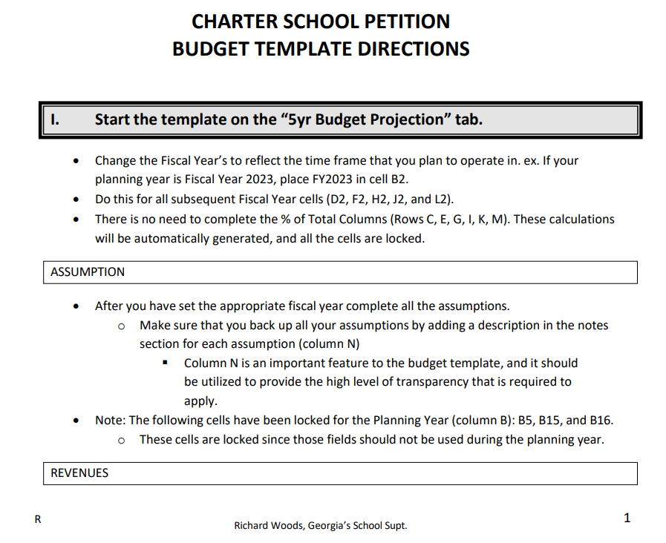
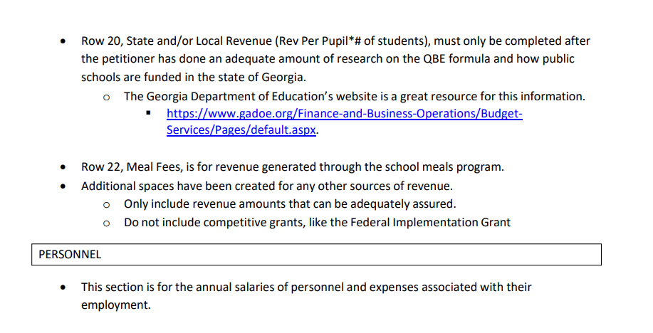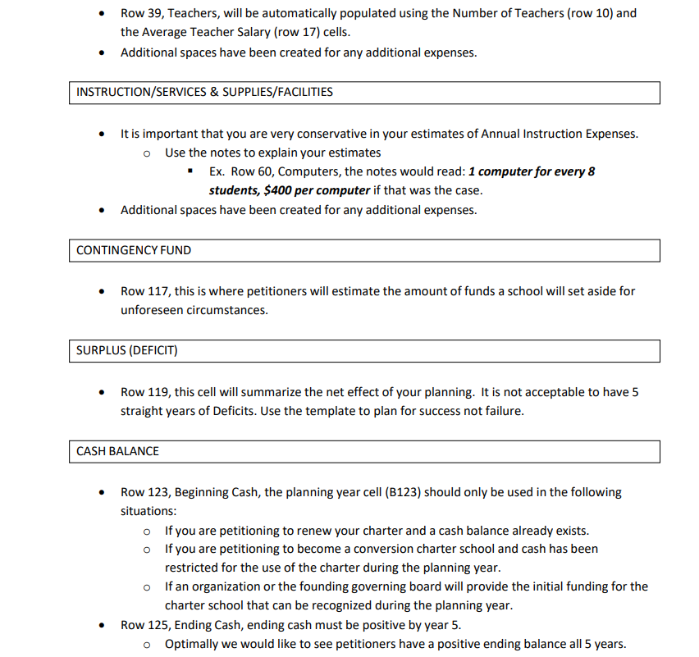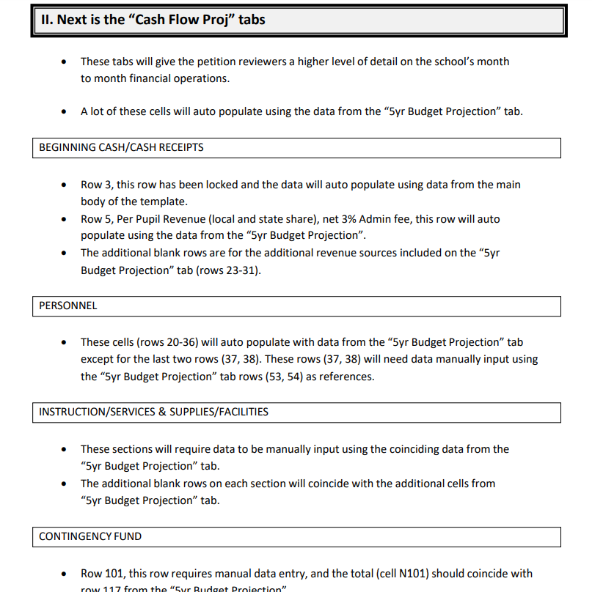
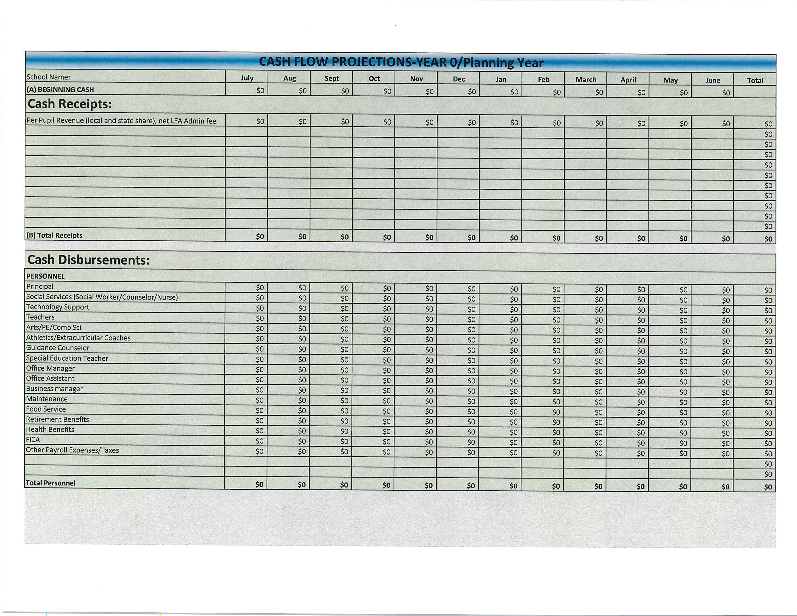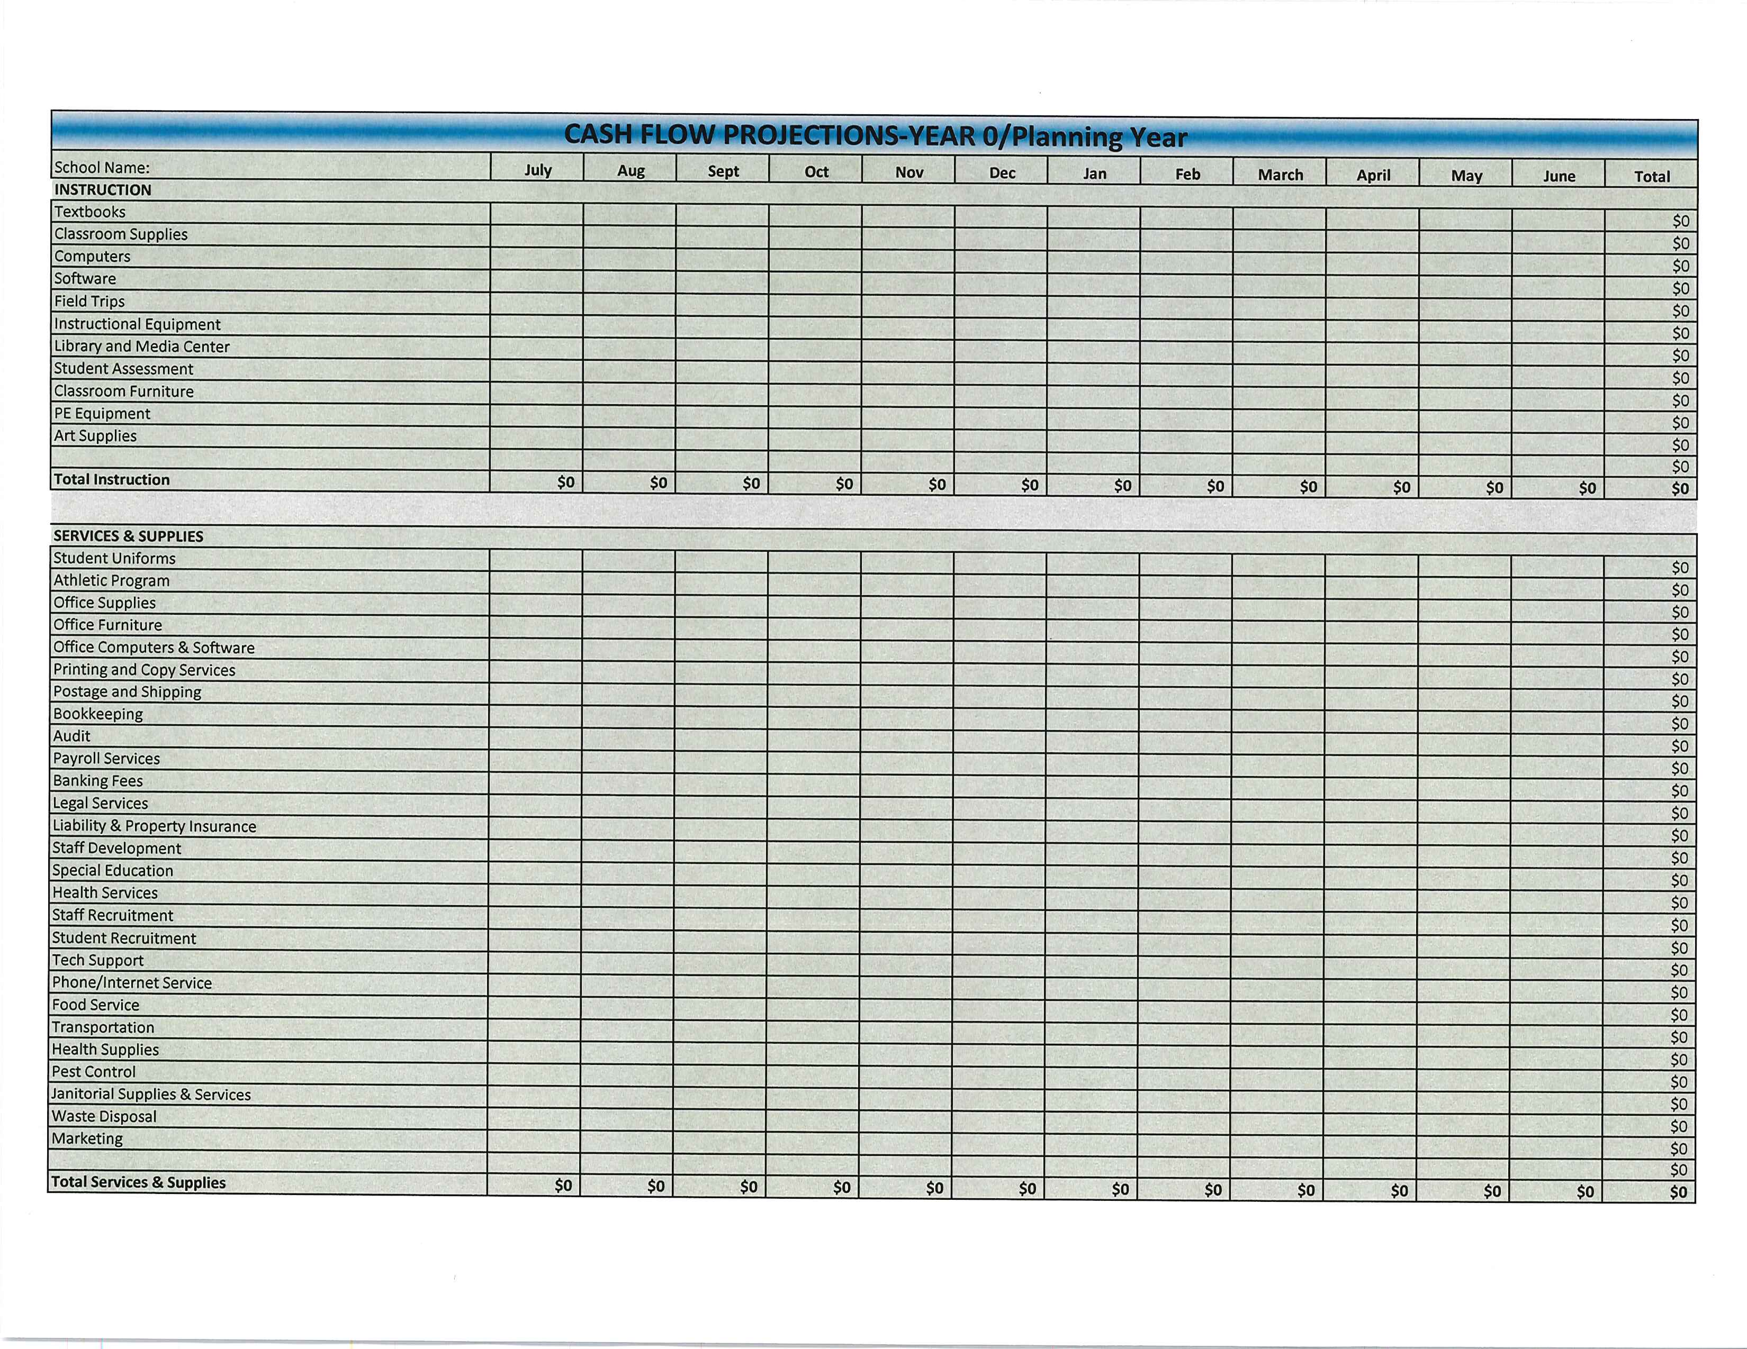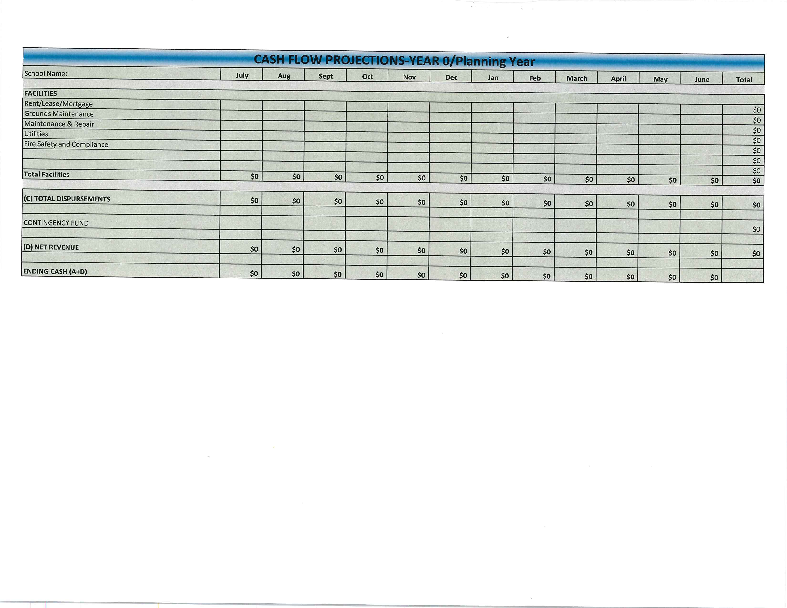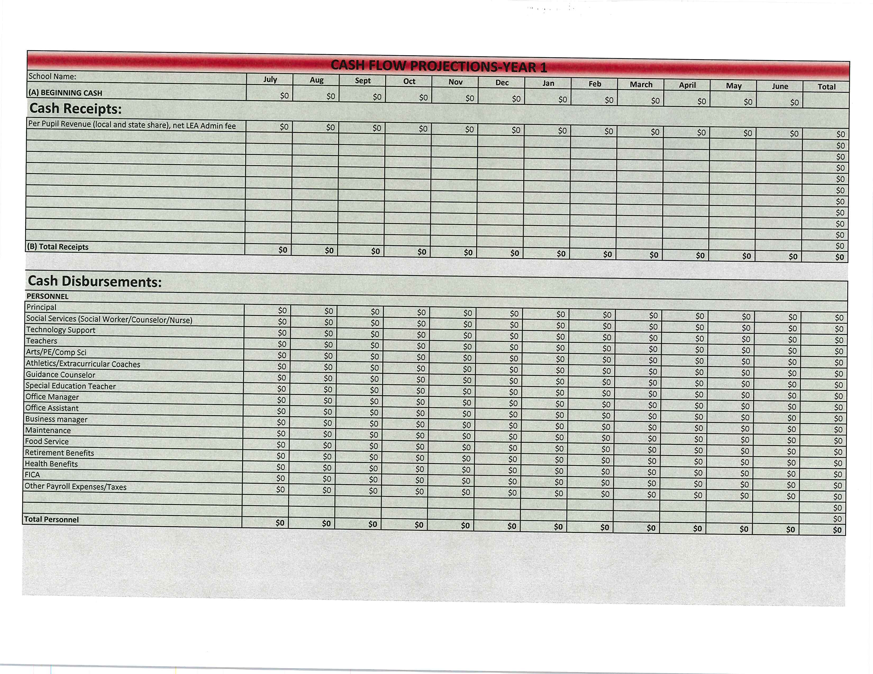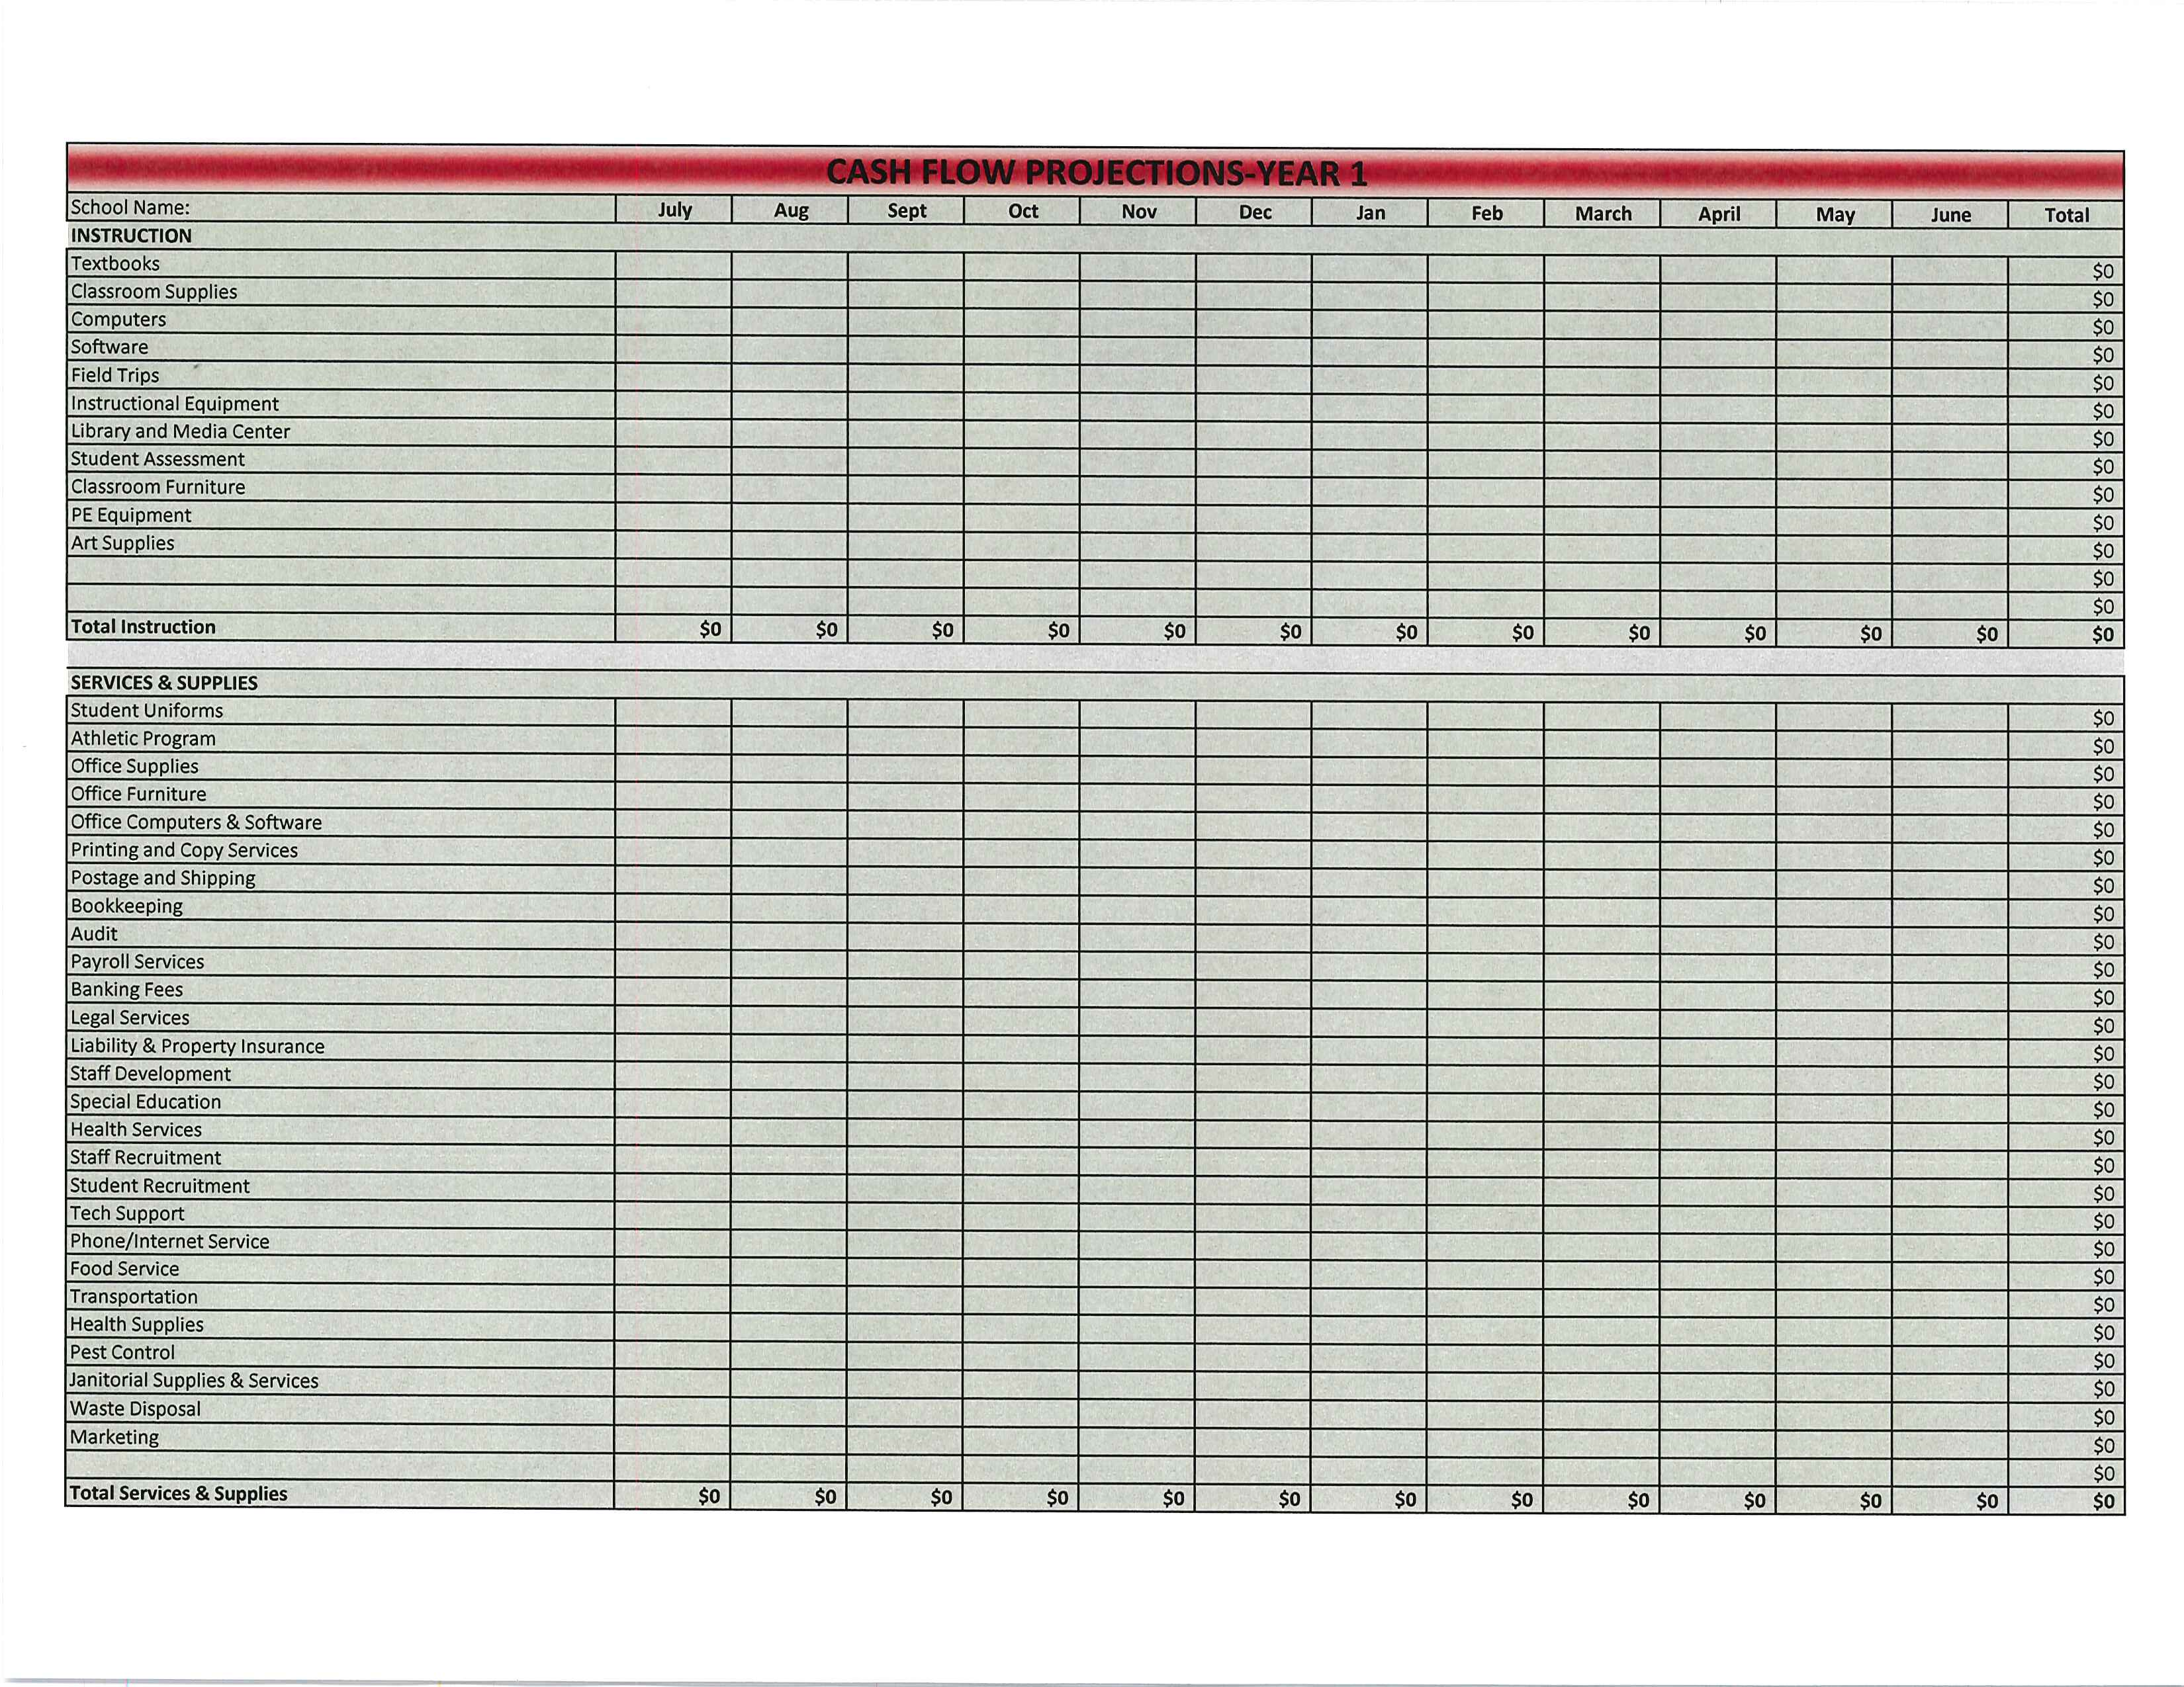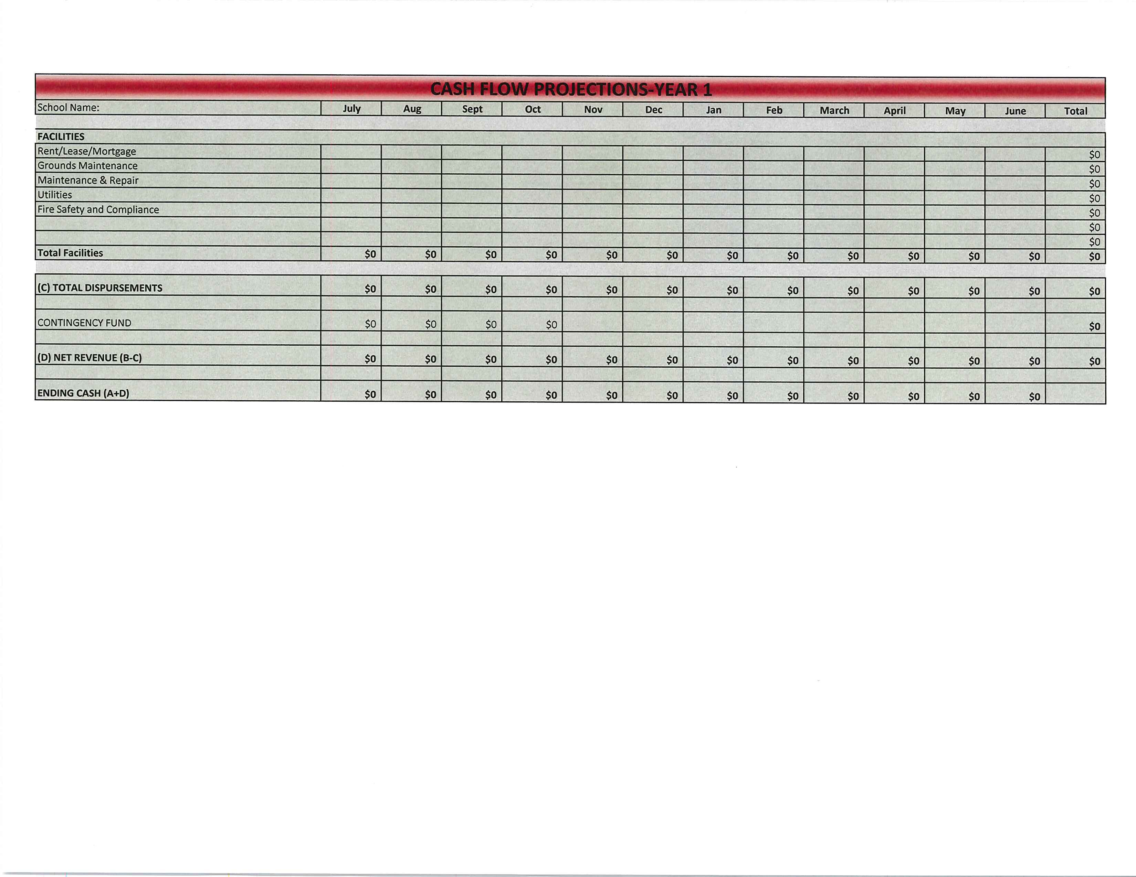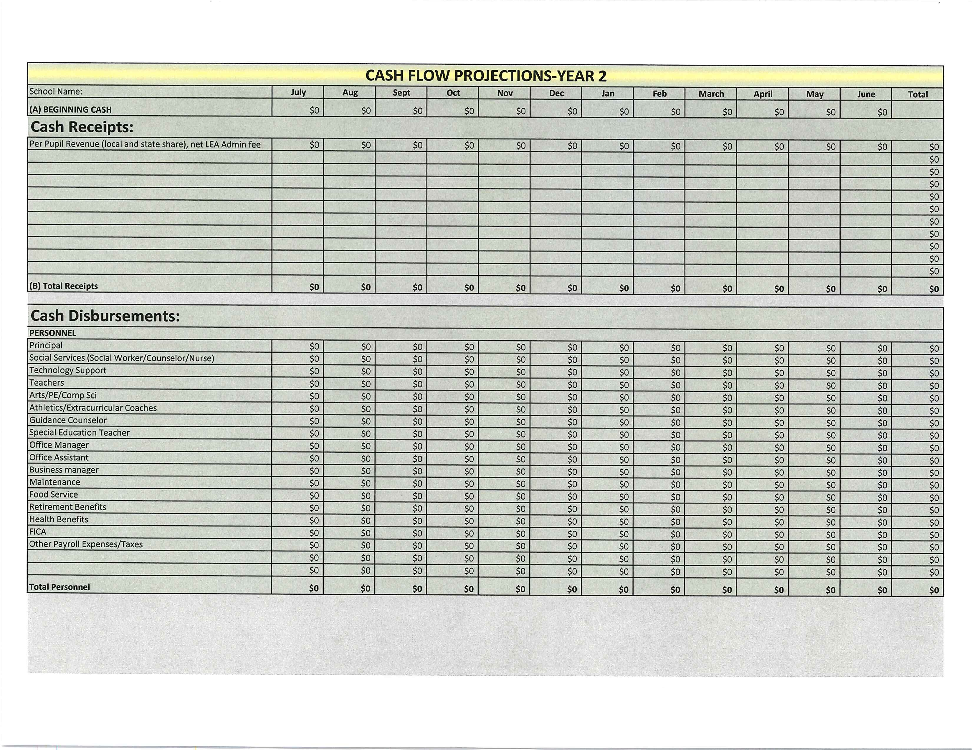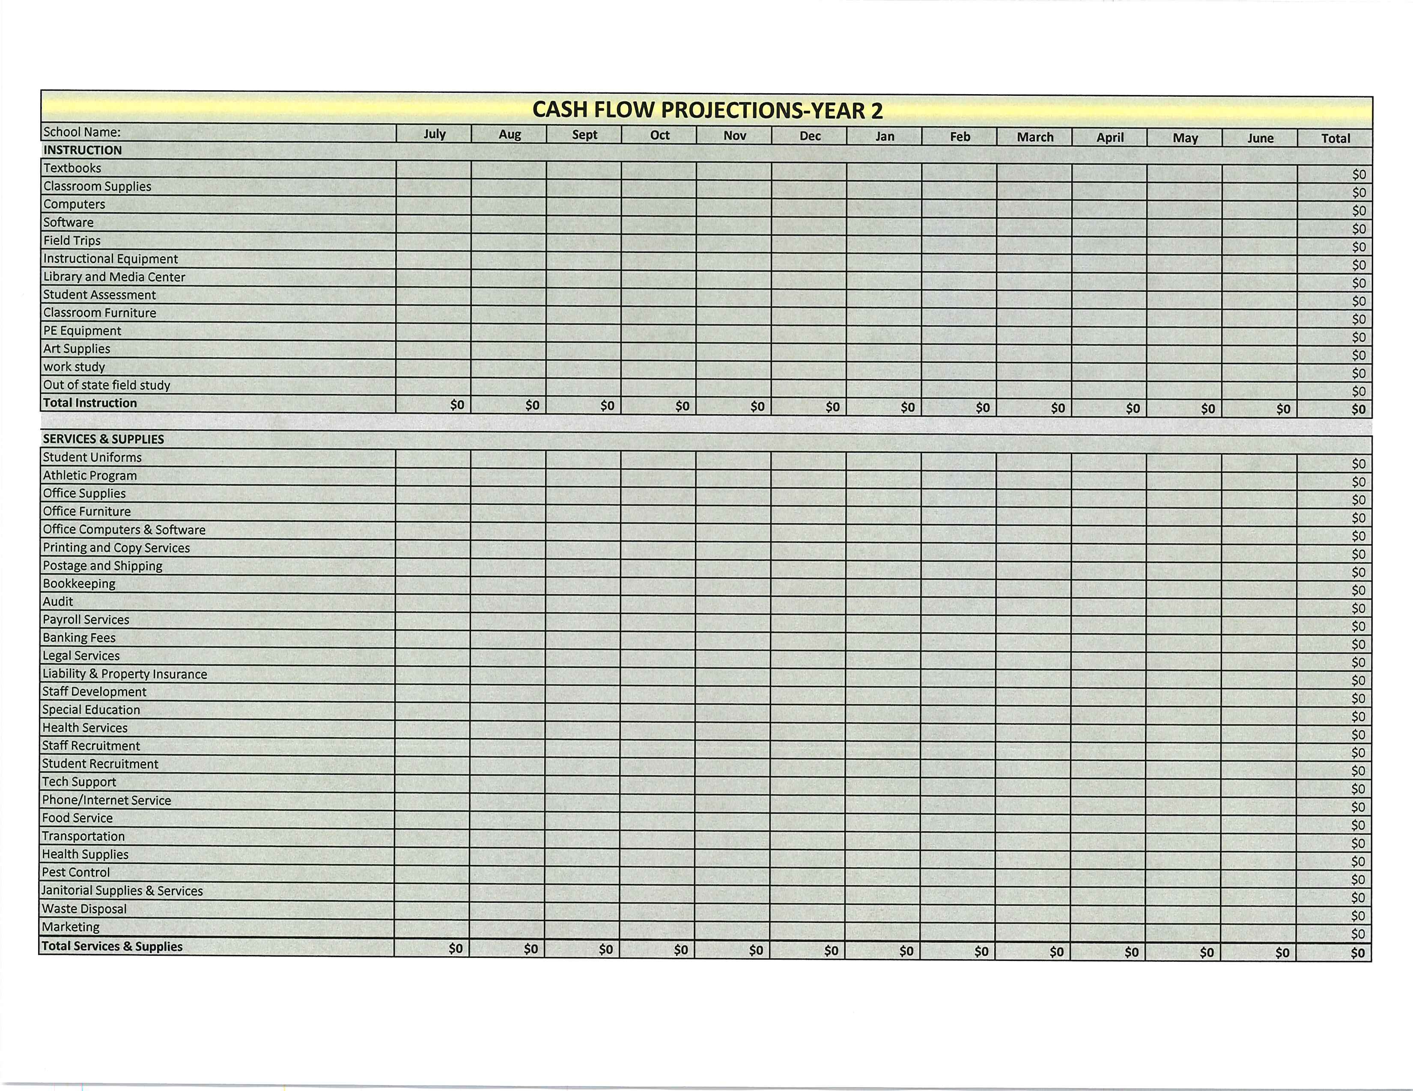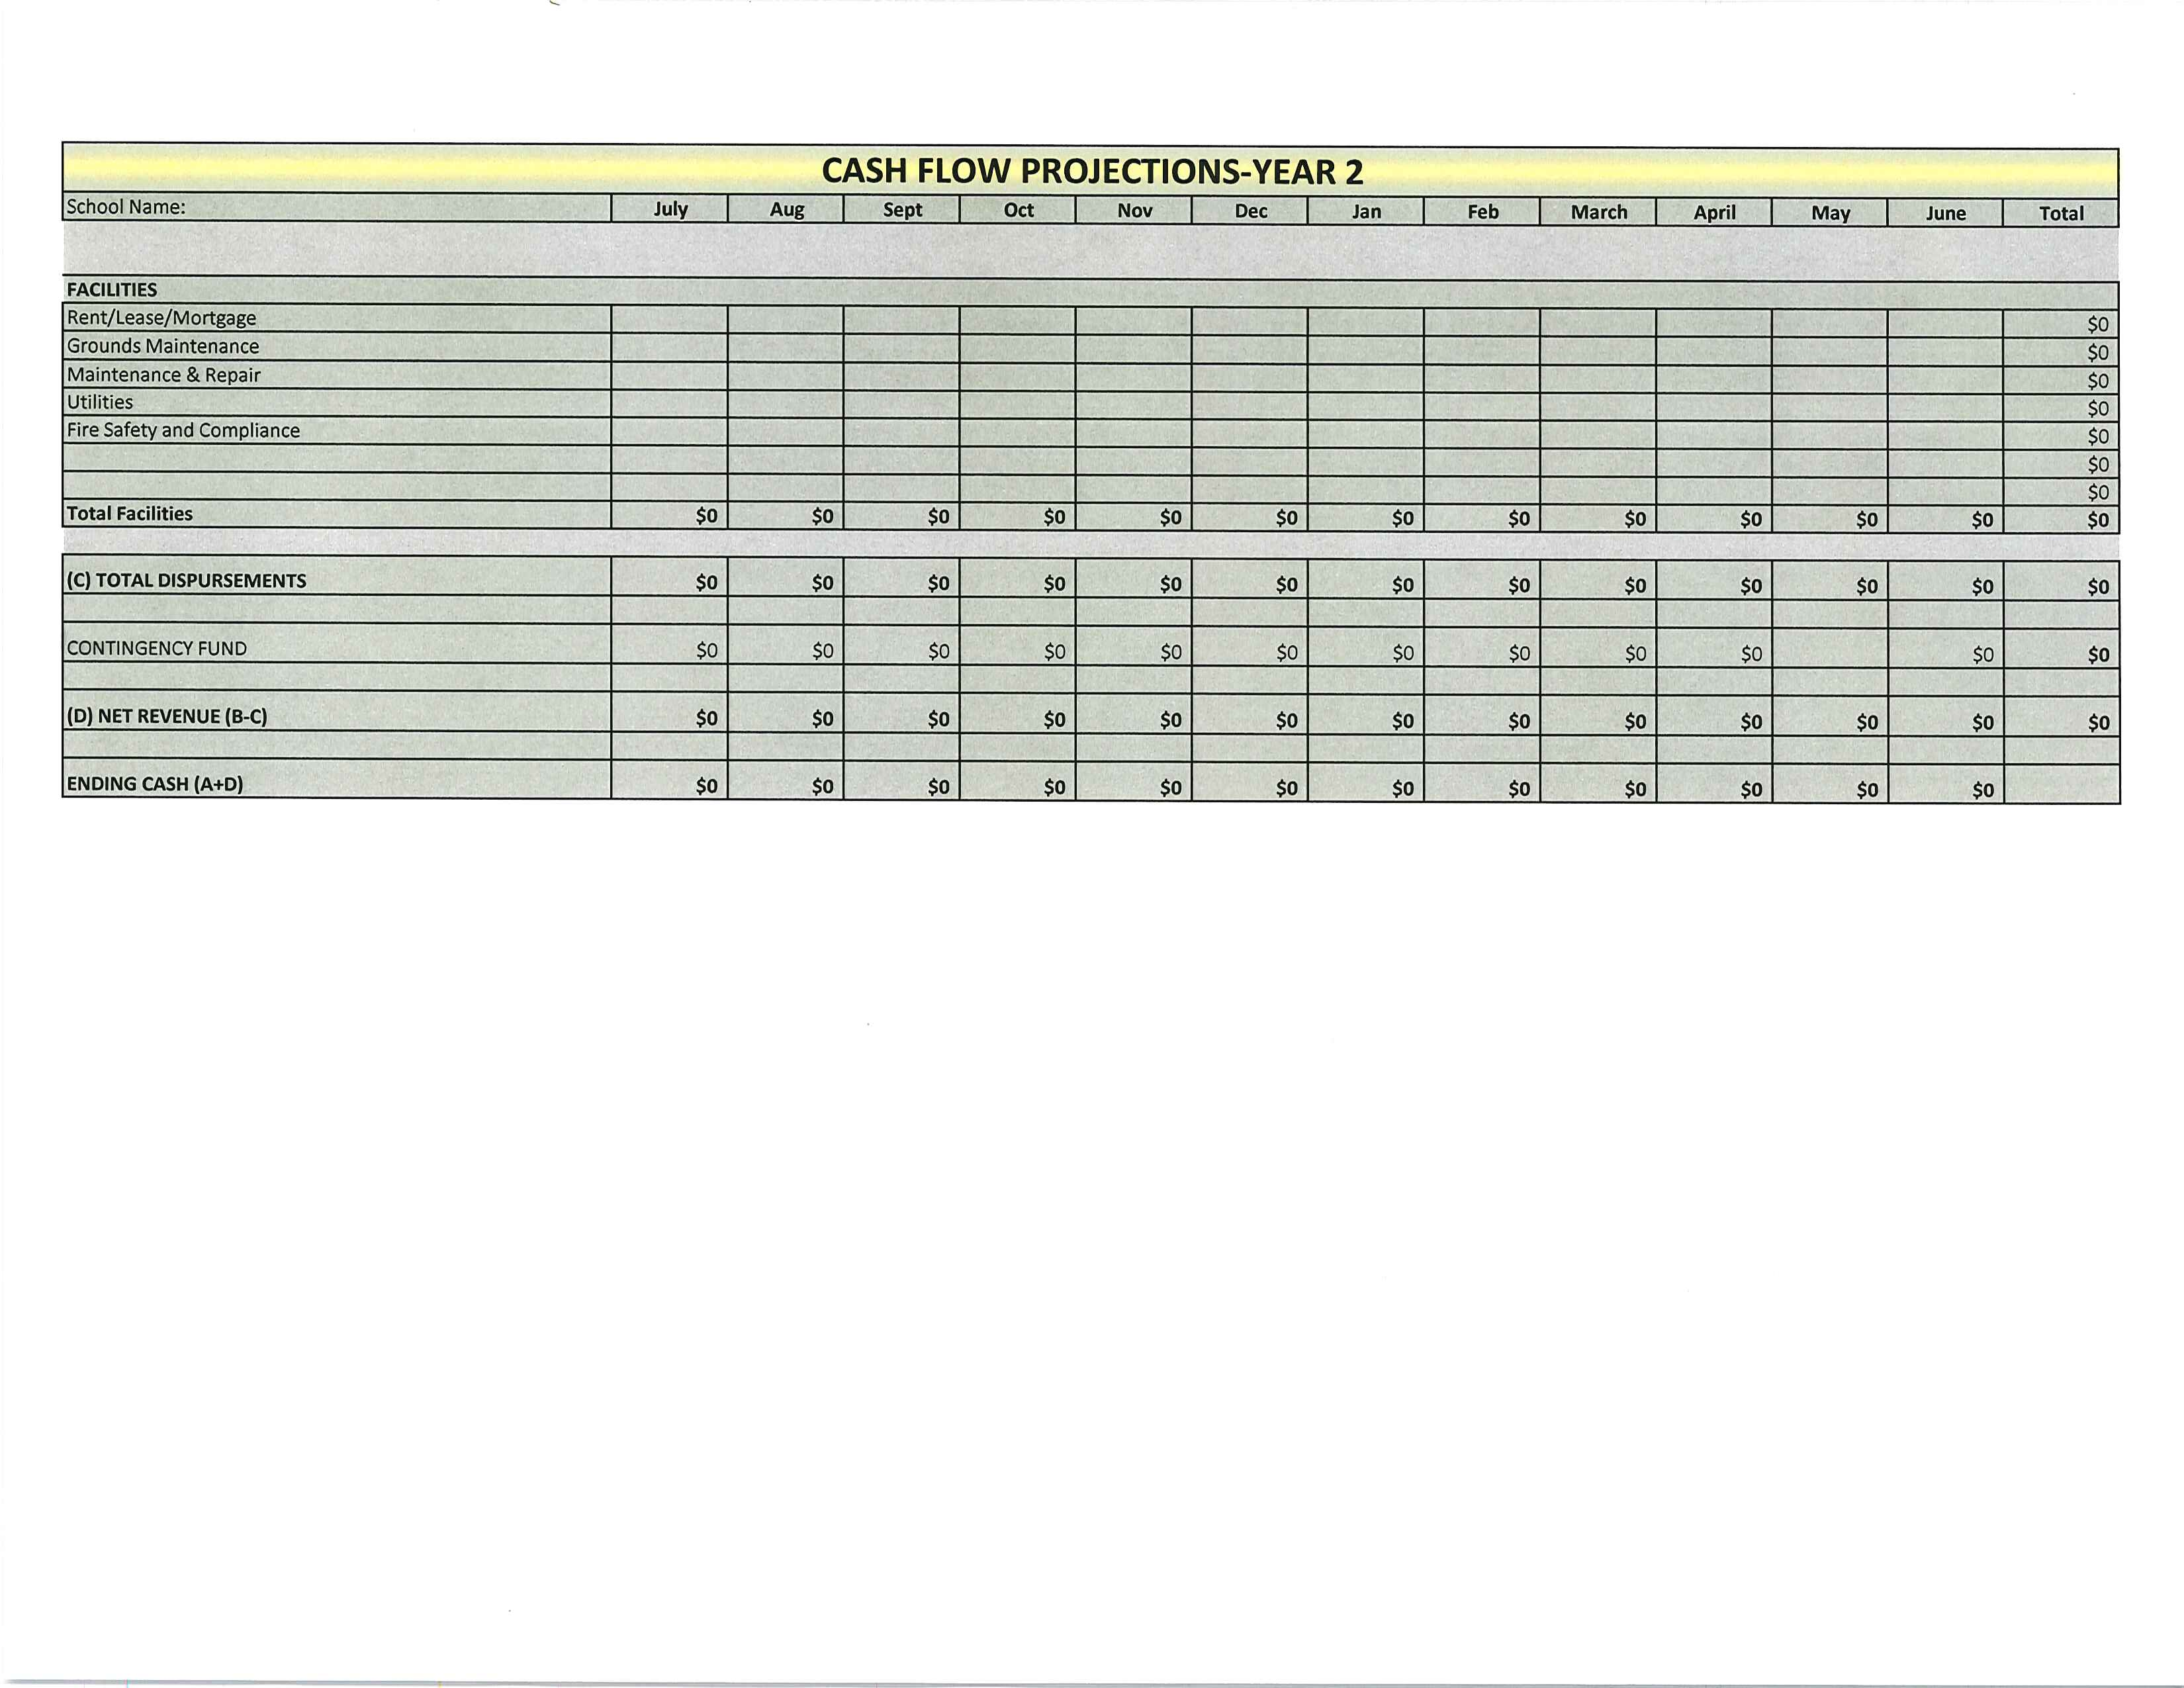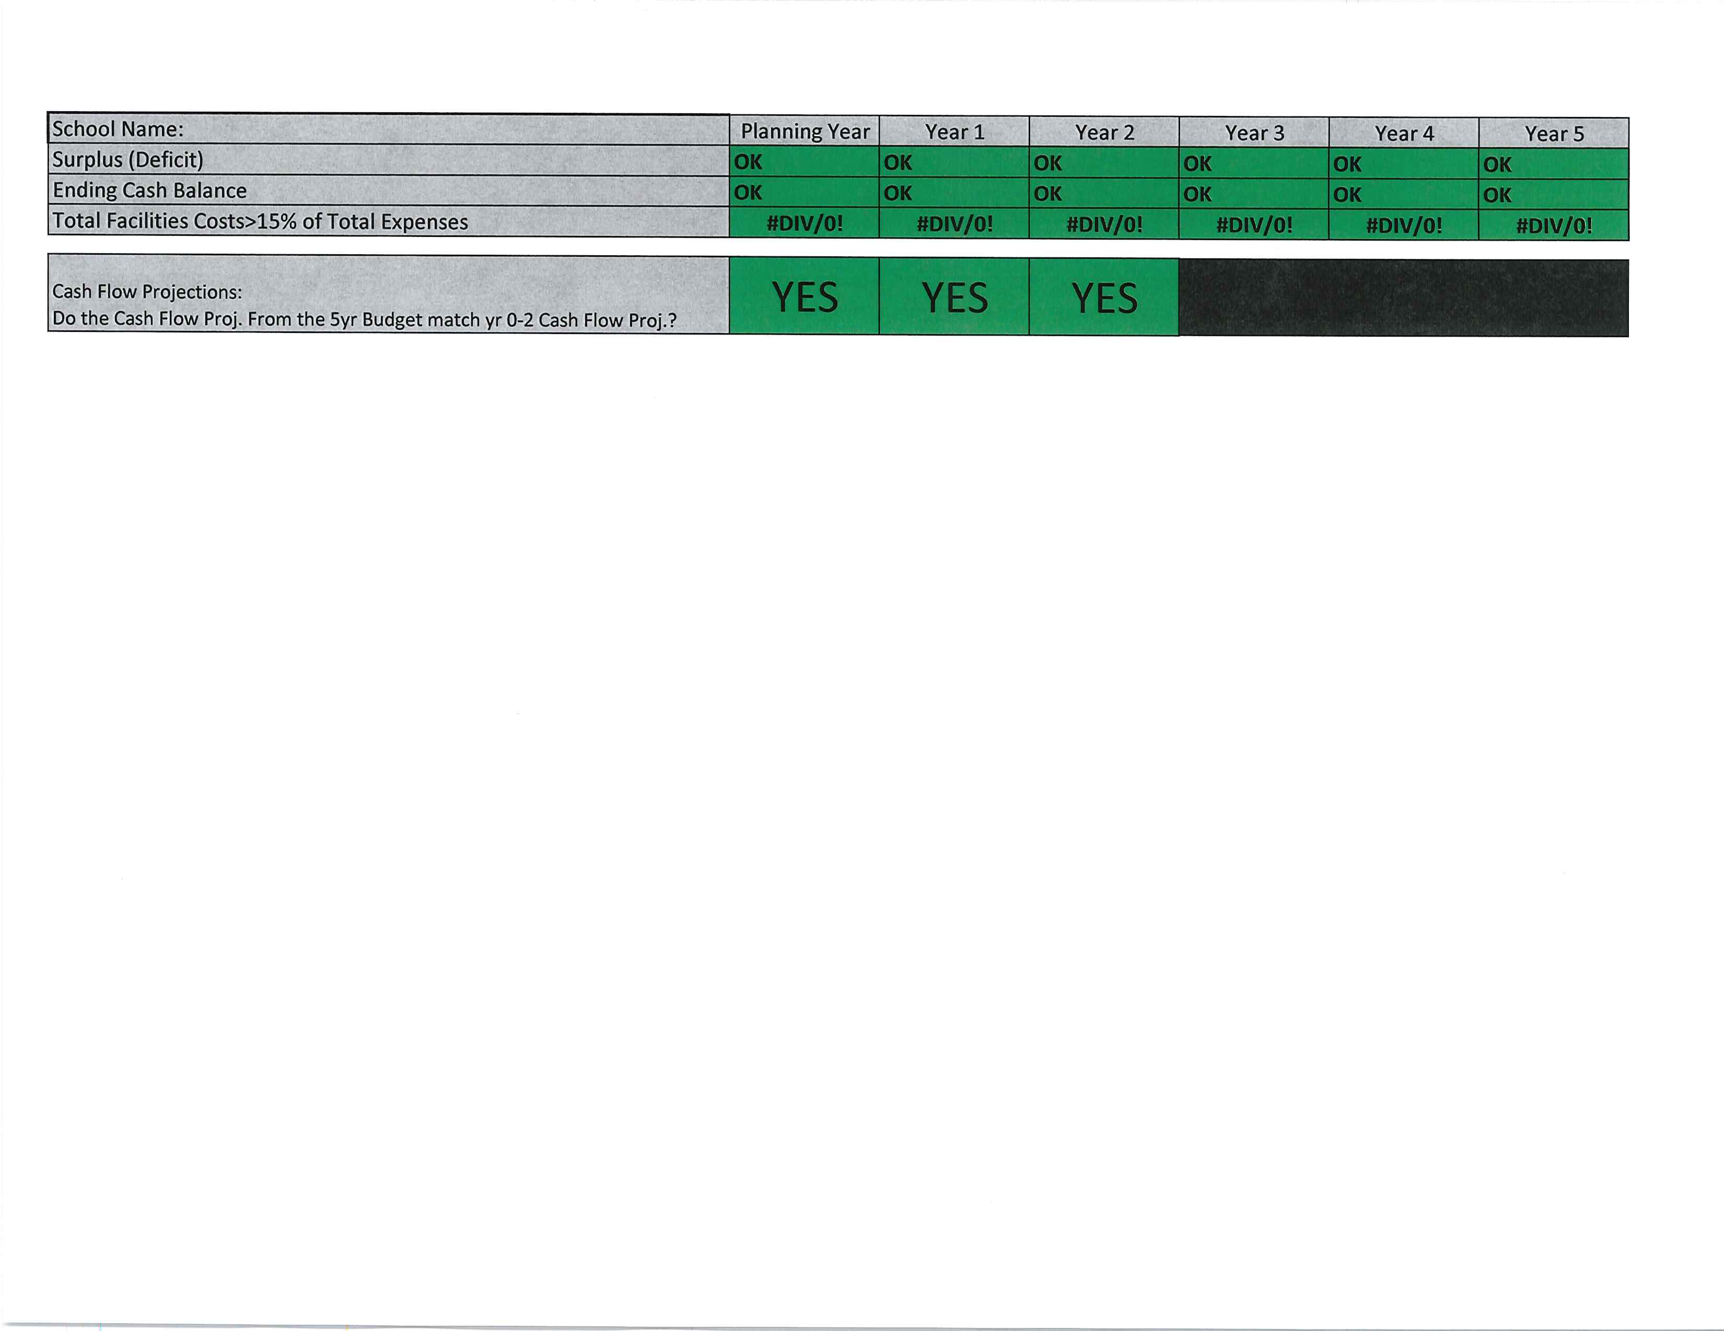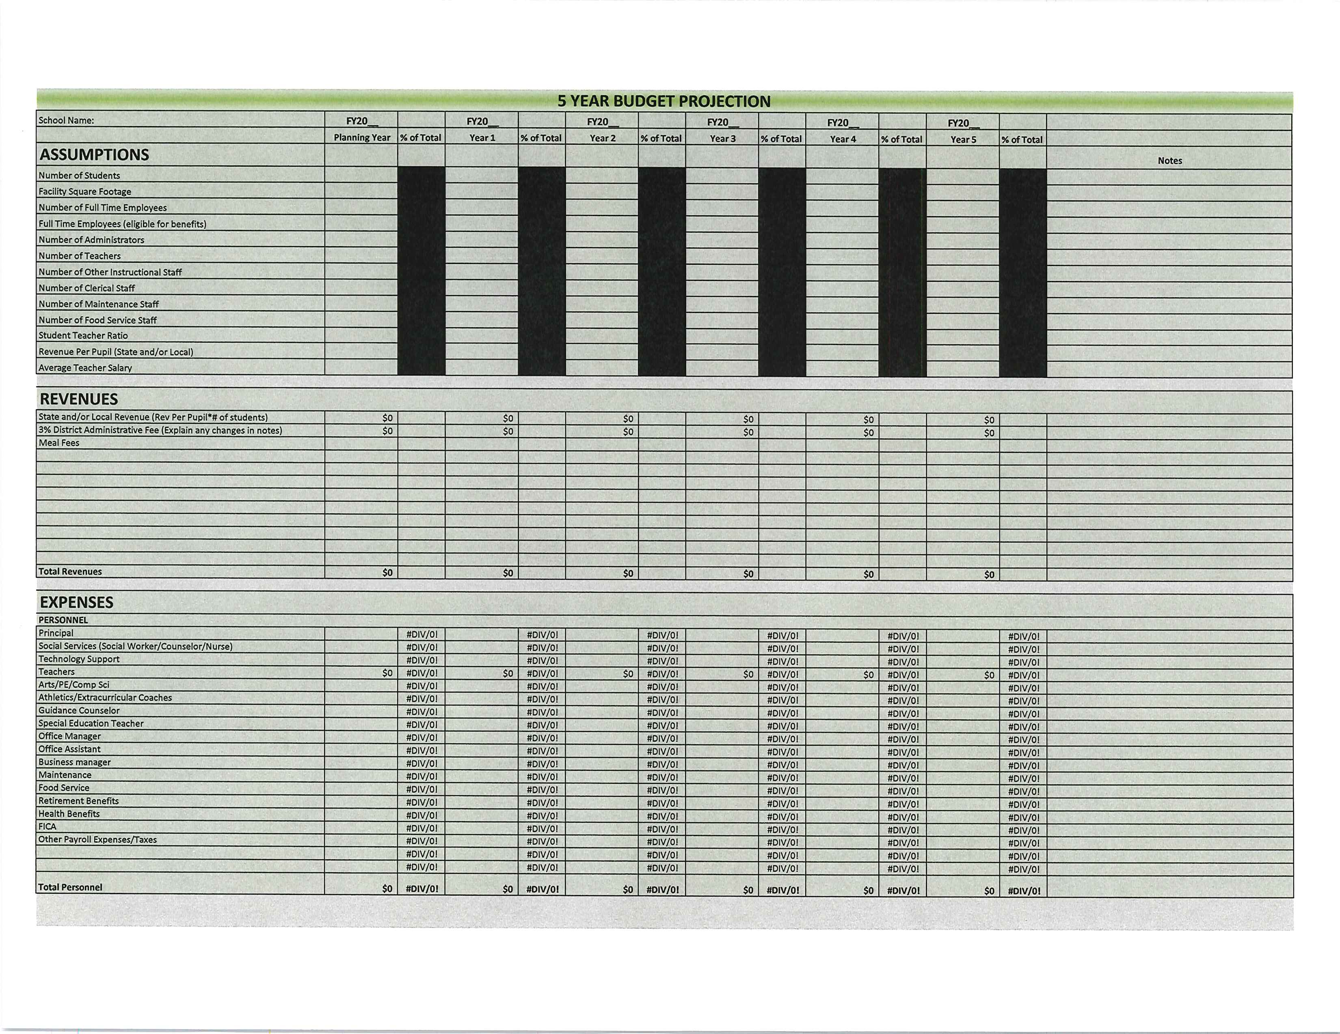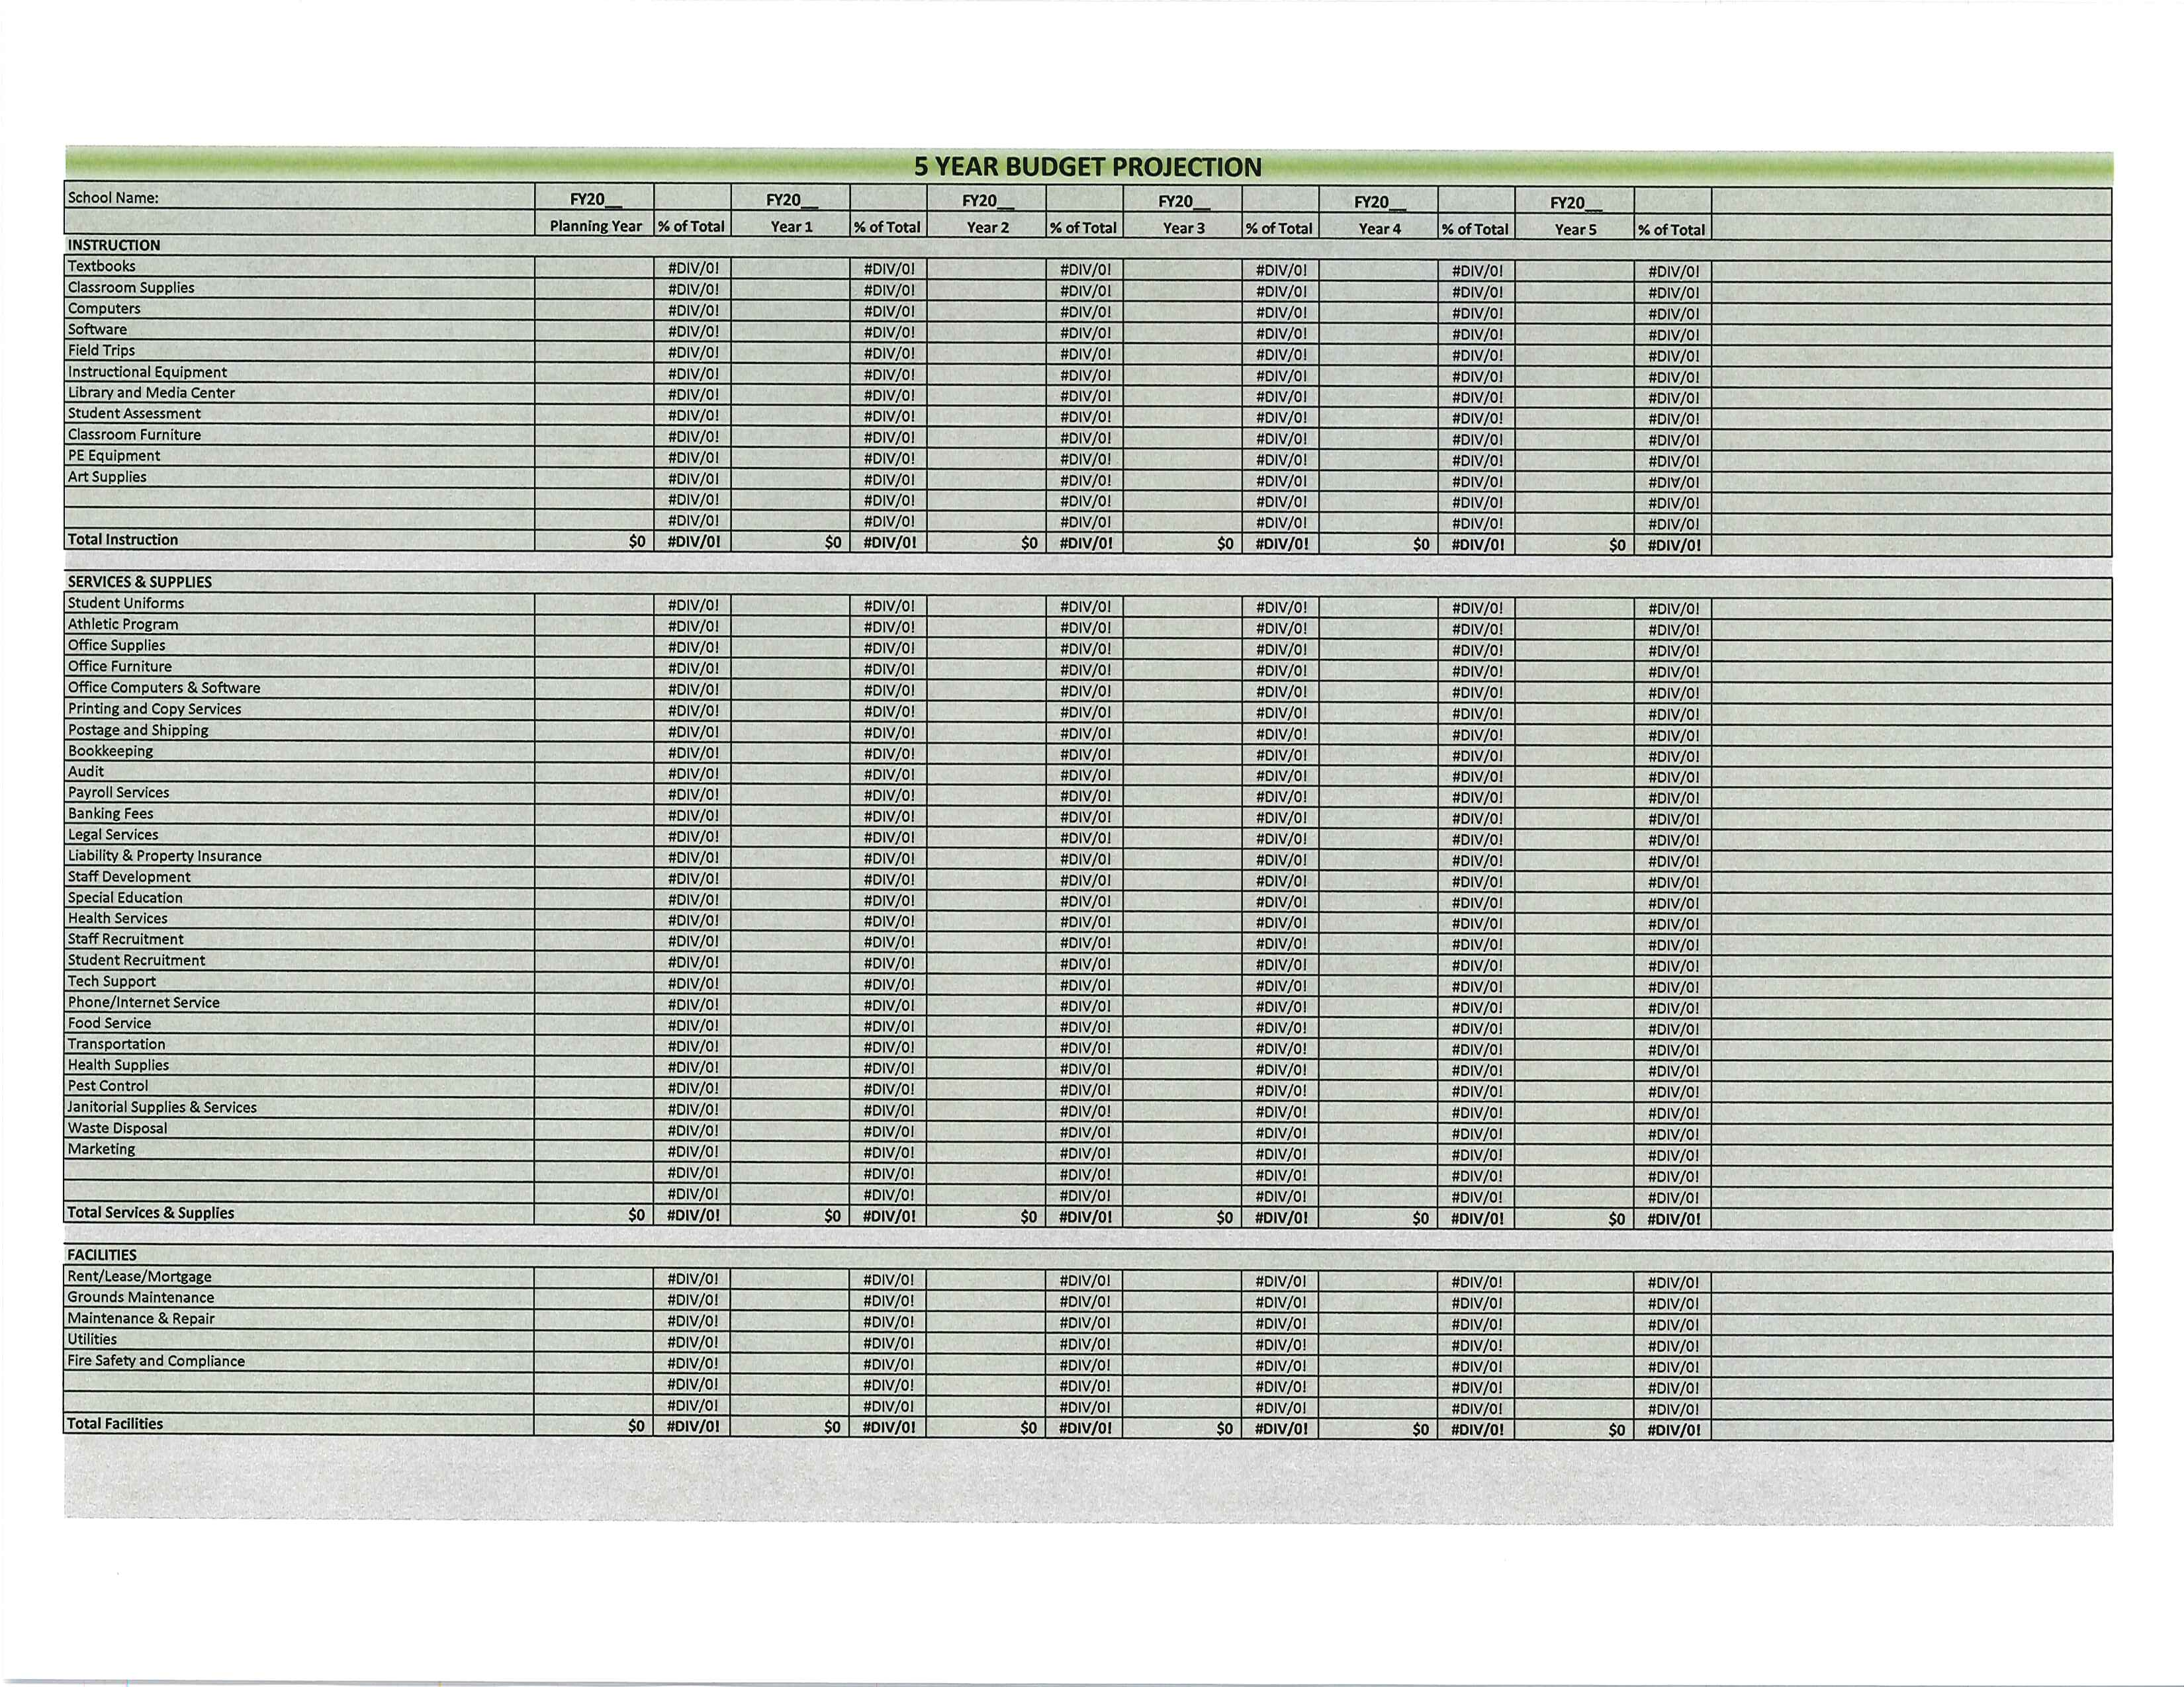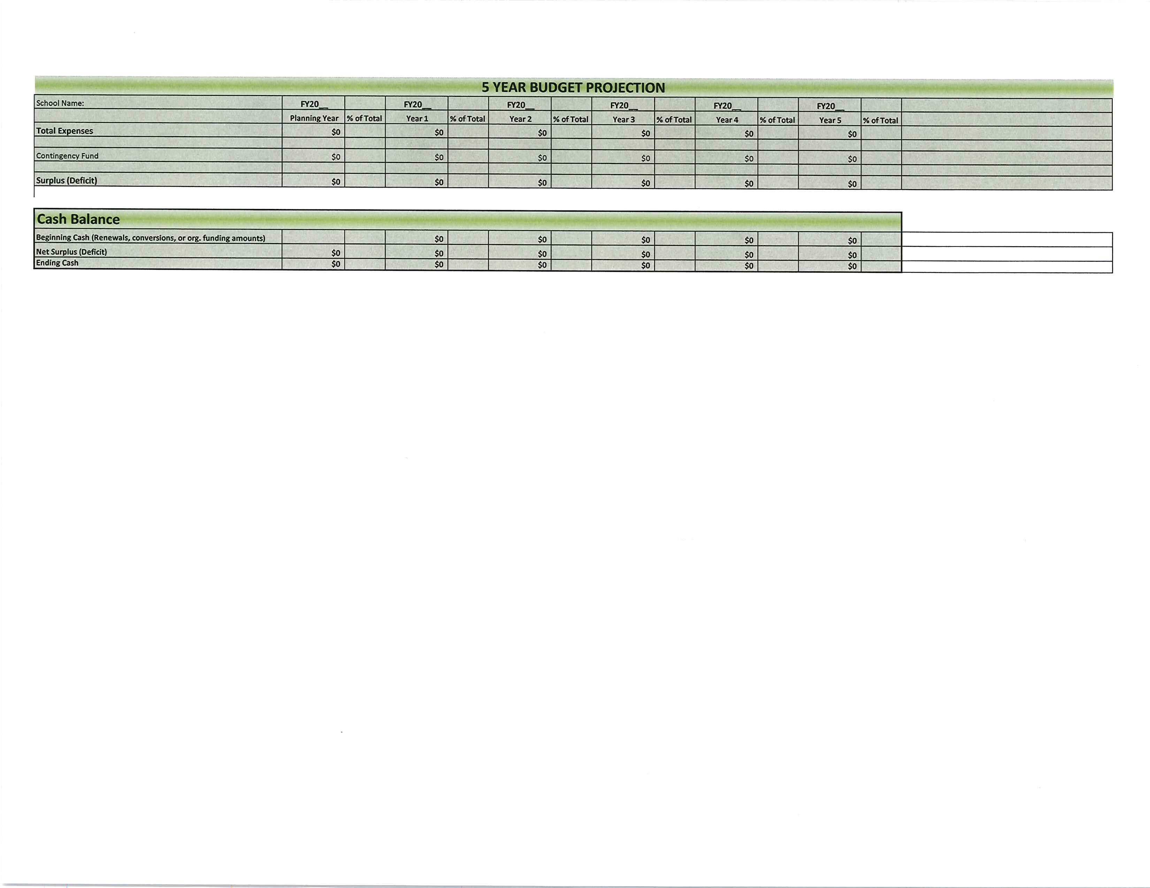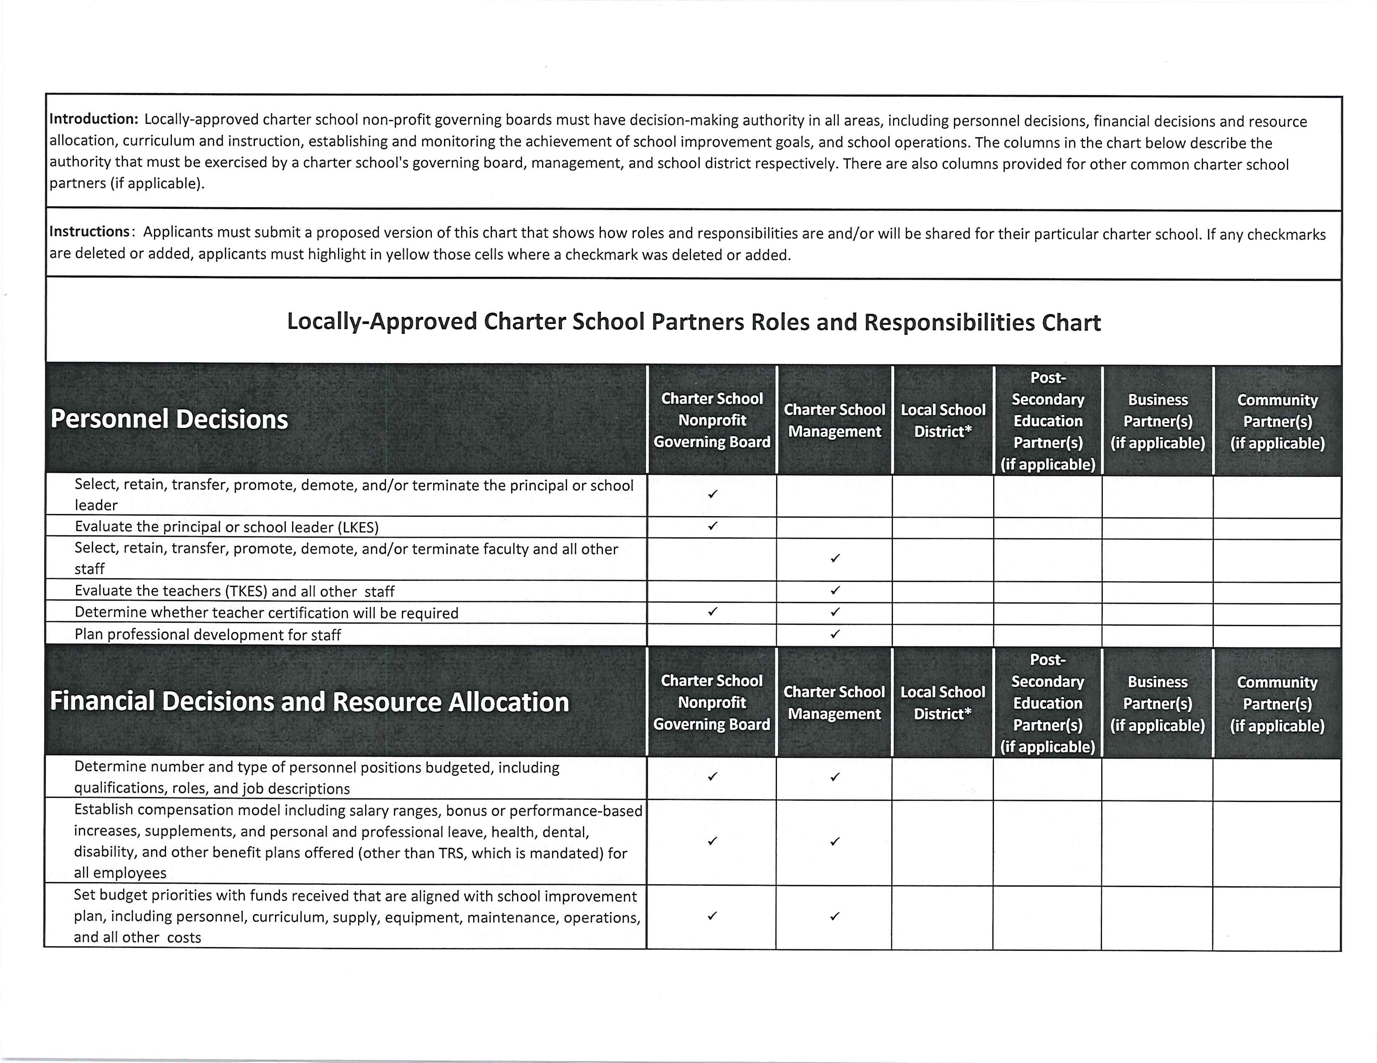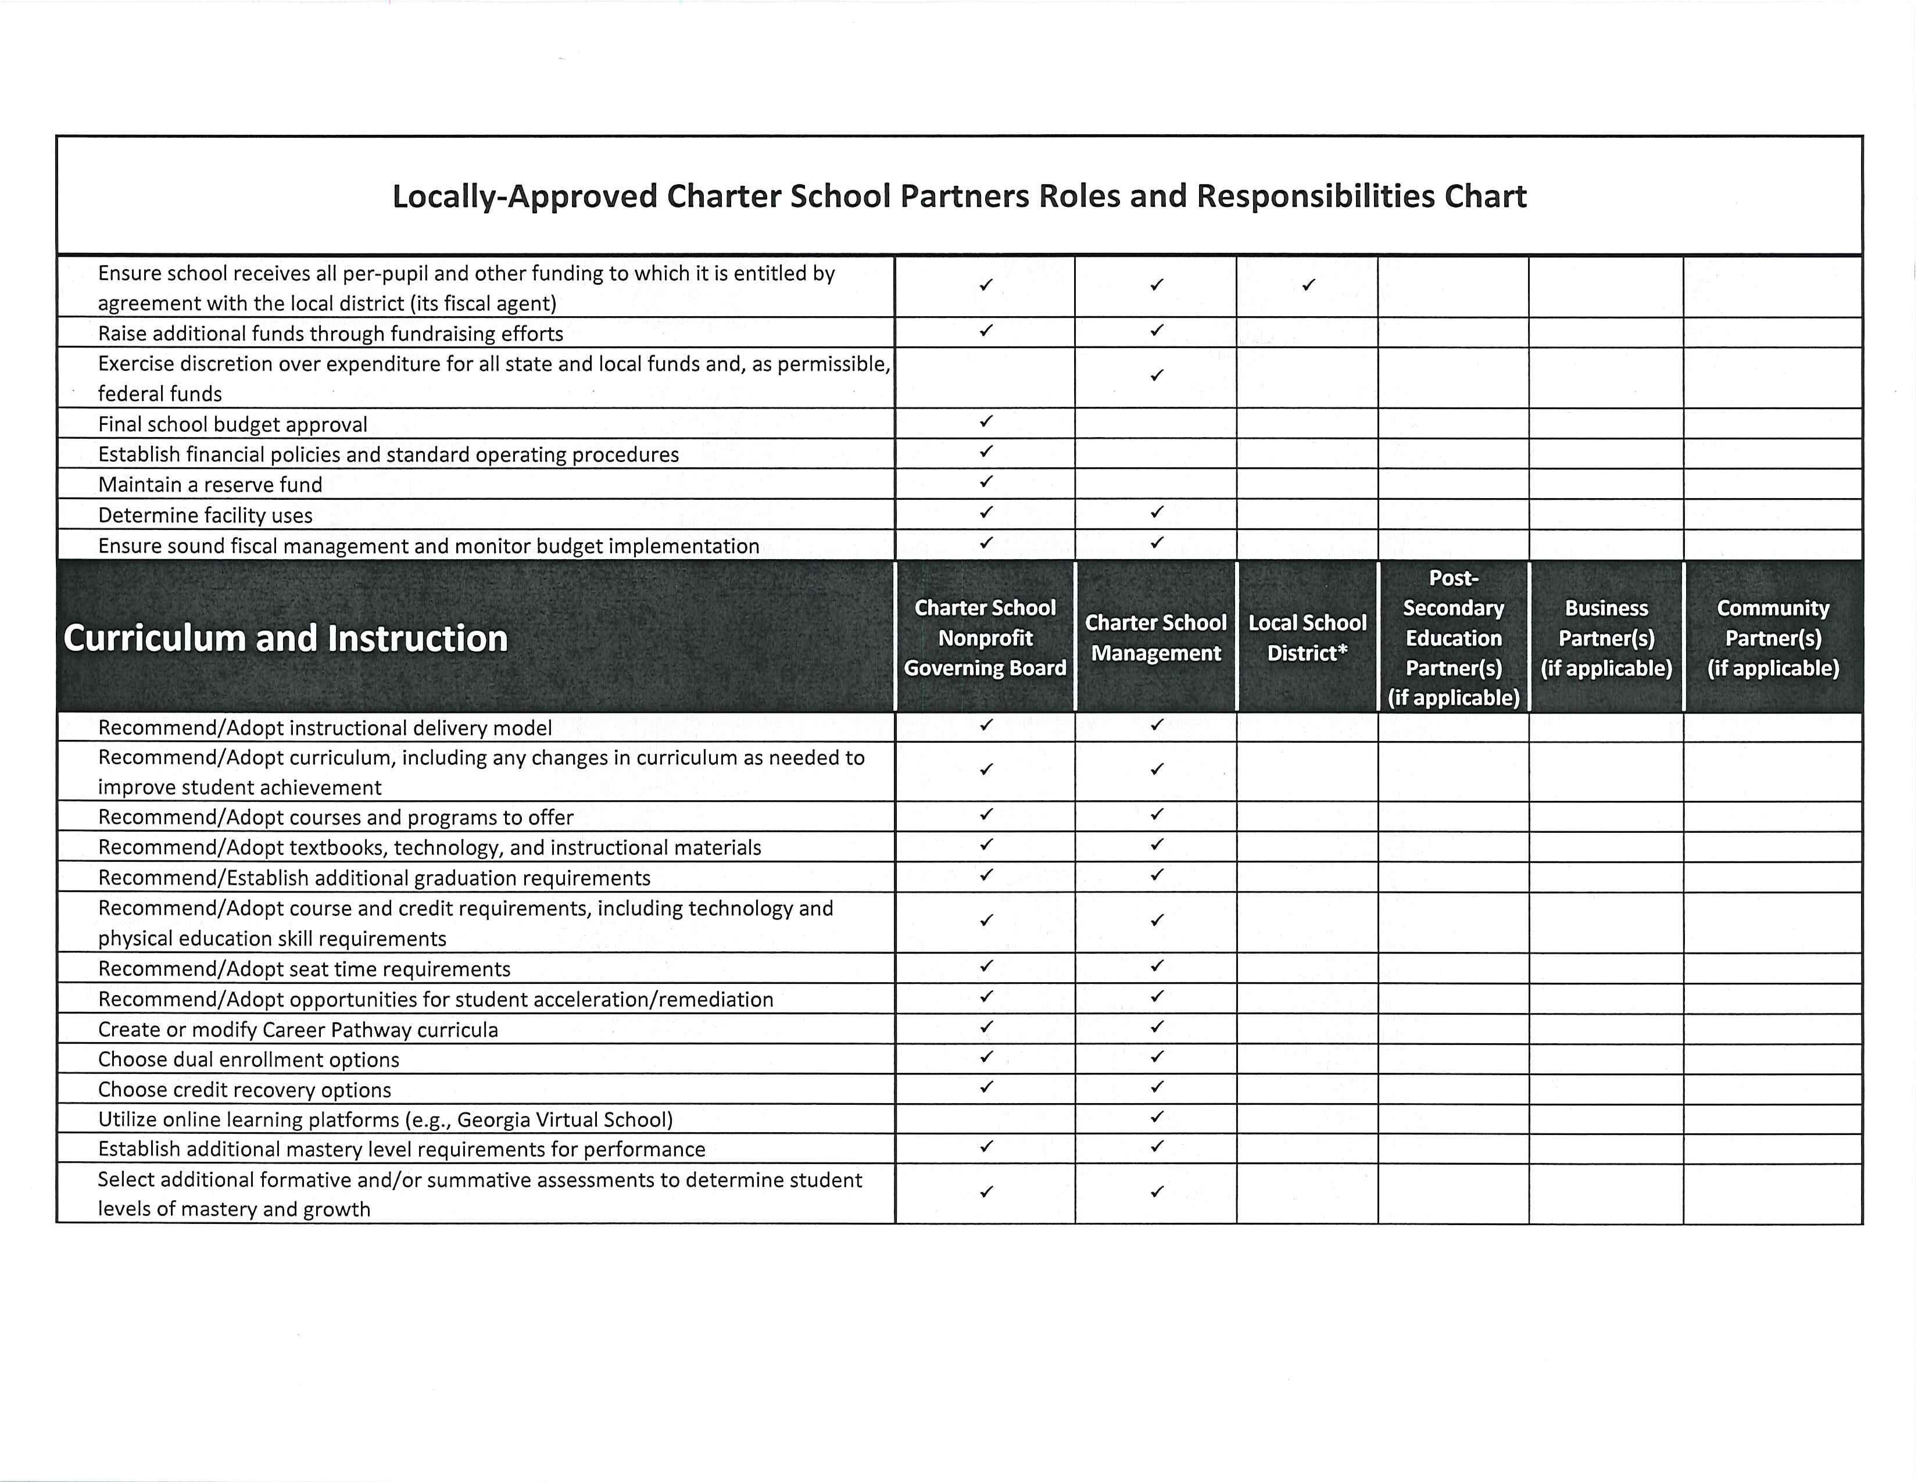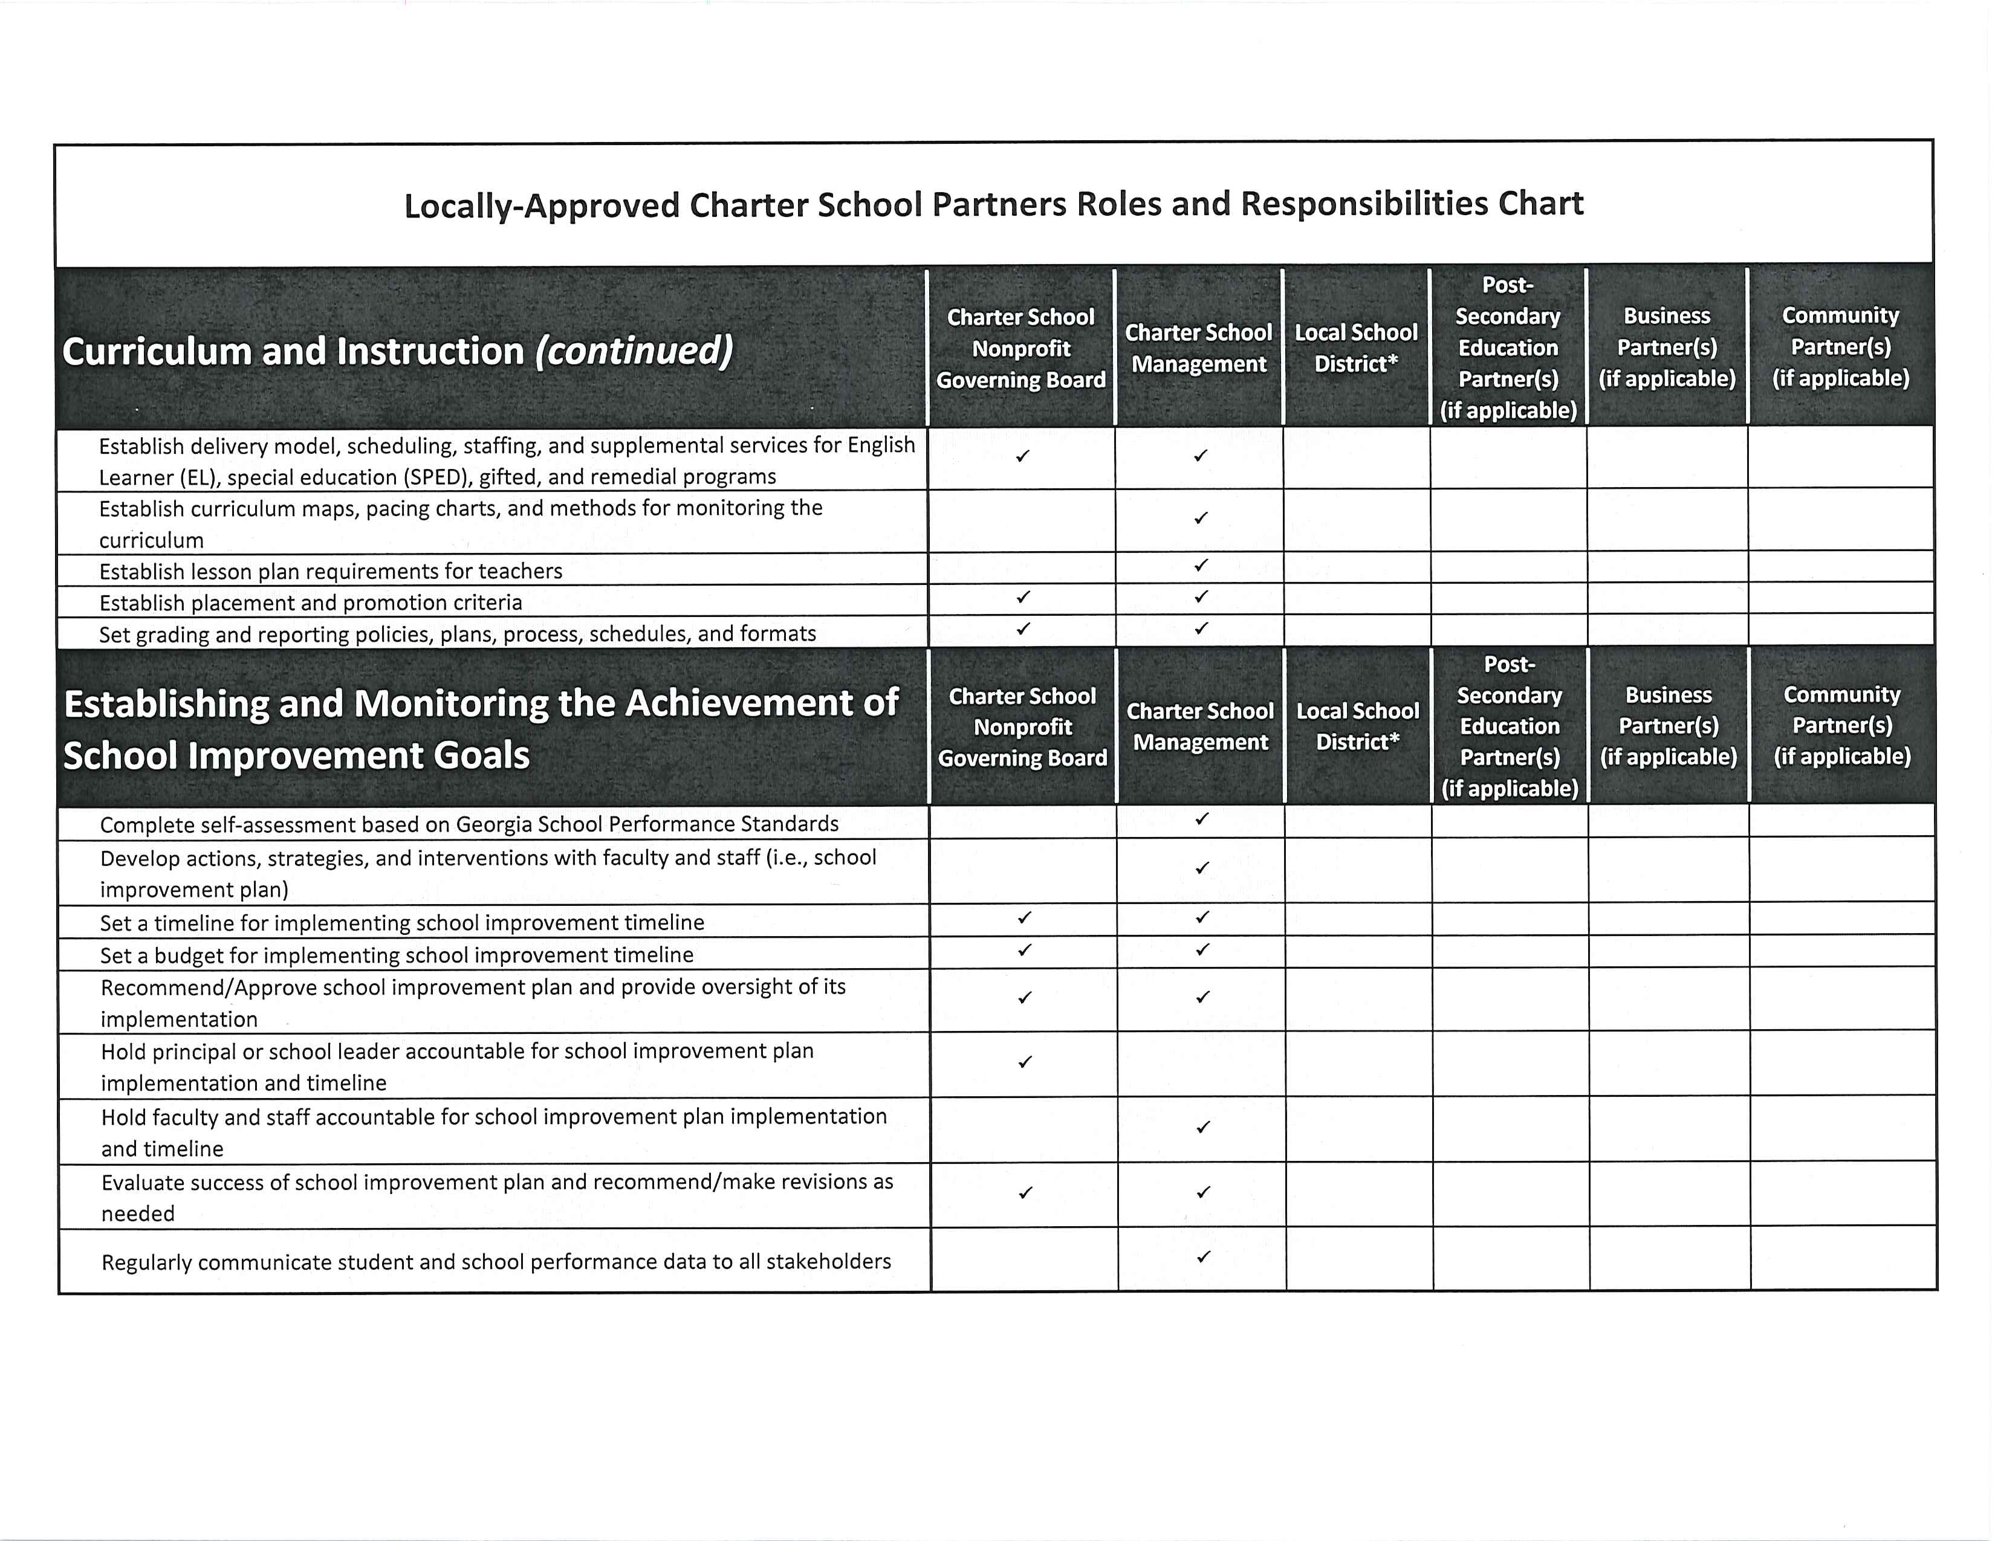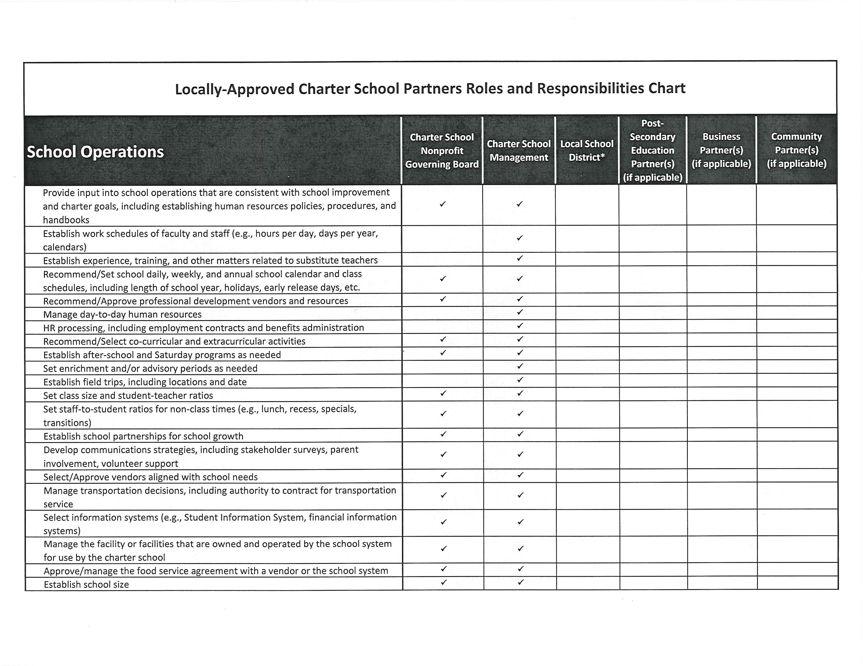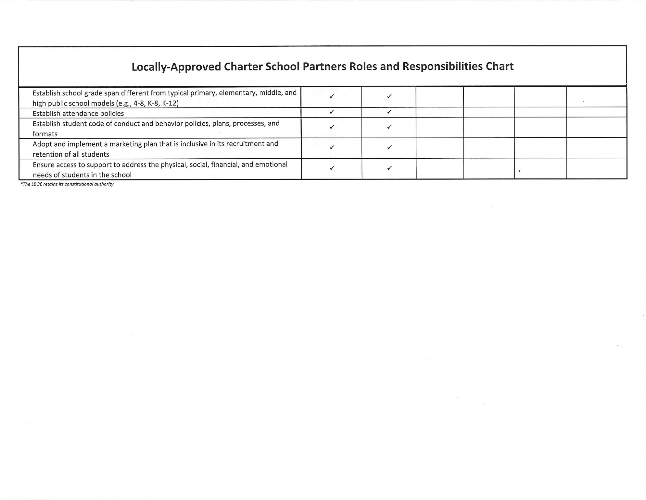
The Roles and Responsibilities Chart should be included in the Petitioner’s Application as Exhibit 6 and can be downloaded from the GA DOE Charter School website under the Application Attachment’s section. Please note instructions provided in the document below.

