Character & Setting

Book title:____________________________________________________________________

Characters:___________________________________________________________________

Setting:________________________________________________________________________

________________________________________________________________________________

Nouns and Verbs

Book Title:__________________________________________________________________

Nouns Verbs

_______________________________ ______________________________

_______________________________ ______________________________

_______________________________ ______________________________

_______________________________ _____________________________

_______________________________ ______________________________

Archeologist Word Dig

(Find little words in archeologist)

A R C H E O L O G I S T

_________________________ _________________________

________________________ _________________________

_________________________ _________________________

_________________________ _________________________

________________________ _________________________

Book Cover

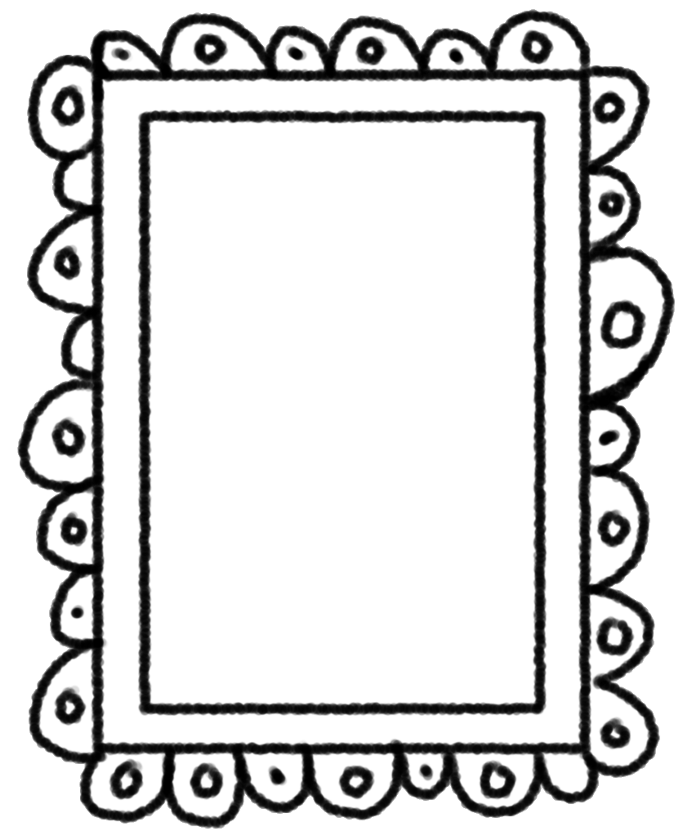

Rainy Day