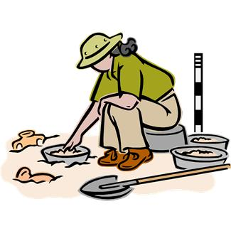Pequea Valley

Elementary Schools’

“Dig Into Summer” Challenge

In an effort to uncover the treasures of learning, we are inviting you to partner with us to help your child “Dig Into Summer.” In an effort to partner with our local library, we have developed our summer activities around their theme of “Dig Into Reading!” To embrace this theme, you will notice many of our activities have an “earthy” feel to them. ☺

Our “Dig Into Summer” Challenge encourages students to read, write, and learn new things throughout the summer. Students will earn various prizes depending on the amount of activities that they complete. Students who earn the Diamond Level prize will be invited on a special after school field trip to Cherry Crest Farm in September. We are very fortunate to once again offer a truly fantastic prize for our winners due to the generosity of a local business.

In order to participate in the challenge, students will complete various activities on the enclosed charts. Parents must initial the activities completed. In addition, students must also complete a designated number of special activities on the chart. Activities that count towards the prizes are marked with an asterisk. The papers that are required to complete the activities are included in this packet. In order to make it easy for you to match the chart with the activity papers, the title on the chart matches the title on the activity sheet.

Students will participate in the challenge from June 8 until August 25. The charts must have parent/adult initials on the activities completed and the selected number of special activities must be returned to school to receive credit. The last page of the charts must also include a parent signature. Charts and special activities are due back to school by Thursday, August 29.



More on reverse side

“Dig Into Summer” Prizes

Three levels of prizes will be awarded:



**Diamond Level** – To earn the highest gemstone level, students must complete at least 40 activities which are marked with parent initials, return 10 special activity sheets and have a parent signature on the last page. Students who earn this level, will be invited to the after school field trip to

Cherry Crest Farm.



**Ruby Level** – To earn the second highest gemstone level, students must complete at least 30 activities which are marked with parent initials, return 5 special activity sheets and have a parent signature on the last page.

Prizes will be announced.



**Emerald Level** – To earn this level, students must complete at least 20 activities which are marked with parent initials, return 5 special activity sheets and have a parent signature on the last page. Prizes will be announced.

**In order to be eligible for prizes, all reading charts and activity sheets must be returned to school by Thursday, August 29. Please return activities in the envelope provided.**

Copies of the Reading Charts and activities can be found online at [www.pequeavalley.org](http://www.pequeavalley.org). Select Paradise from the drop down menu at the top left side of the page. Click Summer Challenge under the shortcuts on the left side of the page.

Thank you for supporting your child’s participation in the “Dig Into Summer” Contest. If you have any questions, please e-mail either

[l](mailto:lannie_blank@pequeavalley.org)

[annie_blank@pequeavalley.org](mailto:lannie_blank@pequeavalley.org) or [marie_johnston@pequeavalley.org](mailto:marie_johnston@pequeavalley.org).

Sincerely,

Annie Blank

Marie Johnston

Reading Teachers