Ruffle Scarf
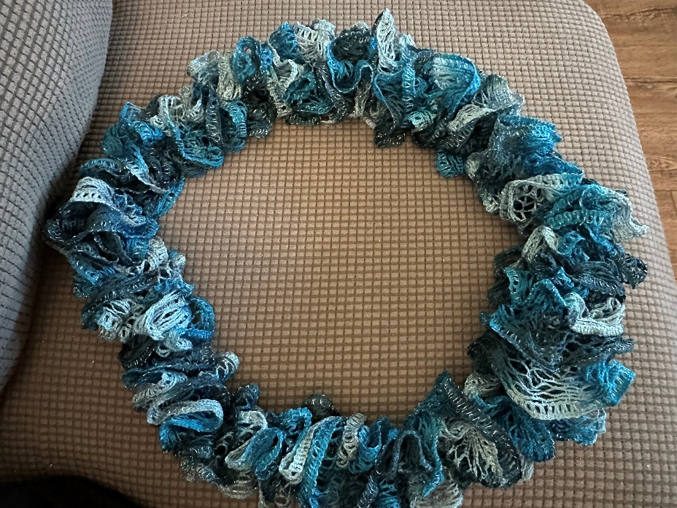
There are several different brands of ruffle yarn. My preferred yarn is Red Heart Sashay. For this project, you would work in the top loops of the yarn. As shown in Image 1. Red Heart Sashay yarn has smaller spaces, so I recommend knitting in every other. For yarn with bigger spaces like Starbella and some German brands, I recommend knitting every space.

Materials: As Shown in Image 2
Red Heart Sashay Yarn
Knitting Needles
Scissors
Tapestry Needle

Note: This makes a longer scarf. Should you like a fuller, shorter scarf then cast on more stitches. Cast on 8 for a medium length or 10 for a shorter length. Gauge is not important for this project. As long as the knitting needles can fit into the spaces, then they will work. Straight or circular doesn’t matter either. This pattern is written for right hand dominant, however, just switch which needles are in which hand to accommodate for left hand dominant.

- Cast on 6 stitches. To cast on, enter from the back to the front in the 5th full space. Note: Normally yarn has the 1st space that has been cut into and therefore it is not counted as a full space. The reason we start in the 5th space is to create a tail that you will tie on step 3 Skip a space and enter from back to front in the next space. Continue in this manner until 6 stitches are on the knitting needle. As shown in Image 3, Image 4, and Image 5.

- Switch the needle with the cast on stitches to your left hand. Note: The rest of the project, insert needle from the front of the stitch. Knit using the top spaces only. To knit, insert right needle into the 1st stitch on the left needle, where the right needle is underneath the left. Using right needle, skip a space and enter from the front into the next space in the skein of yarn. Lift the left needle up and over the right needle. Now that there is a stitch on the right needle, slide the stitch you just knitted into off the left needle. Continue across knitting the other 5 stitches. As shown in Image 6, Image 7, Image 8, Image 9 and Image 10

- Note: Make sure you are always pulling the yarn around and in front of the project otherwise you will have a curly q scarf like an apple peel. For this round, you will tie in the tail. Skip a space and insert the right needle into the tail from the front and then into the leading yarn like normal. Knit both together. Do this for the rest of the tail and the knit like normal once the tail is tied in. As Shown in Image 11 and Image 12.

- Repeat step 2, continue knitting until you have enough yarn to knit 1 last round plus a 1.5 - 2 inch tail. Note: If your yarn is super twisted, put a knitting needle cap on it and let the scarf dangle in the air as you start from the skein of yarn and run your fingers through the yarn headed to the scarf. It will unwind itself. Do this as many times as you need to. As shown in Image 13, Image 14 and Image 15.

- To cast off, knit the first 2 stitches like normal. Using the tip of the left needle, pull only the bottom stitch on the right needle, over the right needle. Leaving one stitch still on the right needle, knit the next stitch on the like normal. Now that there are 2 stitches on the right needle, pull the bottom stitch over the needle. Repeat in this manner until 1 stitch remains on the right needle. As shown in Image 16, Image 17, Image 18, and Image 19

- Pull the tail through the last stitch and tie a tight knot very close to the stitches. Trim the tail leaving a little bit attached. Tuck the knot with the small tail into the stiches, weaving it through it once or twice. When the scarf hangs, you wont be able to see it. As shown in Image 20 and Image 21.

- Weave the tail of the scarf from the beginning up into the stiches as well so you can’t see the cut end.

Image 1
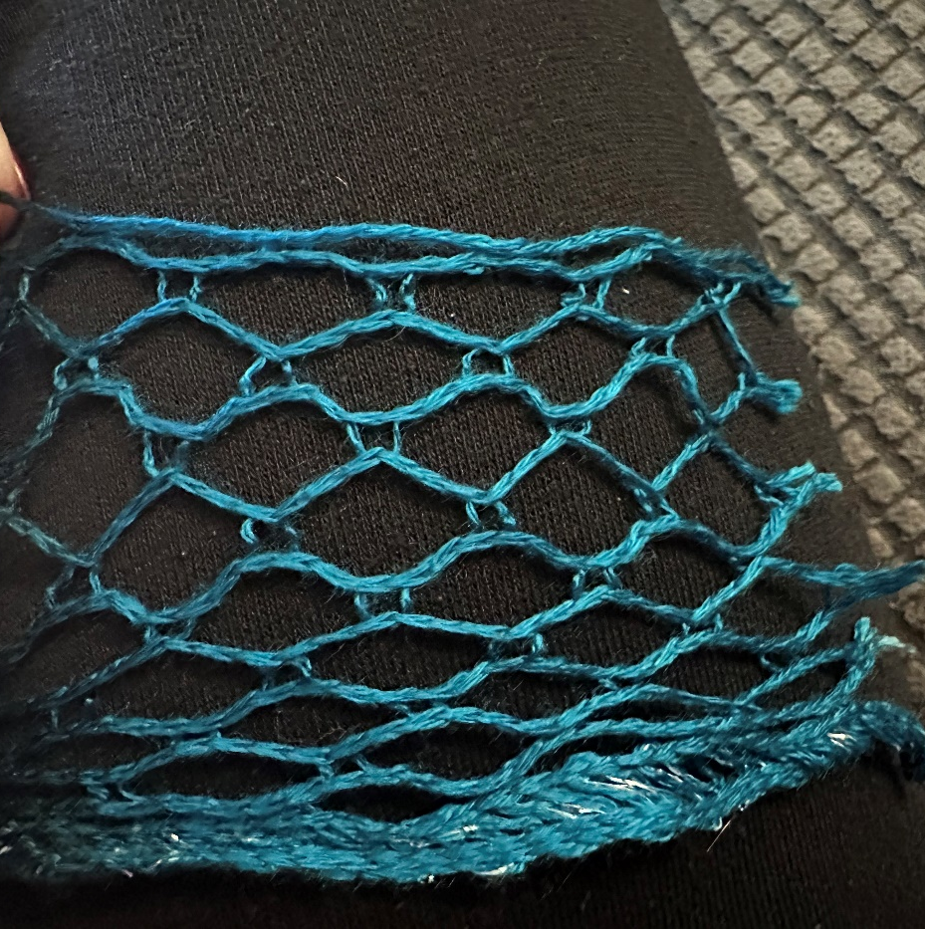

Image 2
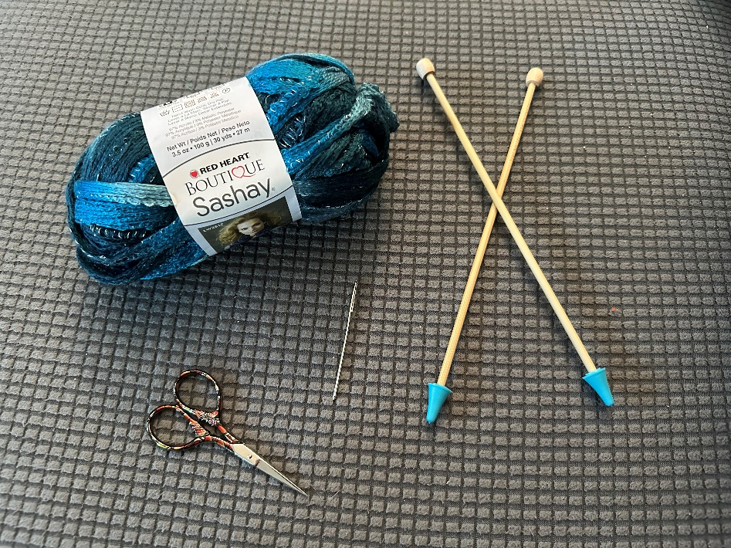

Image 3
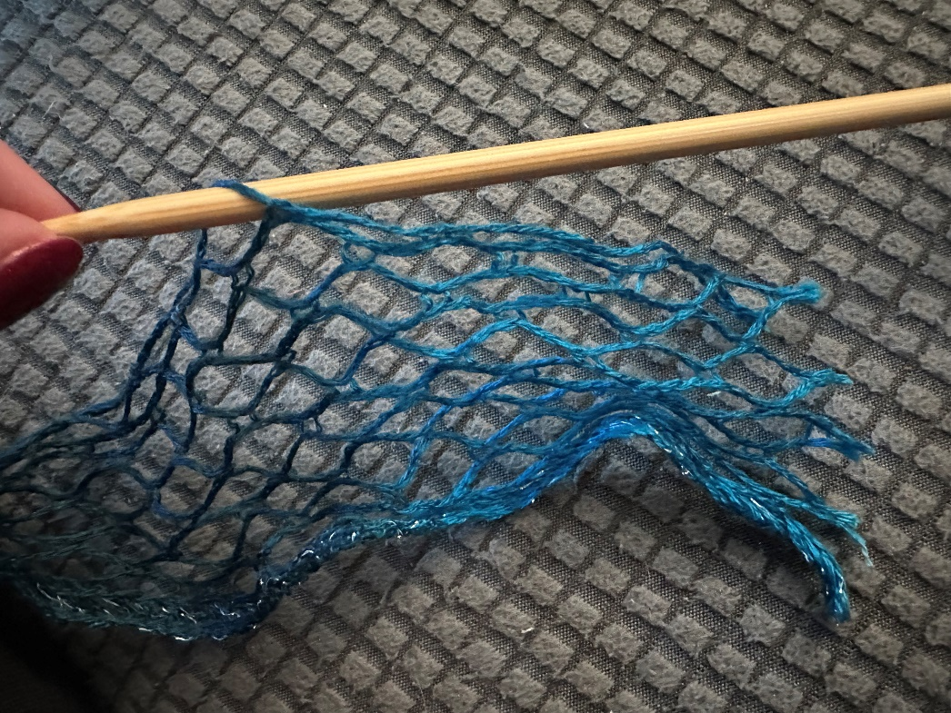

Image 4
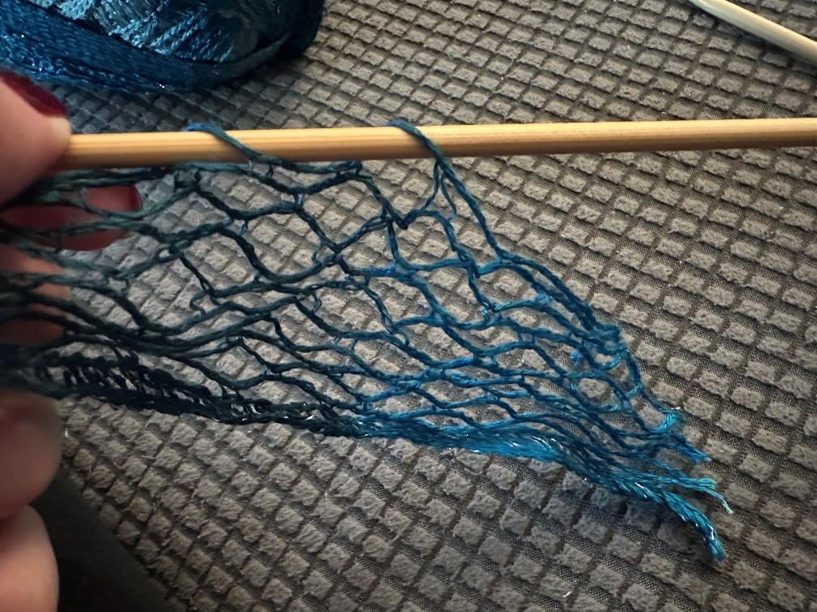

Image 5
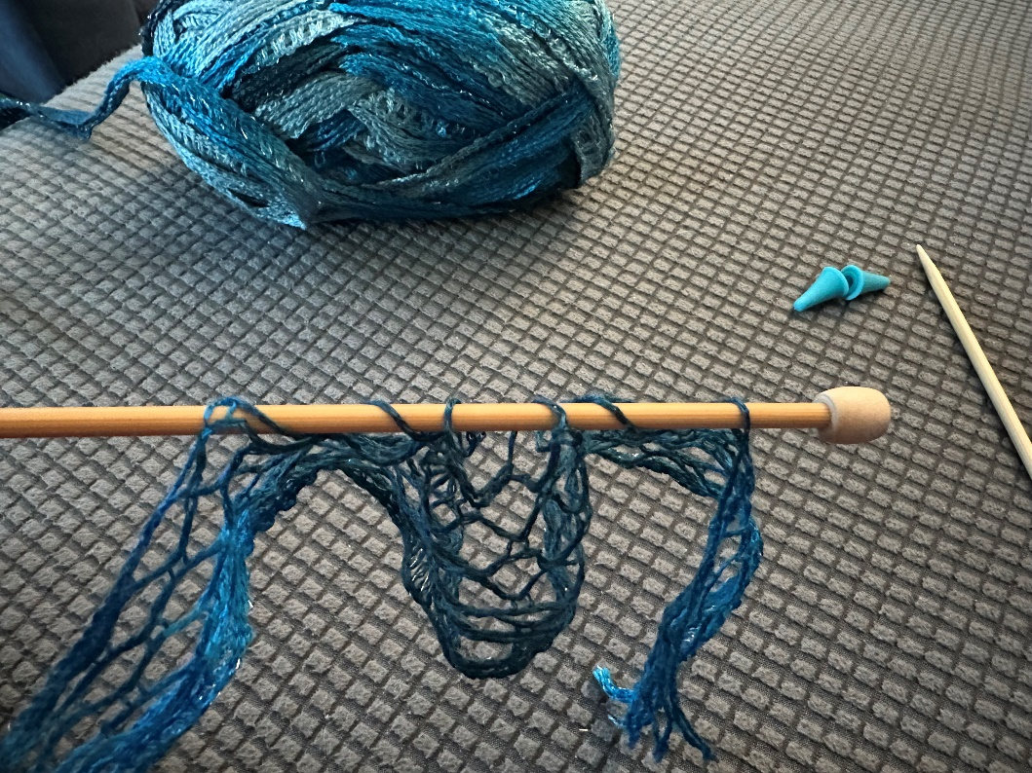

Image 6
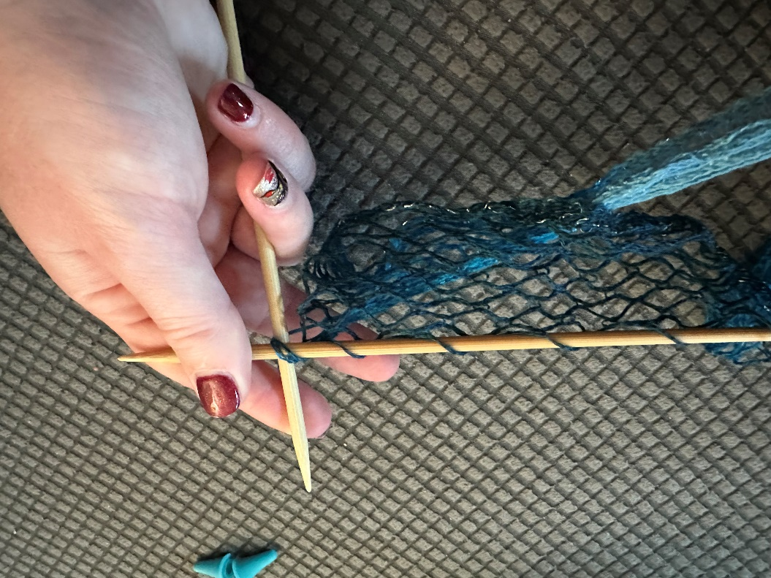

Image 7
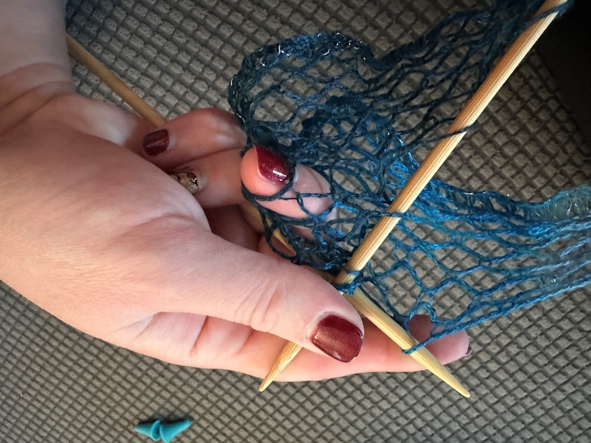

Image 8
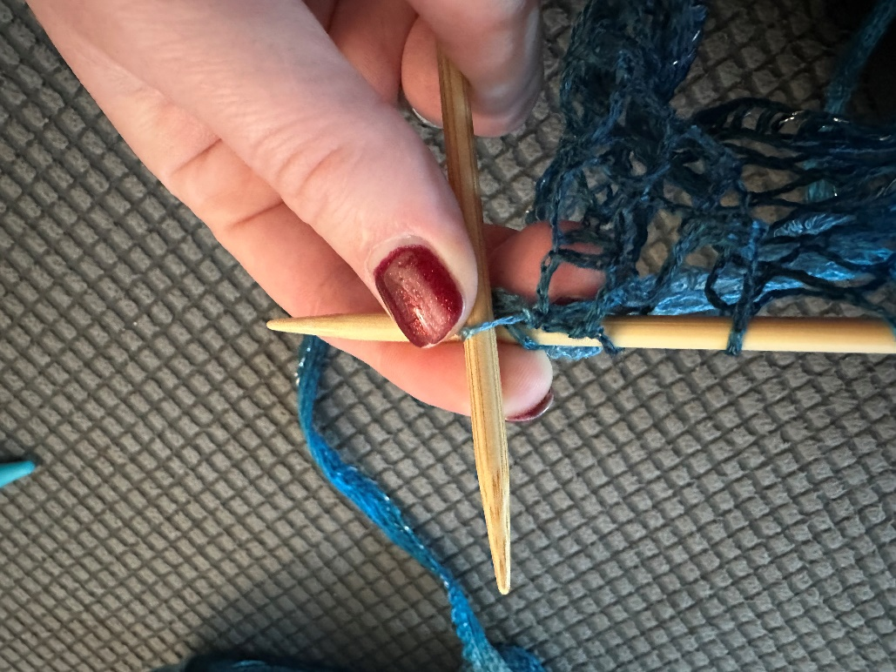

Image 9
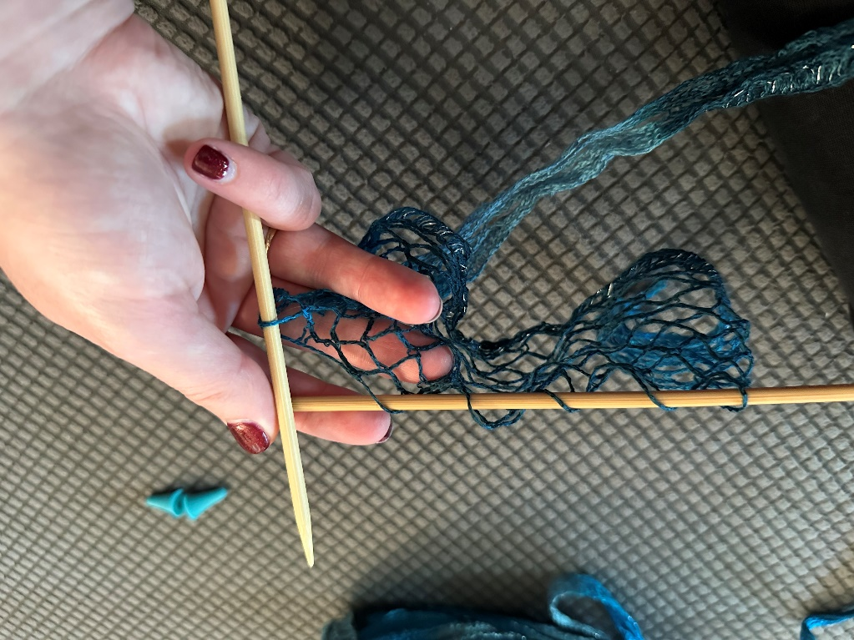

Image 10
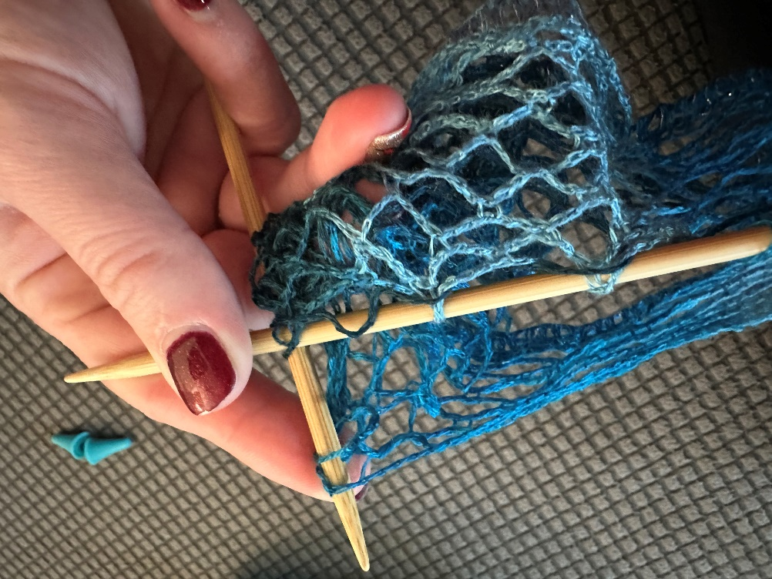

Image 11
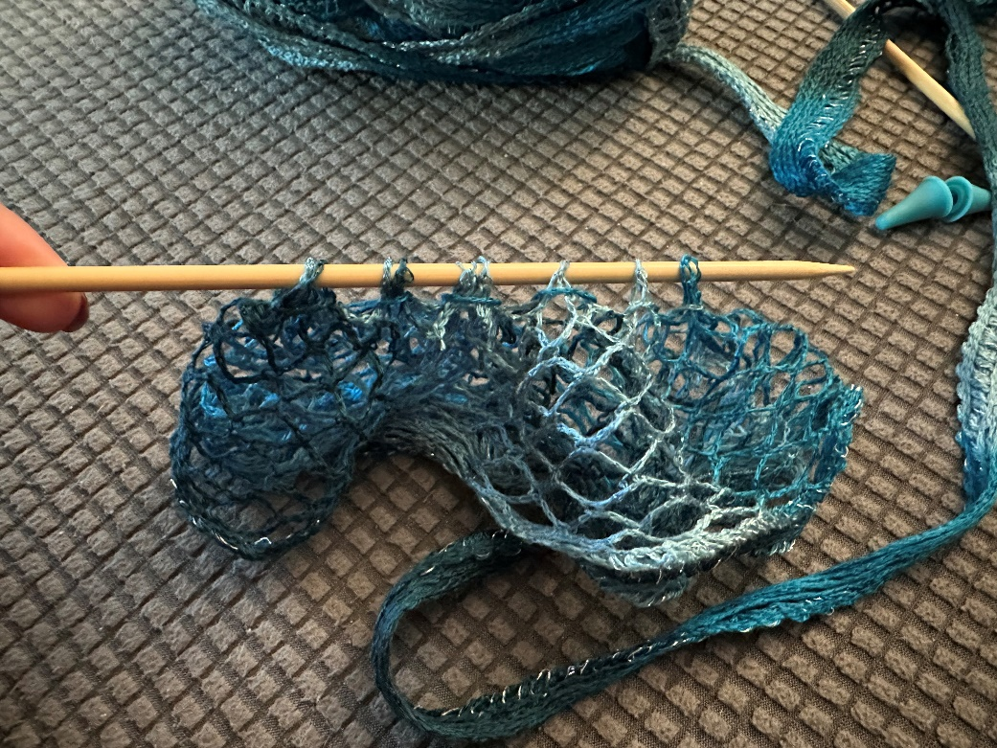

Image 12
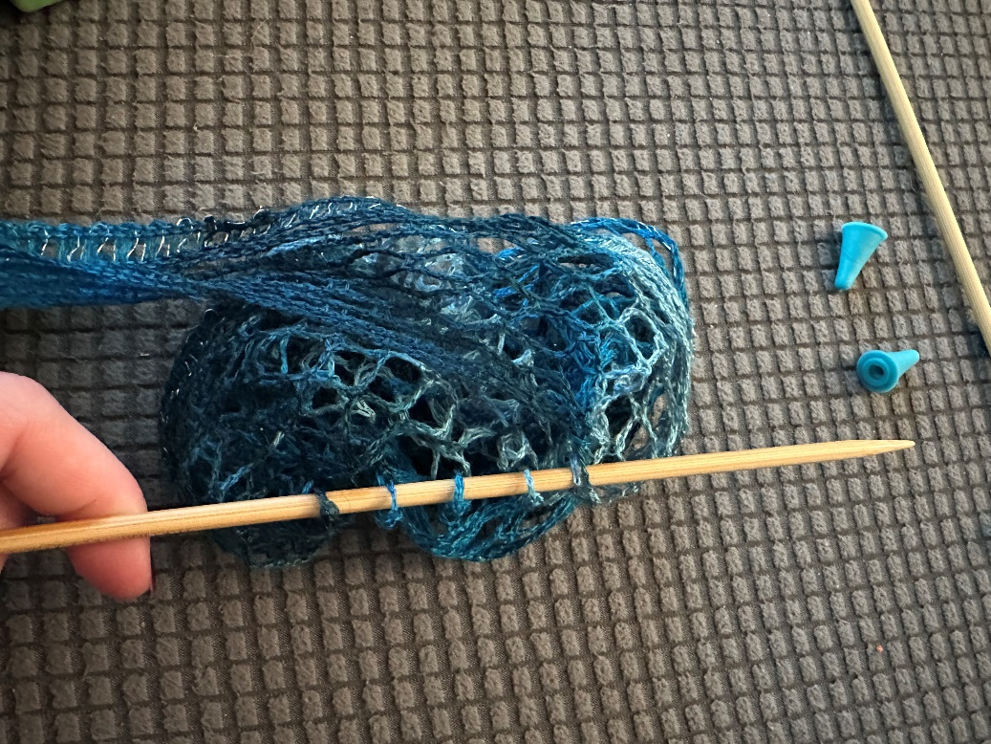

Image 13
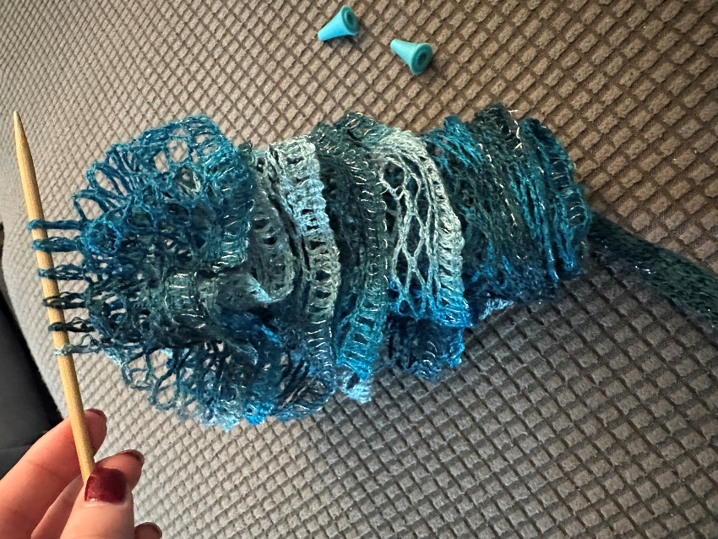

Image 14
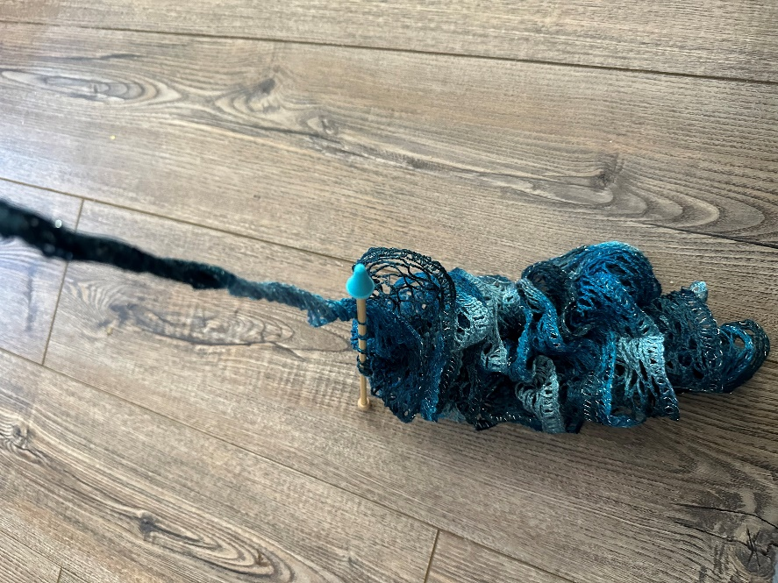

Image 15
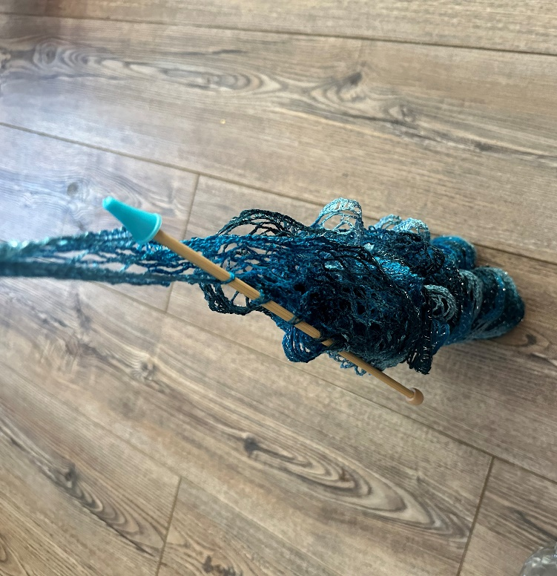

Image 16
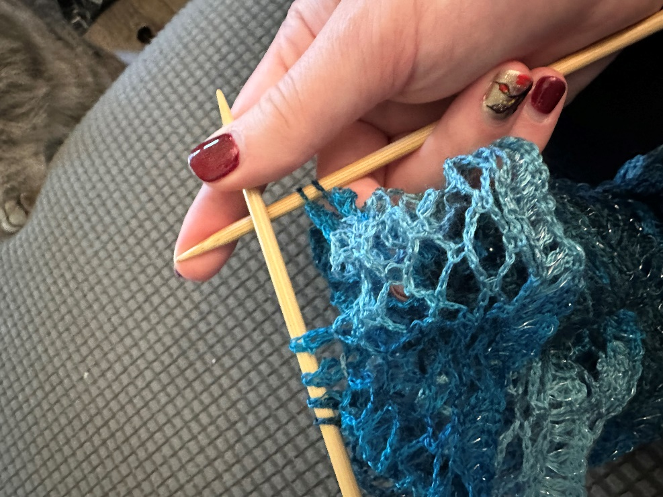

Image 17
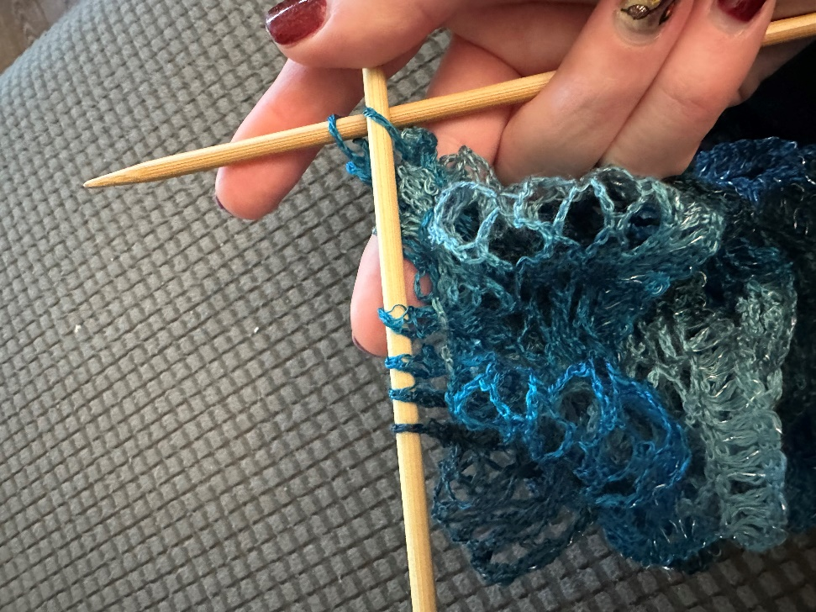

Image 18
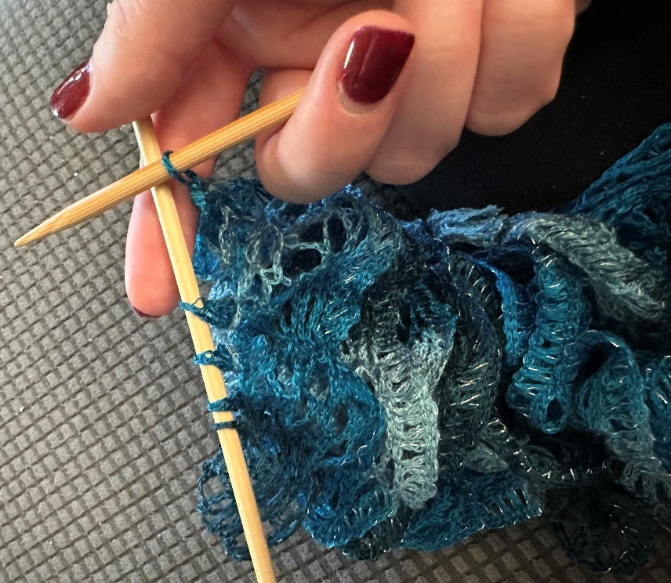

Image 19
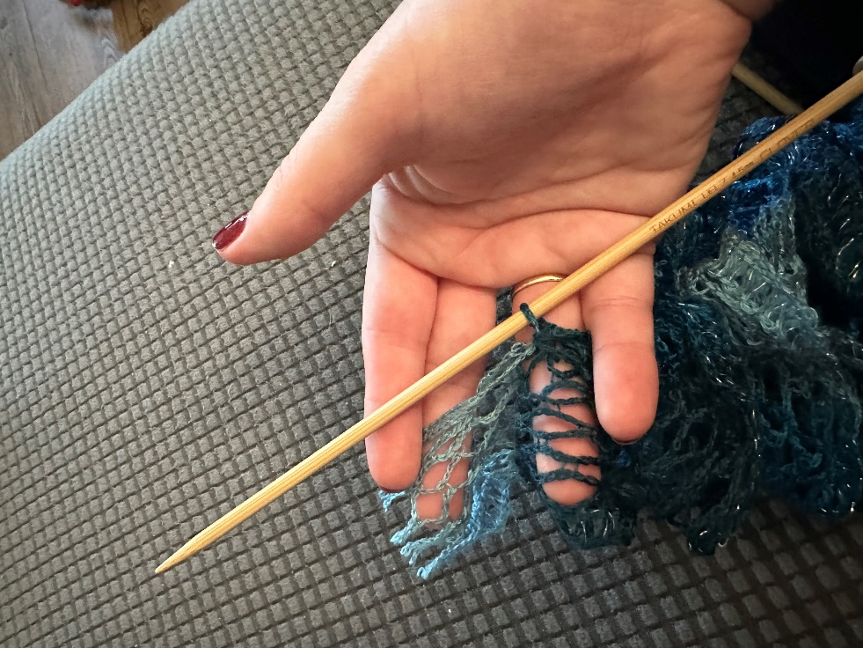
Image 20
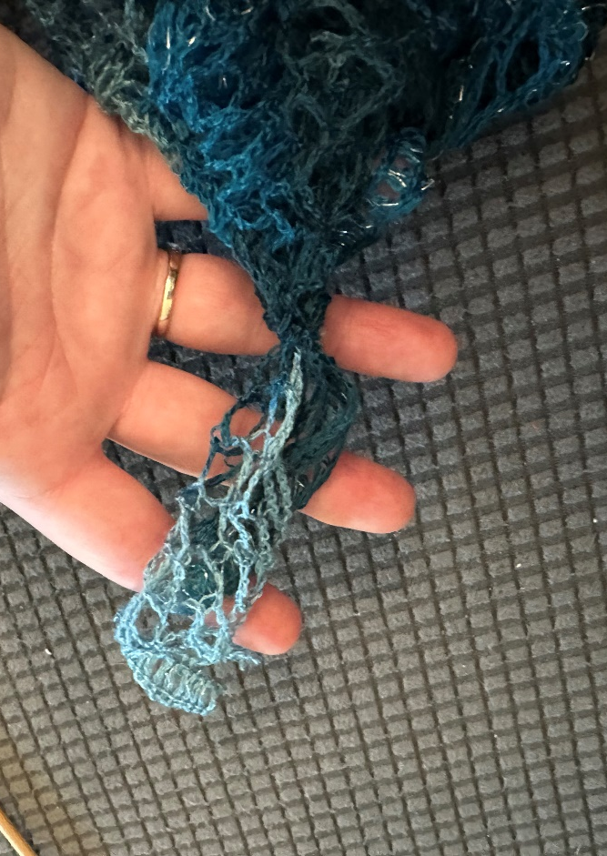

Image 21
