“You’re **BRAVER** than you believe, and **STRONGER** than you seem, and **SMARTER** than you think.” ~Christopher Robin

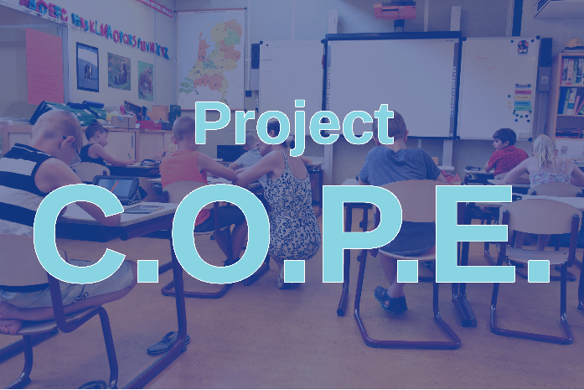

**Children**

**Overcoming**

**Problems**

**Everyday**



**What is Project C.O.P.E.?**

C.O.P.E. stands for Children Overcoming Problems Everyday. It is a partnership with JBS Mental Health Authority and the St. Clair County Schools.

**Project C.O.P.E**. connects children between the ages of 5-18 years, whose struggles are negatively impacting their school experience, with mental health services that will create the potential to overcome their everyday problems.

**Who is JBS?**

JBS is a regional, public, nonprofit corporation established under Act 310 of the 1967 Alabama Legislature. JBS provides individualized mental health services to children, youth and adults in a manner that encourages resilience and wellness. Their goal through education, treatment, and support, is for each person to live a meaningful and productive life of their choice.



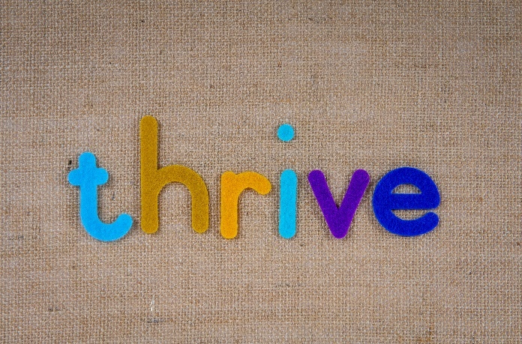

**How does my child get these services?**

To participate in Project C.O.P.E. a student will follow an easy process that is outlined below:

1. A student must be referred to JBS by the school’s guidance counselor.
2. A student will have an information release completed. An information release allows for the school system to send information to JBS. Students under the age of 14 will have the release completed by a legal guardian. Students 14 and older will complete the release themselves.
3. The guidance counselor will send the referral and release form to JBS for review.

**What happens next?**

JBS will contact the student’s family and set up a time for an initial evaluation to assess their mental health challenges. After the student’s evaluation, JBS will create an individualized treatment plan that fits their specific needs. JBS provides services in the school, home and community

**Why is mental health important?**

Mental health can be defined as “a state of well-being in which the individual realizes their own abilities, which the individual realizes their own abilities, can cope with normal stresses of life, can work productively and fruitfully” (WHO, 2007). Poor mental health can hinder a child’s ability to thrive, and its effects can last into adulthood.

