

**What is a School-Parent Compact?**

A School-Parent Compact for Achievement is an agreement that parents, students, and teachers develop together. It explains how parents and teachers will work together to make sure all our students reach or exceed grade-level standards.

Effective compacts:

• Link to goals of the school improvement plan

• Focus on student learning skills

• Describe how teachers will help students develop those skills using high-quality instruction

• Share strategies parents can use at home

• Explain how teachers and parents will communicate about student progress

• Describe opportunities for parents to volunteer, observe, and participate in the classroom

**Butner-Stem Elementary**

**School-Parent Compact for**

**Achievement**

**Achievement**

**Dr. Charmain Day-Heggie, Principal**

**Mrs. Shana Harris, Assistant Principal**



**Communication about Student Learning**

Butner-Stem Elementary School is committed to frequent two-way communication with families about children’s learning. Some of the ways you can expect us to reach you are:

• Weekly homework folders

• Weekly/Monthly “check-in” notes/phone calls,

ClassDojo communications

• Updates on the school Website, social media,

and current grades in PowerSchool

• Class/Parent meetings on understanding and

Progress

**Do you have questions about your child’s progress?** Contact your child’s teacher by phone, Class Dojo, or e-mail. Teachers will respond within 24-hours.

**Jointly Developed**

The parents, students and staff of Butner-Stem Elementary School developed this School-Parent Compact for Achievement. Teachers suggested home learning strategies, parents added ideas to make them more specific, and students told us what would help them learn. Meetings are held each year to review the Compact and make changes based on student needs.

***Parents******can contribute comments any time.***

**Building Partnerships**

If you would like to volunteer, participate and/or observe in the classroom, even while we are in the remote setting, please contact us directly.

**Building Partnerships**

**Family Fun Parent Night Events**

***September 2023 ~ Reading***

***February 2024~Math***

***April 2024~Science***

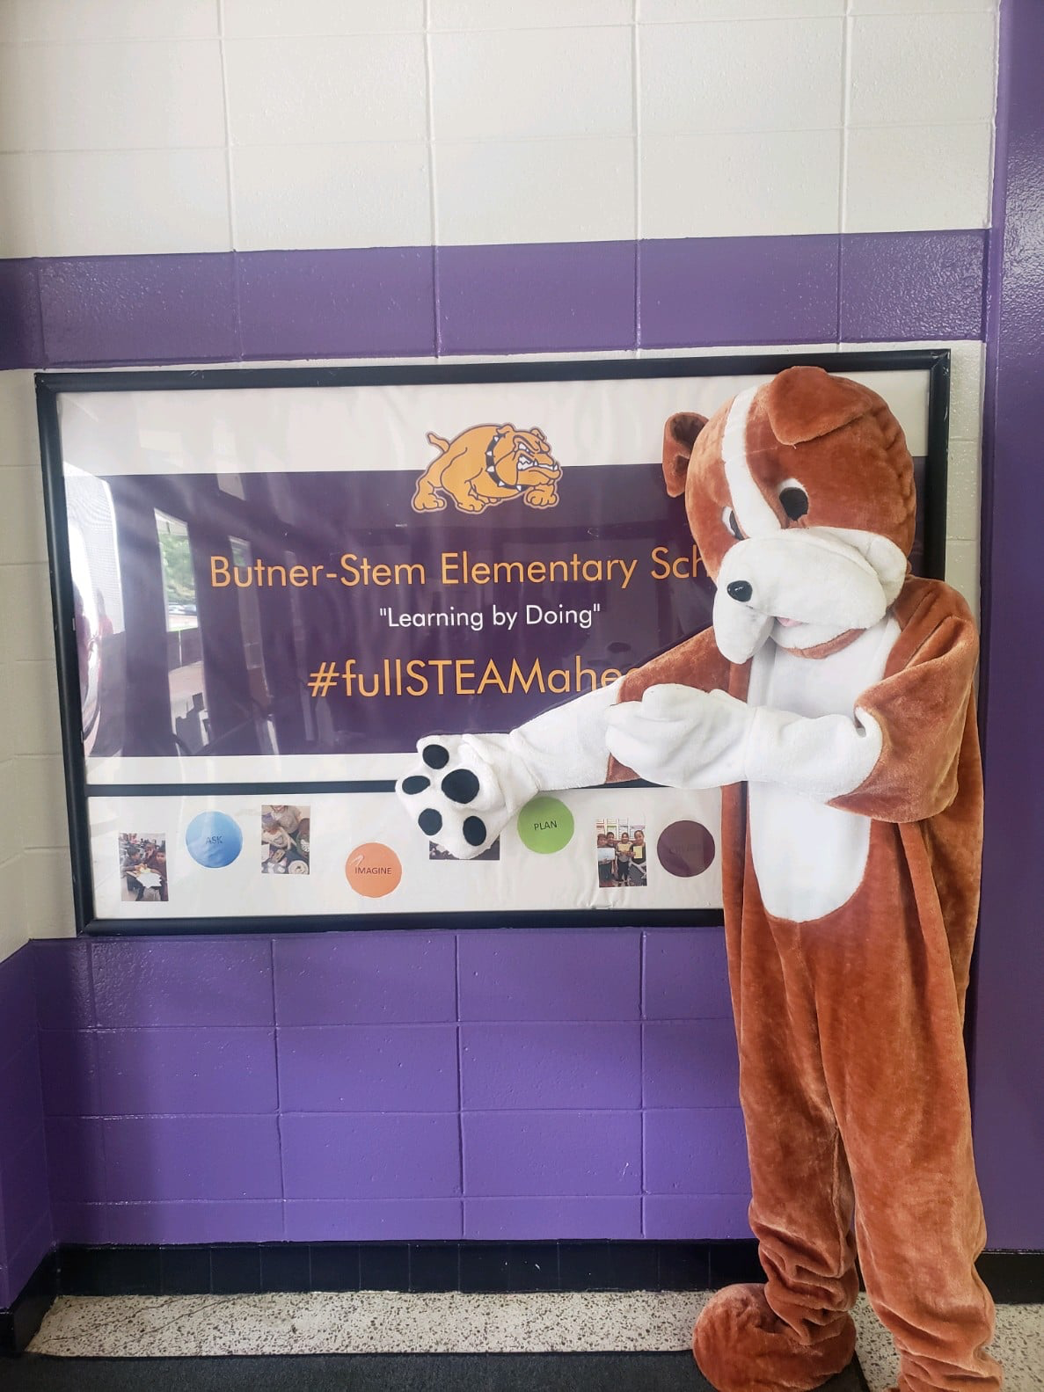

**At Home**

Butner-Stem Elementary School parents joined staff to develop ideas about how families can support students’ success in reading and math. Some of our key at-home activities will be:

• Use the weekly folder and/or monthly calendar to discuss my child’s learning goals and use the teacher’s materials to support my child’s learning at home.

• Post new words on our “word wall” and remember to use them in conversations and stories. Add our own new words.

• Read with my child every day for at least 20-30 minutes and talk about how the story connects with things that he or she has experienced. Attend family fun parent night events to practice new ways to support my child as a reader, mathematician, and scientist.

• Use the math goals and related games or strategies the teacher sends home to improve my child’s estimation and measurement skills

*Parent Signature*

**In ALL Bulldog Classrooms**

All BSES staff commits to working with students and their families to support students’ success in the Common Core Standards for reading and math. Some of our key connections with families will be:

• Develop a weekly goals folder with students and send home materials to help parents support the learning goals.

• Use the “word wall” and storytelling to incorporate new words. Send new words to families each week with information on how to build a home word wall and develop their own stories.

• Design fun family parent nights and share classroom strategies with families on how to help students connect personal experiences to Reading, Math, and Science.

• Develop Reading, Math, and Science goals with students that focus on increasing student growth and mastery and share with parents.

*Teacher Signature*

**Teachers, Parents, Students – Together for Success**

**GCPS Mission**

Every student will reach his or her full potential, prepared to thrive in a changing world.

**GCPS Vision**

We empower every student, every day.

**BSES School Goals**

By June 2024, our students will make a 10% gain in math, reading, and science. By June 2024 at least 90% of parents feel equipped to support their child with academic success as measured by parent surveys.

Our data show the need to focus on the following *Common Core Standards*:

• In reading – the standard of comprehension and understanding the author’s purpose.

• In math – the standard of strengthening our basic skills and math computation.

Dr. Charmain Day-Heggie

*Principal Signature*

**Our Goals for Student Achievement**

**Butner-Stem Elementary School Students**

Butner-Stem Elementary School students joined staff and parents to develop ideas about how they can succeed in school and reach for the stars in math and reading. Students thought of the following ideas to make connections between learning at home and school:

• Set goals for myself to learn new words and read every day.

• Make up stories to tell my family using new words.

• Create science experiments/projects based on what has been learned in Science.

• Help make the grocery list and estimate how much the food will cost.

*Student Signature*

**When teachers, students and families work together, we CAN achieve our goals!**