Dish Scrubby

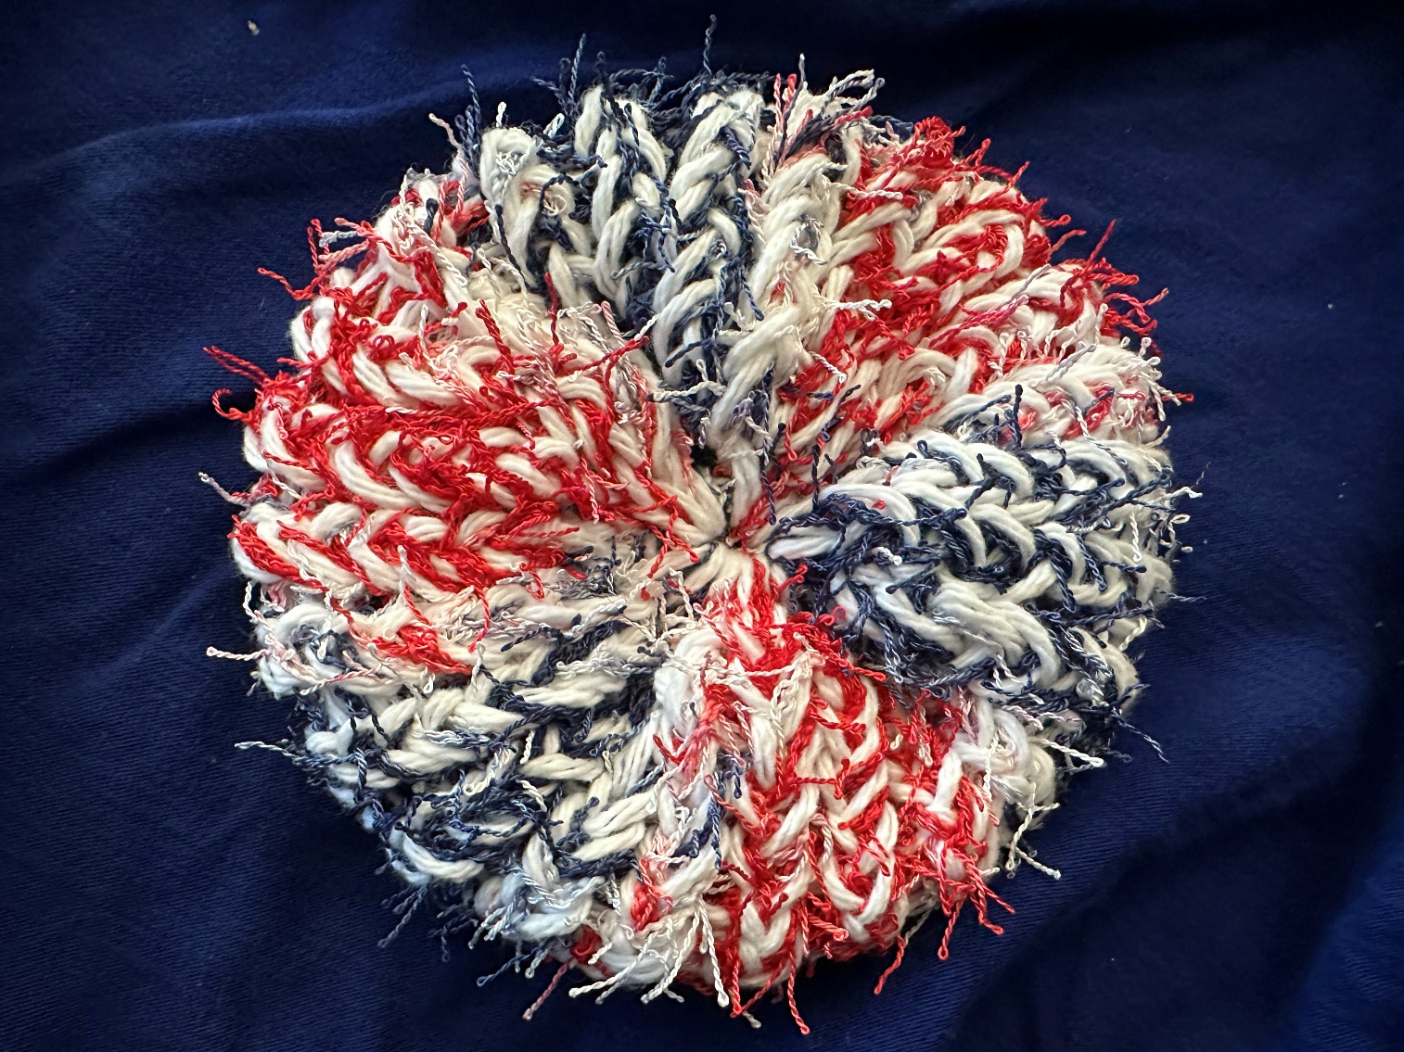

For a dish scrubby you will need 1 skein of cotton yarn and 1 skein scrubby yarn. Note: if you want a heavy duty scrubby, use 2 skeins of scrubby yarn.

Materials: As shown in Image 1
Red Heart Scrubby Yarn
Peaches & Cream Cotton Yarn
24 peg loom that is 5/8 large gauge
Loom pick
Tapestry Needle
Scissors

Note: For this project, we are using 2 strands of yarn (1 scrubby and 1 cotton) together. We are going to treat them as one.

To begin, grab both yarns and place them together and form a slip knot. Place the slip knot on the anchor peg. As shown in Image 2

- E wrap loom all the way around 2 times to start. As shown in Image 3

- E knit (pull bottom loop over the peg) all the way around. As shown in Image 4

- E Wrap 1 time all the way around then E knit. Note: Remove slip knot from anchor peg at this time.

- Repeat step 3 for 13 more times for a total of 14 rows.

- Grab the first row and place it back onto the loom and push it down. We are folding it in half. Note: place beginning tails into the fold. Make sure leading yarn (the yarn going to the skeins) is between ending and beginning pegs. As shown in Image 5, Image 6 and Image 7

- E wrap then E knit both bottom loops over the peg. Should now have 15 rows. As shown in Image 8

- Wrap yarn around outside of the loom about 3/4 around and cut yarn. Thread with tapestry needle. Put the loops on each peg onto the needle and down onto the yarn. When all loops are on, pull tight. It should now look like a dish scrubby. As shown in Image 9 and 10

- Thread tapstry needle through last loop to complete the circle. As shown in Image 11

- To reinforce middle, thread needle up and down going in a circle. Sew in ends in the shape of S. Put the tapestry needle just under the first set of stitches about 3 stitches up, pull needle through. Go to the next row of stitiches and thread needle through 3 stitches. Go one more row over and thread needle through 3 stitches. If you are worried, thread needle through your 2nd row of stitches in the opposite direction. As shown in Image 12 and 13

Image 1
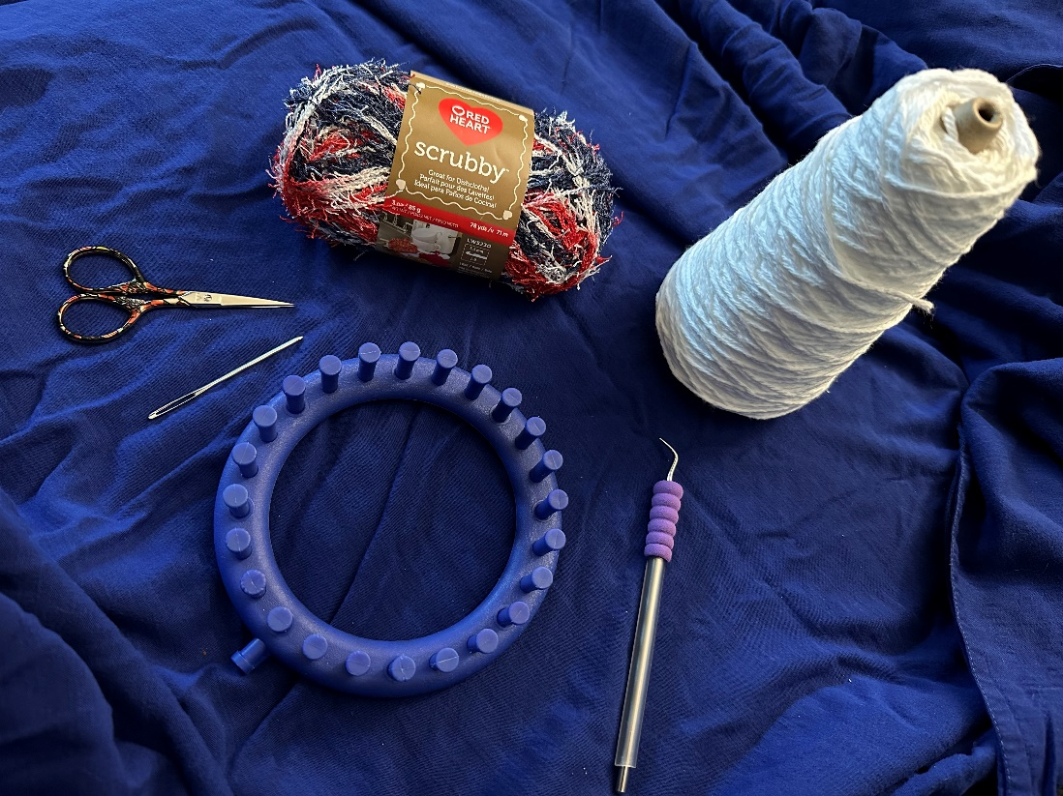

Image 2
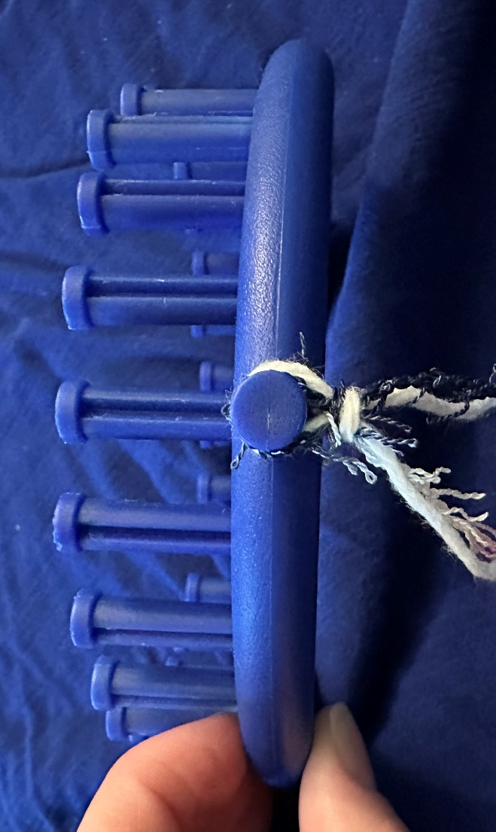

Image 3
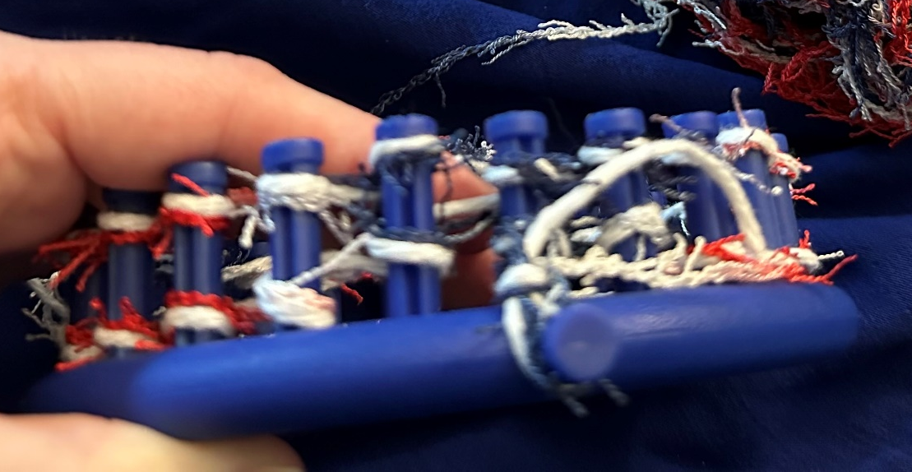

Image 4
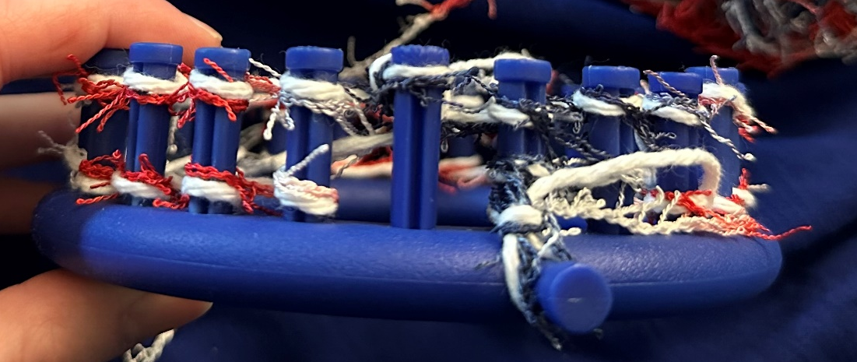

Image 5
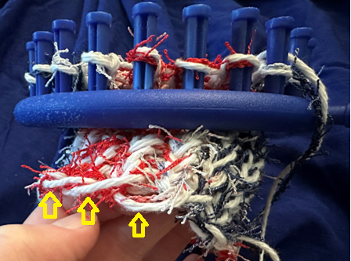

Image 6
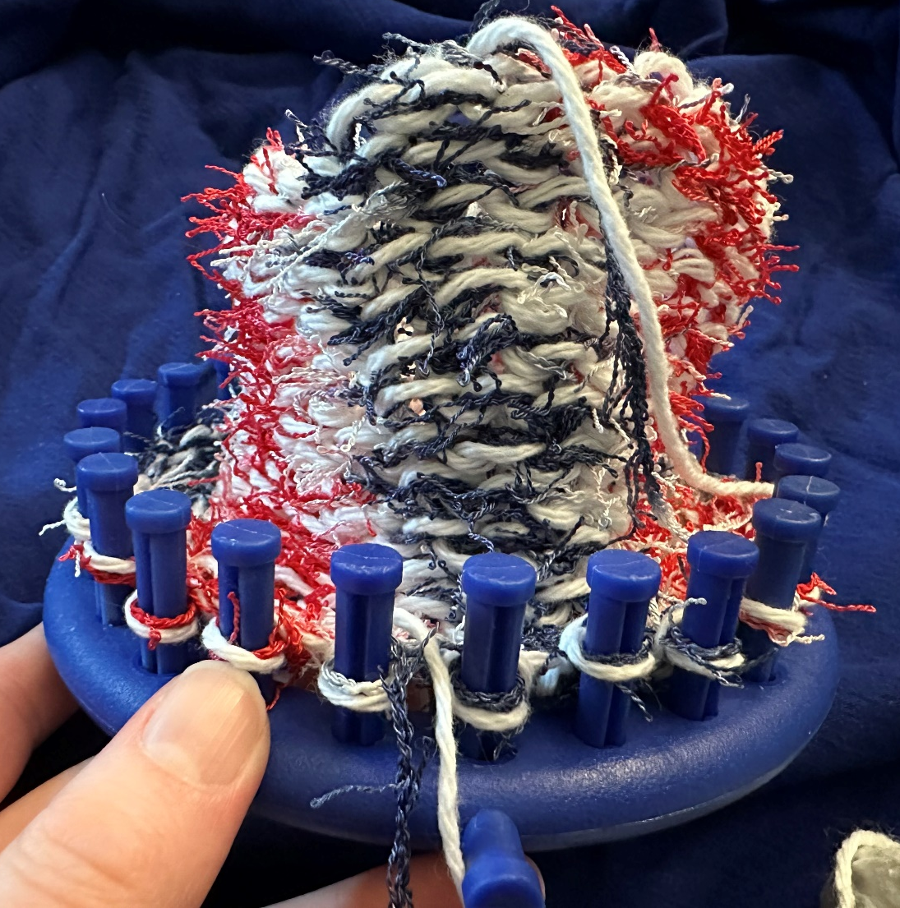

Image 7
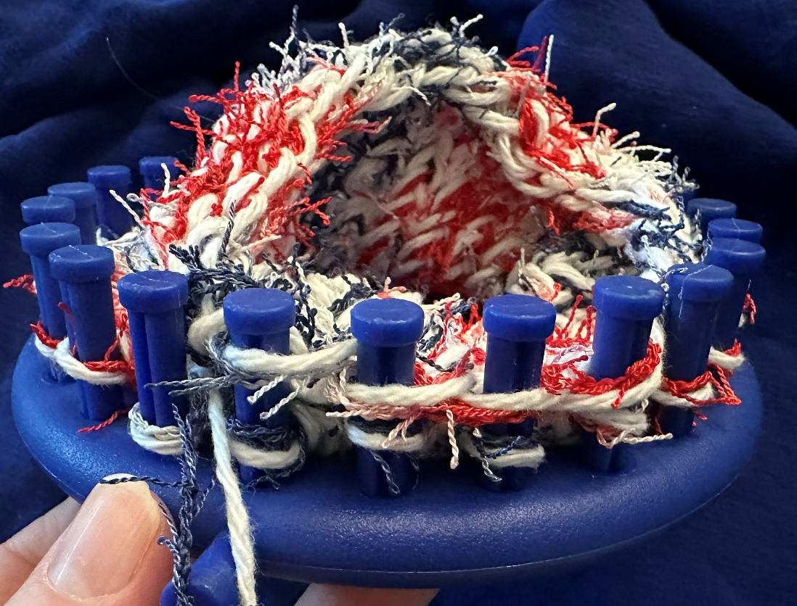

Image 8

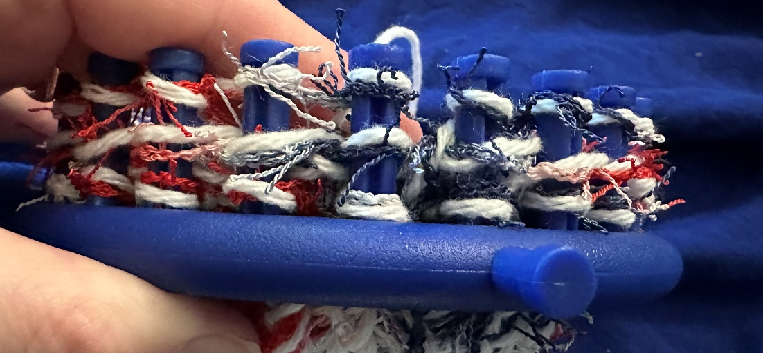

Image 9
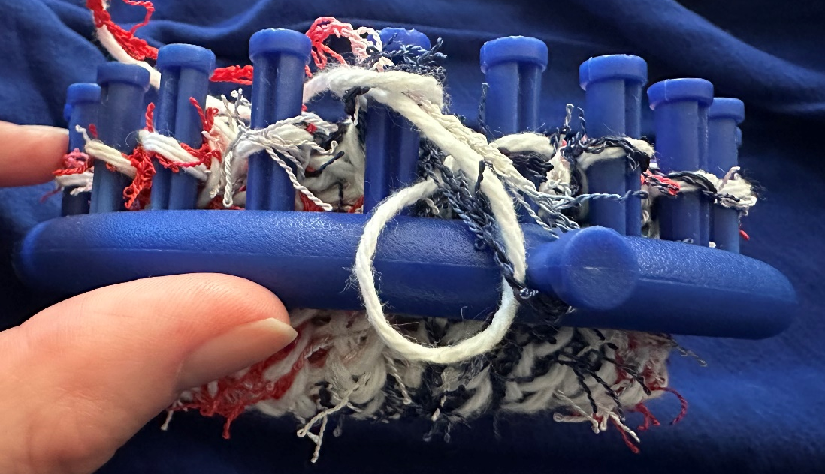

Image 10
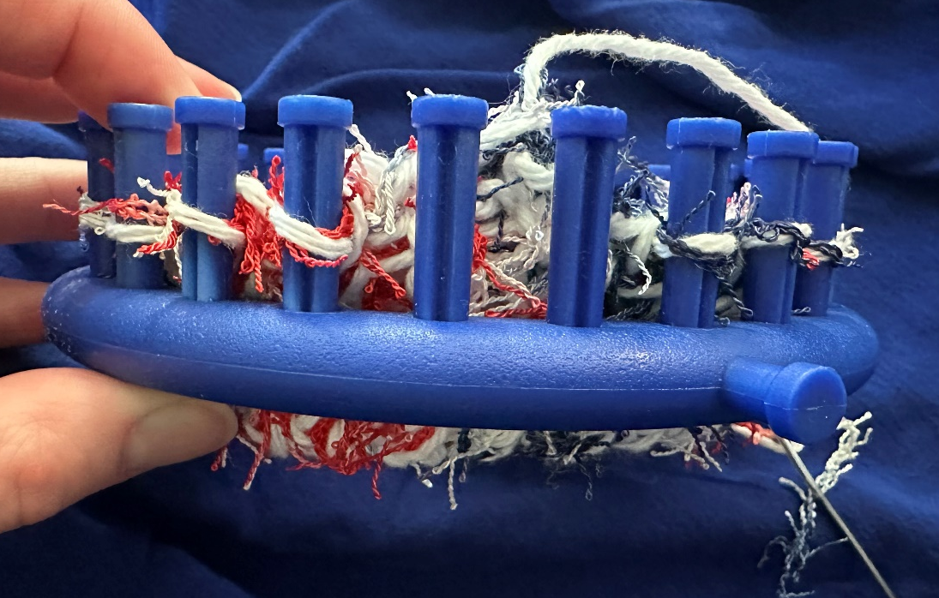
Image 11
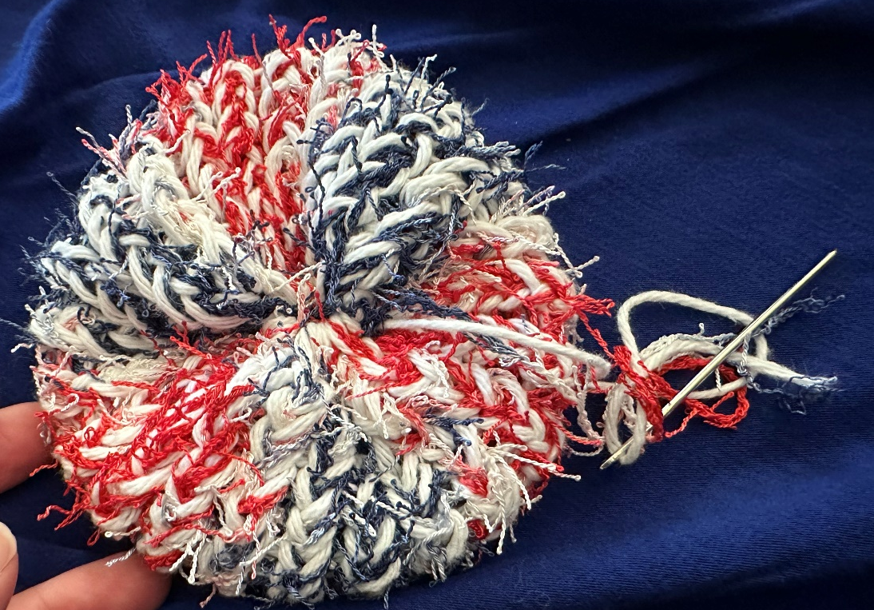

Image 12
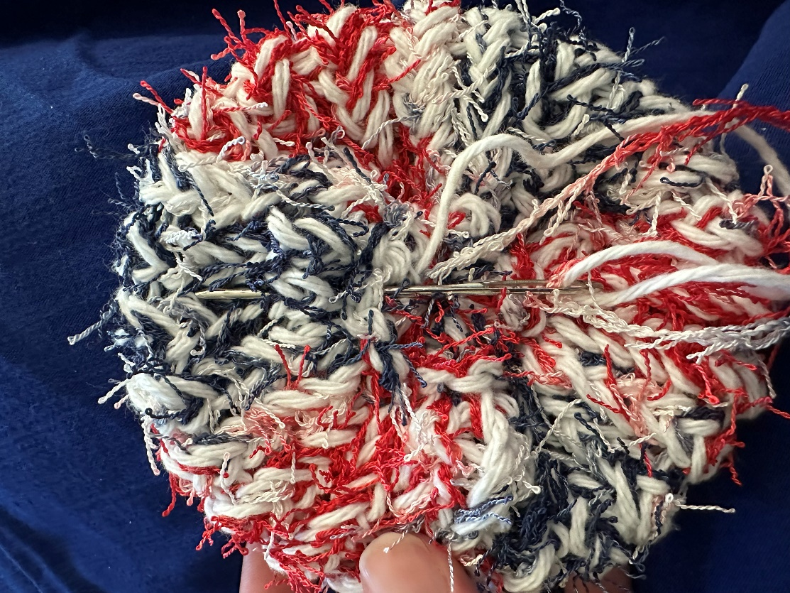

Image 13
