***Directions:*** *Fill in the graphic organizer for each source. Make sure to annotate these sources.*

*Historical Context can be considered events/terms/ideas from your text book that correspond to that particular primary source. It is the setting for the document/event.*

1.

“Kitche Manitou (The Great Spirit) beheld a vision. In this dream he saw a vast sky filled with stars, sun, moon, and earth. He saw an earth made of mountains and valleys, islands and lakes, plains and forests. He saw trees and flowers, grasses and vegetables. He saw walking, flying, swimming, and crawling beings. He witnessed the birth and end of things. At the same time he saw other things live on.…He touched rain and wind. He felt love and hate, fear and courage, joy and sadness. Kitche Manitou meditated to understand his vision. In his wisdom Kitche Manitou understood that his vision had to be fulfilled. Kitche Manitou was to bring into being and existence what he had seen, heard, and felt.”

Basil Johnson, *Ojibway Heritage*

|  |  |  |
| --- | --- | --- |
| **Main Idea**  What is the most important central thought(s)? | **Historical Context**  What key historical facts relate to this document? | **Supporting Details**  What are the key statements/quotes/images that explain the main idea? |
|  |  |  |

2.

“For I knew that they were a people who could be more easily freed and converted to our holy faith by love than by force, gave to some of them red caps, and glass beads to put round their necks, and many other things of little value, which gave them great pleasure, and made them so much our friends.…It appeared to me to be a race of people very poor in everything.…They have no iron, their darts being wands without iron, some of them having a fish’s tooth at the end….They should be good servants and intelligent, for I observed that they quickly took in what was said to them, and I believe that they would easily be made Christians as it appeared to me that they had no religion.”

Christopher Columbus upon reaching the West Indies, 1492

|  |  |  |
| --- | --- | --- |
| **Main Idea**  What is the most important central thought(s)? | **Historical Context**  What key historical facts relate to this document? | **Supporting Details**  What are the key statements/quotes/images that explain the main idea? |
|  |  |  |

**3.**

**“**It is to be understood, that the people which now inhabit the regions of the coast of Guinea, and the middle parts of Africa, as Libya the inner, and Nubia, with diverse other great and large regions about the same, were in old time called Ethiopians and Nigritae, which we now call Moores, Moorens, or Negros, a people of beastly living, without a god, law, religion, or common wealth, and so scorched and vexed with the heat of the sun, that in many places they curse it when it rises….There are also other people of Libya called Garamantes, whose women are common: for the contract on matrimony (marriage), neither have respect to chastity (avoiding pre-marital sex).”

John Lok, *Second Voyage to Guinea*, 1554

|  |  |  |
| --- | --- | --- |
| **Main Idea**  What is the most important central thought(s)? | **Historical Context**  What key historical facts relate to this document? | **Supporting Details**  What are the key statements/quotes/images that explain the main idea? |
|  |  |  |

4.

“Could one give more convincing proof of the superiority of some men to others in intelligence, spirit, and valor (honor), and of the fact that such people are slaves by nature? For although some of them display a certain talent for craftsmanship, this is not proof of human intelligence, for we know that animals, birds, and spiders do certain work that no human industry can completely imitate….Such, in sum, are the disposition and customs of these little men -- barbarous, uncivilized, and inhumane; and we know that they were like this before the coming of the Spaniards. We have not yet spoken of their impious religion and of the wicked sacrifices in which they worshipped the devil as their God, believing that they could offer no better tribute than human hearts.... How can we doubt that these peoples, so uncivilized, so barbarous, contaminated with so many infidelities (cheating on spouse) and vices (bad habits), have been justly conquered by such an excellent, pious (religious), and just king as the late Ferdinand the Catholic, and by a nation that is most humane and excels in every kind of virtue?”

Juan Ginés de Sepúlveda, *Concerning the Just Cause of the War against the Indians*, 1547

|  |  |  |
| --- | --- | --- |
| **Main Idea**  What is the most important central thought(s)? | **Historical Context**  What key historical facts relate to this document? | **Supporting Details**  What are the key statements/quotes/images that explain the main idea? |
|  |  |  |

5.

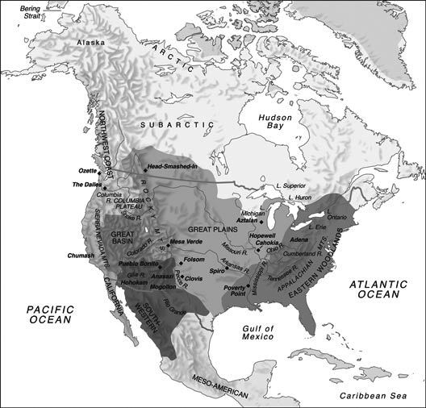

Map of Approximate Tribal Locations at First Sustained Contact with Europeans

|  |  |  |
| --- | --- | --- |
| **Main Idea**  What is the most important central thought(s)? | **Historical Context**  What key historical facts relate to this document? | **Supporting Details**  What are the key statements/quotes/images that explain the main idea? |
|  |  |  |

6.

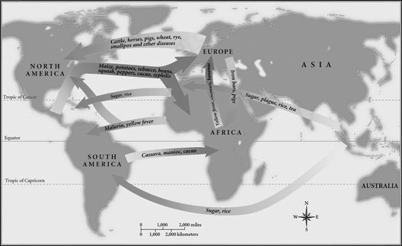

Map Depicting (showing) the Columbian Exchange

|  |  |  |
| --- | --- | --- |
| **Main Idea**  What is the most important central thought(s)? | **Historical Context**  What key historical facts relate to this document? | **Supporting Details**  What are the key statements/quotes/images that explain the main idea? |
|  |  |  |

**7.**

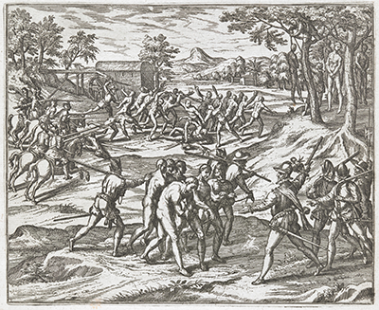

Engraving Depicting Spanish Treatment of Fugitive Black Slaves, 1595

|  |  |  |
| --- | --- | --- |
| **Main Idea**  What is the most important central thought(s)? | **Historical Context**  What key historical facts relate to this document? | **Supporting Details**  What are the key statements/quotes/images that explain the main idea? |
|  |  |  |

8.

"The tough sod discouraged farming, and the plains animals were too fleet of foot to provide a dependable supply of food for large numbers of pedestrians (people). Then the horse gave the Indians the speed and stamina (endourance) needed to take advantage of the opportunity to harvest this immense quantity of food represented by the buffalo herds of North America and the herds of wild cattle that propagated (produced offspring) so rapidly in the grasslands of both Americas. The Indians stopped farming; the work was hard, boring, and unrewarding compared to the nomadic life."

Alfred W. Crosby, Jr., *The Columbian Exchange: Biological and Cultural Consequences of 1492*, 1972.

|  |  |  |
| --- | --- | --- |
| **Main Idea**  What is the most important central thought(s)? | **Historical Context**  What key historical facts relate to this document? | **Supporting Details**  What are the key statements/quotes/images that explain the main idea? |
|  |  |  |

9.

When it became clear that there was no gold left, the Indians were taken as slave labor on huge estates, known later as *encomiendas*. They were worked at a ferocious pace, and died by the thousands. By the year 1511, there were perhaps fifty thousand Indians left. By 1550, there were five hundred. A report of the year 1650 shows none of the original Arawaks or their descendants left on the island.

Howard Zinn “Columbus, the Indians, and Human Progress,”

*A People’s History of the United States,*  1980

|  |  |  |
| --- | --- | --- |
| **Main Idea**  What is the most important central thought(s)? | **Historical Context**  What key historical facts relate to this document? | **Supporting Details**  What are the key statements/quotes/images that explain the main idea? |
|  |  |  |

**10.**

…will it not stand proved that the Reverend Doctor …has falsely and perhaps irreparably slandered (told damaging lies about) them [Indians] before the entire world? From the fact that the Indians are barbarians it does not necessarily follow that they are incapable of government and have to be ruled by others, except to be taught about the Catholic faith and to be admitted to the holy sacraments. They are not ignorant, inhuman, or bestial. Rather, long before they had heard the word Spaniard they had properly organized states, wisely ordered by excellent laws, religion, and custom. They cultivated (grew) friendship, and bound together in common fellowship in populous cities in which they wisely administered the affairs of both peace and war justly and equitably, truly governed by laws that at very many points surpass ours…next I call the Spaniards who exploit that unhappy people torturers.

*Bartolome’ de Las Casas, a Dominican friar in Thirty Very Judicial Propositions (1552). Debating Sepulveda in the Spanish Valladolid Debates.*

|  |  |  |
| --- | --- | --- |
| **Main Idea**  What is the most important central thought(s)? | **Historical Context**  What key historical facts relate to this document? | **Supporting Details**  What are the key statements/quotes/images that explain the main idea? |
|  |  |  |

11.

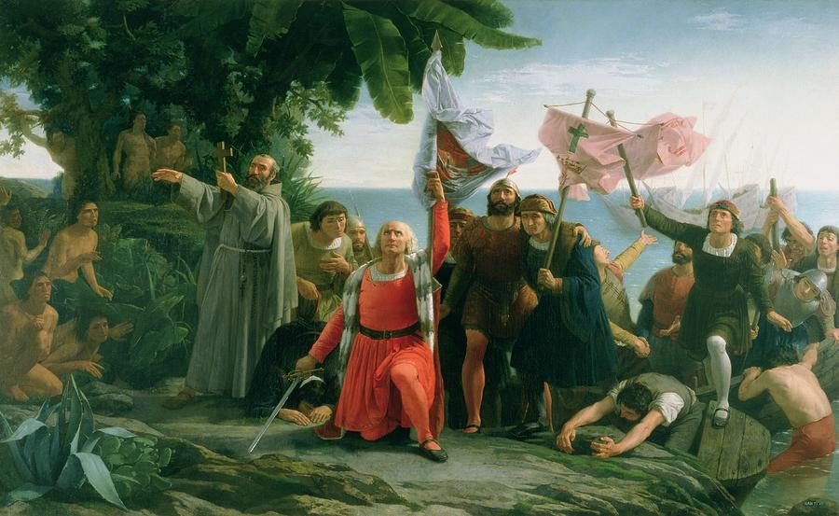

*The First Landing of Christopher Columbus* (1862) by Dioscoro Puebla

|  |  |  |
| --- | --- | --- |
| **Main Idea**  What is the most important central thought(s)? | **Historical Context**  What key historical facts relate to this document? | **Supporting Details**  What are the key statements/quotes/images that explain the main idea? |
|  |  |  |