**DCES 2023-2024 SPIRIT ITEMS (Sponsored by BETA Club)**

**Dodge County Elementary is offering a selection of items so you can show your support and love of our school! We will have shirts and car decals available this year. The shirt is red with black and white print. The car decal is white with red and black print.**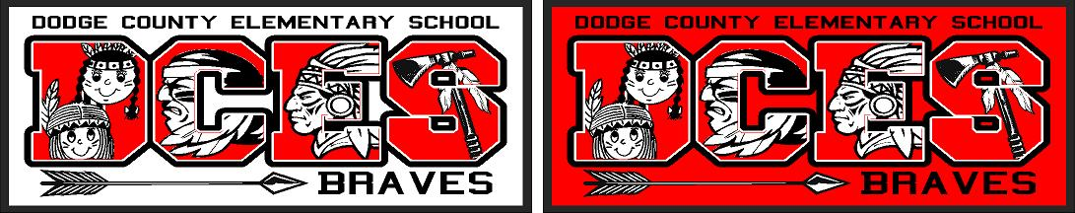

**Youth Small – Adult XL - $15.00 (NO YOUTH XL is available) Decal (white w/ red & black) Shirt (red w/ white & black)**

**Adult 2XL - 4XL - $20.00**

**Car Decals - $5.00 each**

**Shirts are not in stock. They will be ordered in bulk every couple of weeks.**

**Shirts will be sold through September & October.**

**There are NO EXCHANGES available. Please mark the correct size for you and your child.**

**\*\*CASH PAYMENTS ONLY. NO CHECKS \*\***

**ALL ORDERS MUST BE PLACED BY October 27**.

**(Please allow 2-3 weeks for delivery once you have turned in your order.)**

**Student’s first and last name ___________________________________________**

**Teacher’s first and last name ____________________________________**

**Grade**___________

_____Youth Small $15.00 _____Adult Large $15.00

_____Youth Medium $15.00 _____ Adult X-Large $15.00

_____Youth Large $15.00 _____XXL $18.00

_____Adult Small $15.00 _____XXXL $18.00

_____Adult Medium $15.00 _____XXXXL $18.00

Total number of shirts ordered: _________________________

Car Decal $5.00 Quantity _____________

**AMOUNT ENCLOSED_ _$____________________**